**A Dissertation Report on**

**DROPCV: Delta Robot Based Pick and Place Conveyor System Using Computer Vision**

**Submitted by**

**Mohammad Umer Ali** **Enrolment No**: - 21045110028

**Shahan Bilal** **Enrolment No**: - 21045110016

**Danish Ahmad Malik** **Enrolment No**: - 21045110008

**Under the supervision of**

**Dr Sajid Yusuf Bhat**

In partial fulfilment for the award of degree Of

Masters of Computer Applications



**At**

PG Department of Computer Science, University

Of Kashmir, Srinagar, J&K

India-190006

PG Department of Computer Science, University

Kashmir Srinagar J&K India-190006

**Student Declaration**

We hereby declare that our project report titled “Delta Robot Based Pick and Place Conveyor System Using Computer Vision” for the award of the degree of Masters of Computer Applications at University of Kashmir under the direct supervision & guidance of “Dr Sajid Yusuf Bhat” is our authentic work.

This project report has not been copied, duplicate or plagiarised from any other paper,

journal or document & has not been submitted to any educational institute or

otherwise for the award of any certificate, diploma, degree or recognition.

This is an authentic piece of work & in case there is any query regarding the same, we shall be responsible for answering any queries in this regard.

**Names:**

Mohammad Umer Ali Enrolment No: - 21045110028

Shahan Bilal Enrolment No: - 21045110016

Danish Ahmad Malik Enrolment No: - 21045110008

Date: -

Place: -

`

PG Department of Computer Science, University

Kashmir Srinagar J&K India-190006

**Certificate**

This is to certify that the work contained in this project entitled “Delta Robot Based Pick and Place Conveyor System Using Computer Vision”

**Submitted by**

Mohammad Umer Ali Enrolment No: - 21045110028

Shahan Bilal Enrolment No: - 21045110016

Danish Ahmad Malik Enrolment No: - 21045110008

for the award of the degree of Masters of Computer Applications at University of Kashmir is a record of bonafied work carried out under the supervision & guidance of “Dr Sajid Yusuf Bhat” and the project has not formed the basis for the award previously of any other degree, diploma, fellowship or any similar title.

Date: -

Place: -

**Supervisor Head of The Department**

Dr Sajid Yusuf Bhat Dr Javaid Iqbal

Assistant Professor Assistant Professor

DoCS, UoK DoCS, UoK

External Examination

PG Department of Computer Science, University

Kashmir Srinagar J&K India-190006

**Acknowledgement**

We would like to express our special thanks of gratitude to our mentor who gave us an opportunity to do this amazing project & also helped us in finalizing & completing our project with in the limited time frame.

Thanks for supporting, educating and inspiring. You are an incredible professor & we wish you endless incredible days. Your dedication, understanding & time all meant so much to us and we feel very lucky to be able to experience life alongside you. It has been great honour & privilege to undergo training with such a hardworking mentor & providing constant supervision and necessary information.

We would also like to extend our gratitude to the head of the department “Dr Javaid Iqbal” for giving his wonderful support and motivation.

Also, we acknowledge the support from all the faculty members and other authorities of Department of Computer Science, University of Kashmir for providing us with facilities required to do our project.

**Names:**

Mohammad Umer Ali Enrolment No: - 21045110028

Shahan Bilal Enrolment No: - 21045110016

Danish Ahmad Malik Enrolment No: - 21045110008

Date: -

Place: -

Table of Contents

PROBLEM STATEMENT 8

ABSTRACT ……………………………………………………………………………………………………………………………………. 9

WHAT IS A DELTA ROBOT? 10

APPLICATIONS FOR SPIDER ROBOTS 11

DELTA ROBOT KINEMATICS 11

INVERSE KINEMATICS 13

FORWARD KINEMATICS 17

PURE PURSUIT 20

LINE-CIRCLE INTERSECTION 21

CHOOSING THE GOAL POINT 22

WHAT IS A SERVO MOTOR? 24

HOW TO CONTROL SERVO? 25

WHAT IS A STEPPER MOTOR? 26

HOW A STEPPER MOTOR WORKS? 27

NEMA 27

STEPPER MOTOR DRIVING TECHNIQUES 27

SINGLE EXCITATION MODE 27

FULL STEP DRIVE 27

HALF STEP DRIVE 28

MICRO STEPPING 28

STEPPER DRIVER 28

MICROCONTROLLER-BASED STEPPER DRIVERS 28

ARDUINO UNO 29

ARDUINO UNO PINOUT 29

ARDUINO PINS 30

WHAT IS CNC? 32

WHAT IS A CNC MACHINE? 32

WHAT IS FUSION 360? 33

ELECTRONICS USED 34

HARDWARE USED 35

CNC COMPONENTS 36

CONNECTIONS 37

**COMPUTER VISION SYSTEM FOR DELTA ROBOT** …………………………………….... 38

INTRODUCTION ………………………………………………………………………… 38

METHODOLOGY ………………………………………………………………………… 39

IMAGING THREAD ……………………………………………………………………………... 41

INTRODUCTION ..……………………………………………………….………………. 41

IMAGE ACQUISITION AND PREPROCESSING …………………………………….... 41

REMOVE BOUNDARY…………………………………………………………………... 42

DRAW CONTOURS .……………………………………………………………………... 42

IMAGE REGISTRATION ………………………………………………………………… 42

GETTING DETAILS FOR EACH OBJECT ……………………………………………… 45

COLOR DETECTION ……………………………………………………………….... 45

REAL-WORLD CENTROID DETECTION ………………………………………….. 47

COUNTING AND ASSIGNING UNIQUE IDS TO EACH OBJECT ……………….. 48

CAMERA CALIBRATION ……………………………………………………………….. 49

FLOWCHARTS …………………………………………………………………………… 50

IMPLEMENTATION OF IMAGING THREAD …………………………………………. 55

UPDATION THREAD…………………………………………………………………………… 62

INTRODUCTION ………………………………………………………………………… 62

WORKING ………………………………………………………………………………... 62

FLOWCHARTS …………………………………………………………………………... 64

IMPLEMENTATION OF UPDATION THREAD ……………………………………….. 66

DESIGN AND FUNCTIONALITY OF THE GUI……………………………………………... 68

INTRODUCTION ………………………………………………………………………… 68

GUI LAYOUT AND DESIGN …………………………………………………………… 68

ROOT WINDOW …………………………………………………………………….. 68

LEFT FRAME COMPONENTS AND THEIR FUNCTIONALITY ………………… 69

RIGHT FRAME COMPONENTS AND THEIR FUNCTIONALITY ………………. 71

IMPLEMENTATION OF GUI …………………………………………………………… 74

DELTA ROBOT METHODOLOGY 83

CODE 84

CALCULATING SOLUTION USING PURE PURSUIT ALGORITHM 90

CODE 91

CALCULATING INVERSE KINAMATICS 94

CODE 95

CONVERTING DEGREES TO STEPS 98

CODE 99

CONVERTING STEPS TO BINARY 100

CODE 101

ESTABLISH CONNECTION VIA COMPORT 103

CODE 104

GENRATING ROBOT MOTOR COMMANDS AND SET IT VIA COM PORT 105

CODE 106

CHANGING ROBOT MOTOR SPEED 108

CODE 109

ACTIVATE/DEACTIVATE THE ELECTROMAGNET 110

CODE 111

SET CONVEYOR SPEED AND ON/OFF 112

CODE 113

NORMALIZING STEP SIZE TO ROBOT SPEED 114

NORMALIZING ROBOT SPEED TO DELAY 114

ARDUINO METHODOLOGY 115

RECEIVING AND INTERPRETING THE COMMAND 117

CODE 118

TO SET SERVO SPEED 123

CODE 123

TO SET SERVO/ROBOT POSITION 125

CODE 126

TURN THE ELECTROMAGNET ON/OFF 127

CODE 127

SET THE CONVEYOR SPEED 128

CODE 129

FUTURE SCOPE 131

ACTUALSYSTEM AND DISCUSSION …………………………………………………………. 132

# PROBLEM STATEMENT

The problem that we face in the day-to-day industries like food and packaging is of pick and place and of sorting objects. It is mostly carried out by humans manually and is labour intensive process. Our goal was to automate that process using a robotic system.

Robots are increasingly being used in automation. With the ability to operate accurately and without fatigue, robots gradually replace humans in repetitive activities or in dangerous jobs. Using robots in automation systems has helped increase productivity, reduce costs, reduce material waste, and reduce defective products.

By using the delta robot, camera mounted over the conveyor belt and a computer that runs many algorithms for image processing, especially detection and classification algorithm.we created a working model, in which we used coloured iron pieces as objects and an electromagnet as an end effector, and sort the coloured objects into different bins, however it can be generalised and used for multiple applications, by changing the end effector and make some changes to the algorithms running behind the camera depending upon the objects that we are going to sort or pick and place.

**ABSTRACT**

A delta robot is designed to grasp objects in an automatic sorting system. The system consists of a delta robot arm for grasping objects, a belt conveyor for transmitting objects, a camera mounted above the conveyor to capture images of objects, and a computer for processing images to classify objects. The delta robot is driven by three direct current (DC)servo motors. The controller is implemented by an Arduino board and a computer. The Arduino is programmed to provide rotation to each corresponding motor. The computer is used to process images of objects to classify objects according to a certain criterion, for example their color. An image processing algorithm is developed to classify objects by color. The blue, green, red (BGR)image of objects is converted to HSV color space and then different thresholds are applied to recognize the object’s color. The robot grasps objects and put them in the correct position according to information received from computer.

[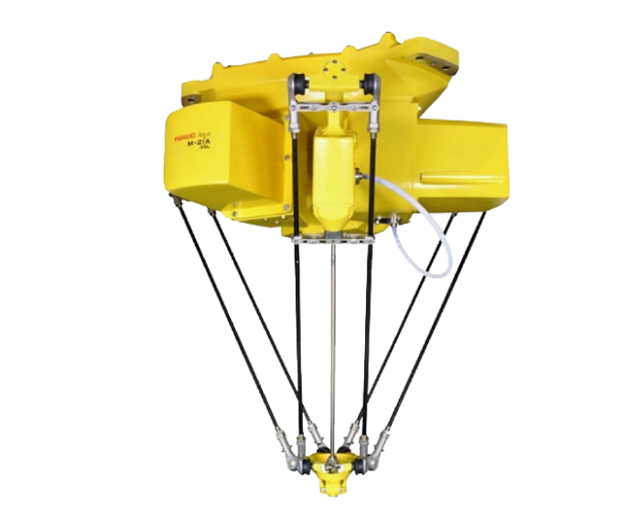](https://robotsdoneright.com/FANUC/M-Series/FANUC-M-2ia.html)[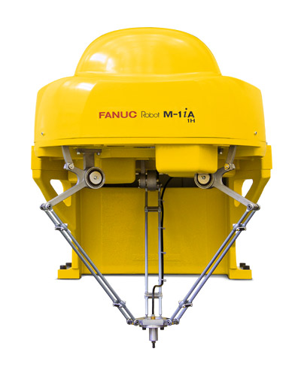](https://robotsdoneright.com/FANUC/M-Series/FANUC-M-1ia.html)

Fig: - 1

# WHAT IS A DELTA ROBOT?

[Delta robots](https://robotsdoneright.com/Articles/what-is-a-delta-robot.html) were originally created in the 1980s but did not start to gain notice in the manufacturing world until about ten years ago. Now delta robots can be commonly found along many assembly lines across numerous industries. These robots are also known as parallel-link robots due to their parallelogram arm design. Delta robots typically have three to four carbon-fibre, lightweight arms that extend downward from the main robot body. Because of this design they are often referred to as [spider robots](https://robotsdoneright.com/Articles/what-is-a-delta-robot.html) with the spider-like resemblance of their arms.  
  
Delta robot arms are jointed in the middle, causing them to bend inward and connect to a small tooling plate. This small tooling plate is where the [end-effector](https://robotsdoneright.com/Articles/robot-end-effectors.html) can be attached. Each arm is connected to a motor that is located within the main robot body. The motors coordinate movements of the arms in up and down motions, which pushes their joints inward and outward. These joint movements cause the tooling plate to move across X, Y, and Z axes, creating a cylindrical work envelope. One of the robot arms is used to control the end-effector by extending from the centre of the robot body.

Delta robots are known for their high speed and high accelerations. Their design is what makes them speedier than other types of [industrial robots](https://robotsdoneright.com/Industrial-robots.html). Most industrial robots have motors located in the robot arm, making them conducive for [heavier payload applications](https://robotsdoneright.com/Articles/heavy-payload-robots.html). However, having the motors in the robot arm adds additional weight and prohibits fast speeds. With delta robots all motors are located in the main body above the work area. This keeps all the main weight of the robot stationary. All movement comes from the extremely light robot arms, allowing for low inertia for incredibly fast operating speeds and accelerations.

[FANUC](https://robotsdoneright.com/FANUC-robots.html) is one of the [top robotic manufacturers in the world](https://robotsdoneright.com/Articles/top-robotic-manufacturers-in-the-world.html) and offers an extensive line of delta robots. Their delta robots consist of variants with three, four, and even six axes. The [M-1ia](https://robotsdoneright.com/FANUC/M-Series/FANUC-M-1ia.html) is a small parts specialist with its payload capacity for 1 kg. While the [M-2ia](https://robotsdoneright.com/FANUC/M-Series/FANUC-M-2ia.html) offers a wider [work envelope](https://robotsdoneright.com/Articles/industrial-robot-work-envelope.html) than others in its class. Refer to fig 1

# APPLICATIONS FOR SPIDER ROBOTS

Delta robots are ideal for [assembly](https://robotsdoneright.com/applications/assembly-robots.html), [dispensing](https://robotsdoneright.com/applications/dispensing-robots.html), [pick and place](https://robotsdoneright.com/applications/pick-and-place-robots.html), [material handling](https://robotsdoneright.com/applications/material-handling-robots.html), [part transfer](https://robotsdoneright.com/applications/parts-transfer-robots.html), and [packaging robotic applications](https://robotsdoneright.com/applications/packaging-robots.html). Parts handled by delta robots should be lightweight and consist of simple geometries, since these robots operate at fast speeds. Heavier parts or complex parts are not conducive to the speeds and accelerations of delta robots.  
  
Many of these robots have been deployed in the food, electronic, medical, and pharmaceutical industries for lightweight assembly processes. These robots have been proven to [drastically increase productivity](https://robotsdoneright.com/Articles/how-robots-increase-productivity.html) and reduce cycle times. Some delta robots are capable of picking up to 300 parts per minute for dramatically high throughput rates. Delta robots can also be integrated with additional robotic technology such as [force sensors](https://robotsdoneright.com/Articles/robotic-force-sensors.html) and [vision](https://robotsdoneright.com/Articles/robotic-vision-systems.html). These systems enhance and fine-tune the precision and accuracy of spider robots, allowing for more complex applications to be automated.

# DELTA ROBOT KINEMATICS

When one talks about industrial robots, most of people imagine robotic arms, or articulated robots, which are doing painting, welding, moving something, etc. But there is another type of robots: so-called parallel delta robot, which was invented in the early 80's in Switzerland by professor Reymond Clavel. Below the original technical drawing from U.S. Patent 4,976,582 is shown, and two real industrial delta robots, one from ABB, and one from Fanuc.

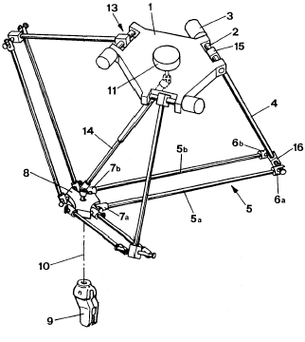

Fig: - 2

The delta robot consists of two platforms: the upper one (1) with three motors (3) mounted on it, and smaller one (8) with an end effector (9). The platforms are connected through three arms with parallelograms, the parallelograms restrain the orientation of the lower platform to be parallel to the working surface (table, conveyor belt and so on). The motors (3) set the position of the arms (4) and, thereby, the XYZ-position of the end effector, while the fourth motor (11) is used for rotation of the end effector. Refer to fig 2

The core advantage of delta robots is speed. When typical robot arm has to move not only payload, but also all servos in each joint, the only moving part of delta robot is its frame, which is usually made of lightweight composite materials. Due to its speed, delta robots are widely used in pick-n-place operations of relatively light objects (up to 1 kg).  
  
KINEMATICS  
If we want to build our own delta robot, we need to solve two problems. First, if we know the desired position of the end effector (for example, we want to catch pancake in the point with coordinates X, Y, Z), we need to determine the corresponding angles of each of three arms (joint angles) to set motors (and, thereby, the end effector) in proper position for picking. The process of such determining is known as **inverse kinematics.**  
And, in the second place, if we know joint angles (for example, we've read the values of motor encoders), we need to determine the position of the end effector (e.g., to make some corrections of its current position). This is **forward kinematics** problem.

To be more formal, let's look at the kinematic scheme of delta robot. The platforms are two equilateral triangles: the fixed one with motors is green, and the moving one with the end effector is pink. Joint angles are *theta1*, *theta2* and *theta3*, and point *E0* is the end effector position with coordinates (*x0*, *y0*, *z0*). To solve inverse kinematics problem, we have to create function with E0 coordinates (*x0*,*y0*, *z0*) as parameters which returns (*theta1*, *theta2*, *theta3*). Forward kinematics functions get (*theta1*, *theta2*, *theta3*) and returns (*x0*, *y0*, *z0*). Refer to fig 3

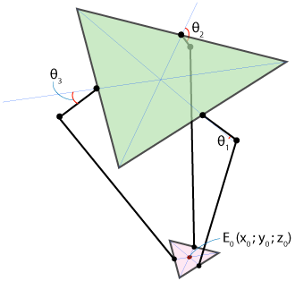

Fig: - 3

In the following two paragraphs will come the theoretical part of delta robot’s kinematics. Those who don't like mathematics and trigonometry may jump right to the practical part: sample programs written in C language. So, let's start from

INVERSE KINEMATICS

First, let's determine some key parameters of our robot's geometry. Let's designate the side of the fixed triangle as f, the side of the end effector triangle as e, the length of the upper joint as rf, and the length of the parallelogram joint as re. These are physical parameters which are determined by design of your robot. The reference frame will be chosen with the origin at the centre of symmetry of the fixed triangle, as shown below, so z-coordinate of the end effector will always be negative. Refer to fig 4

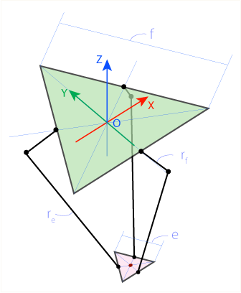

Fig: - 4

Because of robot's design joint *F1J1* (see fig 5) can only rotate in YZ plane, forming circle with centre in point *F1* and radius *rf*. As opposed to *F1*, *J1* and *E1* are so-called [universal joints](http://en.wikipedia.org/wiki/Universal_joints), which means that *E1J1* can rotate freely relatively to *E1*, forming sphere with centre in point *E1* and radius *re*.

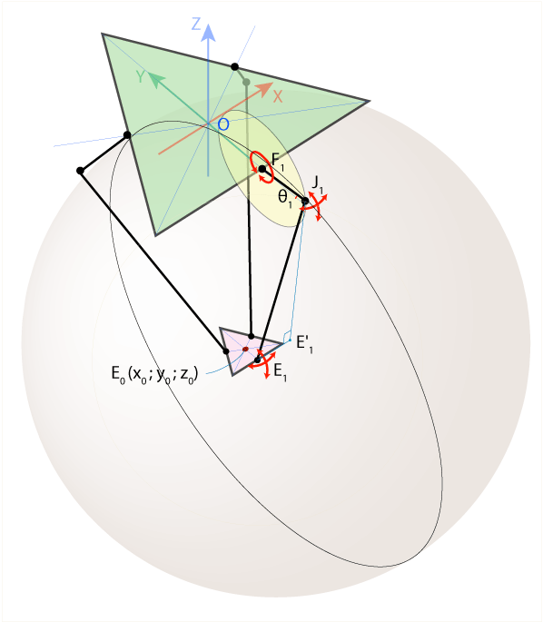

Fig: - 5

Intersection of this sphere and YZ plane is a circle with centre in point *E'1* and radius *E'1J1*, where *E'1* is the projection of the point *E1* on YZ plane. The point J1 can be found now as intersection of two circles of known radius with centres in *E'1* and *F1* (we should choose only one intersection point with smaller Y-coordinate). And if we know *J1*, we can calculate*theta1* angle.

Below you can find corresponding equations and the YZ plane view refer to fig 6:

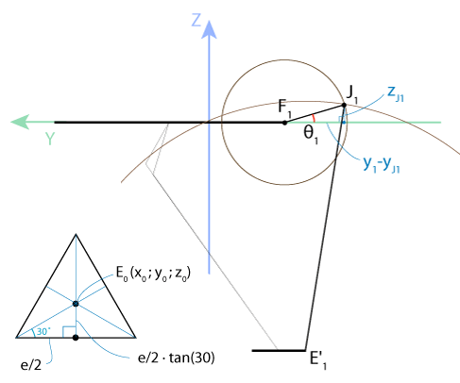

Fig: - 6

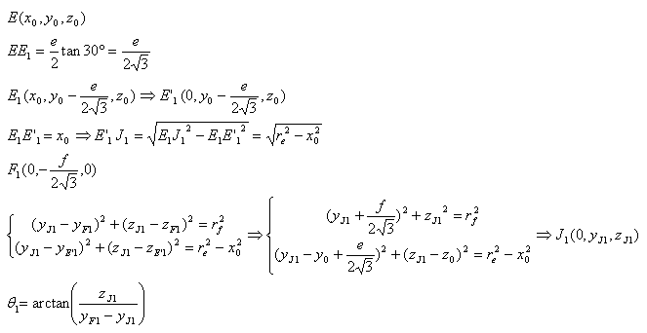

Such algebraic simplicity follows from good choice of reference frame: joint *F1J1* moving in YZ plane only, so we can completely omit X coordinate. To take this advantage for the remaining angles *theta2* and *theta3*, we should use the symmetry of delta robot. First, let's rotate coordinate system in XY plane around Z-axis through angle of 120 degrees counter clockwise, as it is shown below in fig 7.

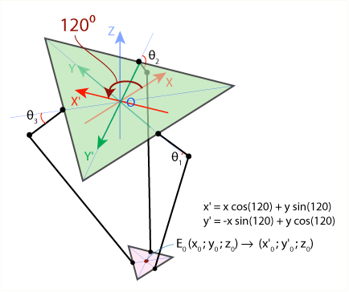

Fig: - 7

We've got a new reference frame X'Y'Z', and it this frame we can find angle *theta2* using the same algorithm that we used to find *theta1*. The only change is that we need to determine new coordinates *x'0* and *y'0* for the point *E0*, which can be easily done using corresponding [rotation matrix](http://en.wikipedia.org/wiki/Rotation_matrix). To find angle*theta3* we have to rotate reference frame clockwise. I have one function which calculates angle theta for YZ plane only, and call this function three times for each angle and each reference frame.

FORWARD KINEMATICS

Now the three joint angles theta1, theta2 and theta3 are given, and we need to find the coordinates (x0, y0, z0) of end effector point E0.  
As we know angles theta, we can easily find coordinates of points J1, J2 and J3 (see fig 8). Joints J1E1, J2E2 and J3E3 can freely rotate around points J1, J2 and J3 respectively, forming three spheres with radius re.

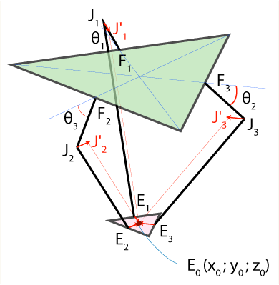

Fig: - 8

Now let's do the following: move the centres of the spheres from points *J1*, *J2* and *J3* to the points *J'1*, *J'2* and *J'3* using transition vectors *E1E0*, *E2E0* and *E3E0* respectively. After this transition all three spheres will intersect in one point: *E0*, as it is shown in fig 9 below:

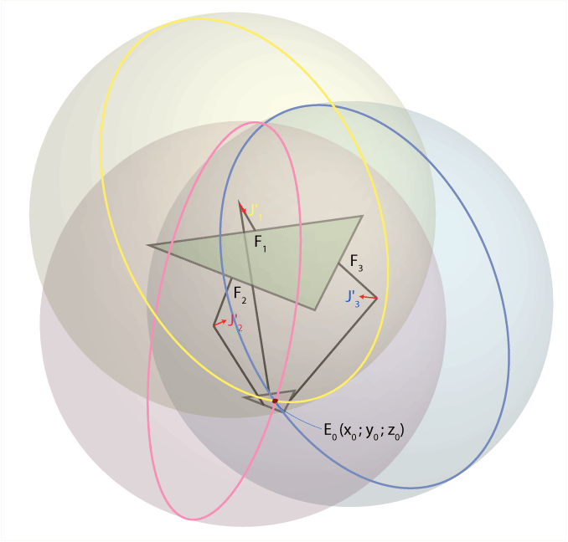

Fig: - 9

So, to find coordinates (*x0*, *y0*, *z0*) of point *E0*, we need to solve set of three equations like (x-xj)^2+(y-yj)^2+(z-zj)^2 = re^2, where coordinates of sphere centres (*xj*, *yj*, *zj*) and radius *re* are known.

First, let's find coordinates of points *J'1*, *J'2*, *J'3 refer to fig 10*:

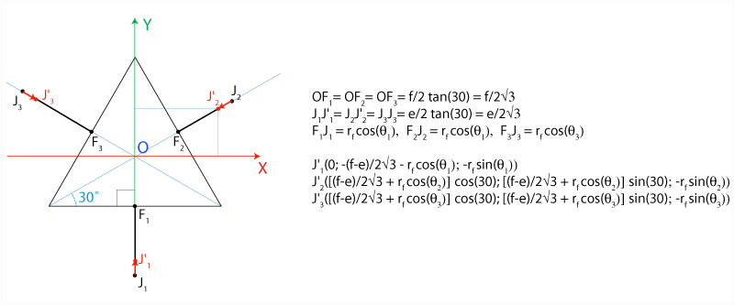

Fig: - 10

In the following equations I'll designate coordinates of points J1, J2, J3 as (x1, y1, z1), (x2, y2, z2) and (x3, y3, z3). Please note that x0=0. Here are equations of three spheres:

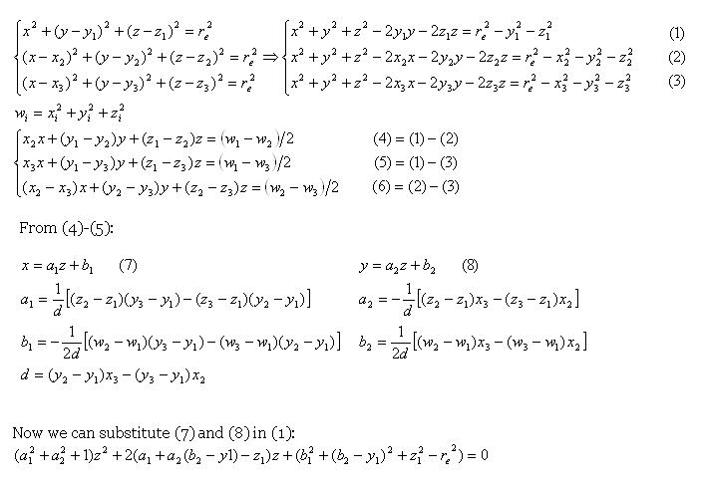

Finally, we need to solve this quadric equation and find *z0* (we should choose the smallest negative equation root), and then calculate *x0* and *y0* from eq. (7) and (8).

# PURE PURSUIT

Pure pursuit is a path tracking algorithm. It computes the angular velocity command that moves the robot from its current position to reach some look-ahead point in front of the robot. The linear velocity is assumed constant.

hence you can change the linear velocity of the robot at any point. The algorithm then moves the look-ahead point on the path based on the current position of the robot until the last point of the path. You can think of this as the robot constantly chasing a point in front of it. The property “Look Ahead Distance” decides how far the look-ahead point is placed.

To find the appropriate goal point for the robot to follow mathematically, a circle cantered at the robot's current position with radius Ld is made. The circle's intersections with the path are the potential goal points

In our implementation of the pure pursuit controller, the path is a 2D array represented by equally spaced points (1D array). The basic algorithm is to use a for loop to go through each pair of points to determine if there are any intersections within each line segments. If goal points are found, follow the most appropriate one. These steps will be repeated until the end of the path is reached. Refer to fig 11.

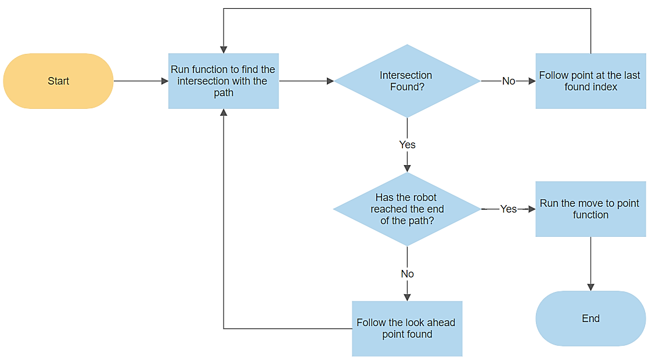

Fig: - 11

# LINE-CIRCLE INTERSECTION

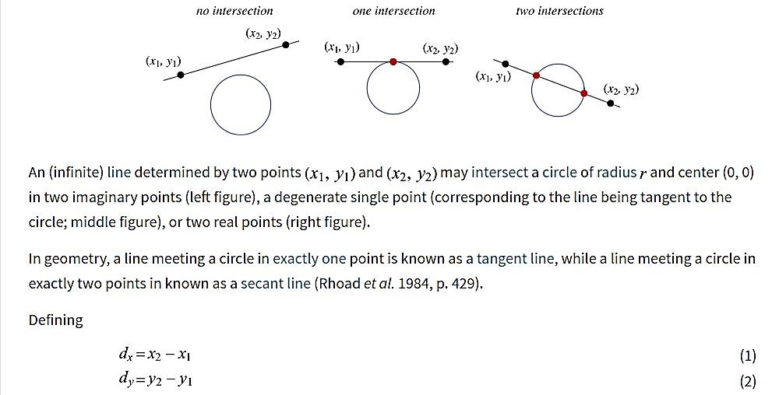

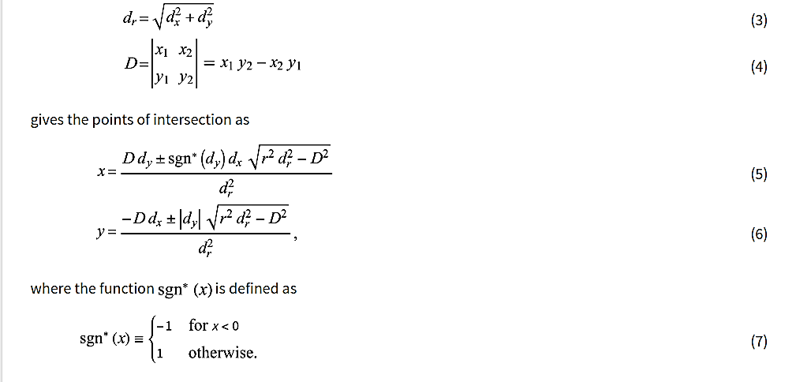

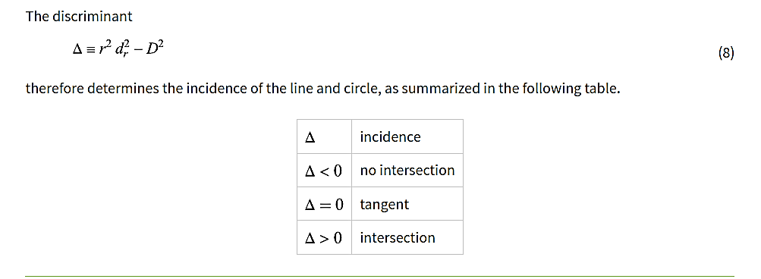

Let's start by looking at the basic math behind choosing goal points -- the line-circle intersection. There are multiple ways to find the intersection, we have found that [this method](https://mathworld.wolfram.com/Circle-LineIntersection.html) (above) was the easiest to implement and debug.

In the method presented above, the circle is assumed to be centered at the the origin. In our application, the circle would be centered at the robot's current position [currentX, currentY] and the two points that define the line would be arbitrary points pt1 = [x1, y1] and pt2 = [x2, y2]. Therefore, to apply this method, we first need to subtract currentX and currentY from [x1, y1] and [x2, y2] to center the system at origin. Again, we perform such offsets so that we can use the method from the screenshot above, which requires the circle to be centered at the origin.

Refer to fig 12

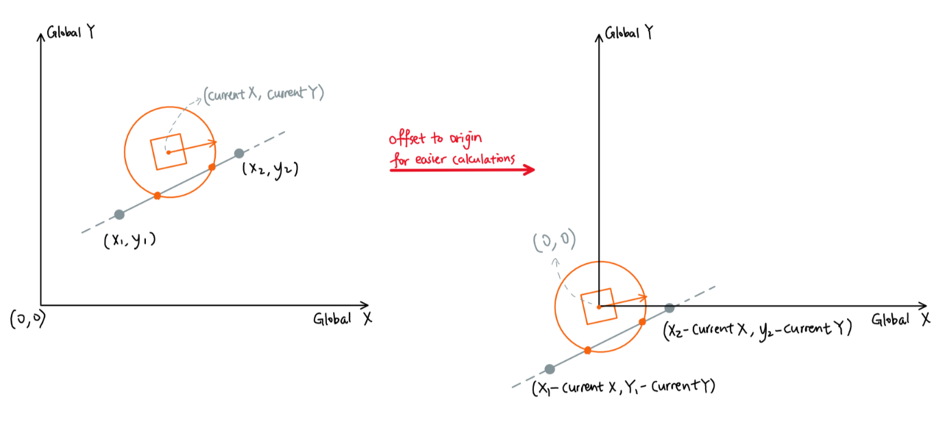

Fig: - 12

After solution is found the system is offset back to its original position.

# CHOOSING THE GOAL POINT

All possible outcomes of the line-circle intersections (with a single line segment) are the following:

**Situation 1:**

No intersection. If this is the case, the discriminant will be negative, see fig 13.

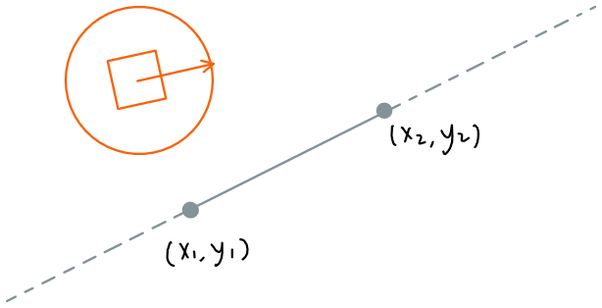

Fig: - 13

**Situation 2:**

Intersections are found, but they are not in between (x1, y1) and (x2, y2). The discriminant is positive, but we should still consider this situation as “no intersection”, see fig 14

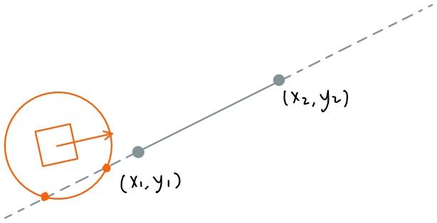

Fig: - 14

**Situation 3:**

There is one and only one intersection inside the range of (x1, y1) and (x2, y2). The discriminant is positive, and the robot should follow the intersection found. See fig 15

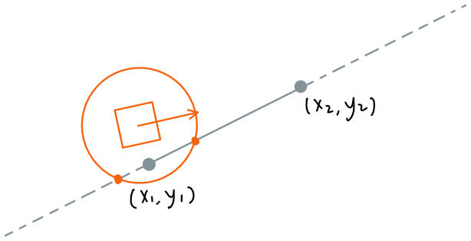

Fig: - 15

**Situation 4:**

There are two intersections and both are in between (x1, y1) and (x2, y2). In this situation, we have to determine which point is better for the robot to follow. One method we can to use is to calculate the distance between the intersections and the second point (x2, y2)(the path goes in the direction of (x1, y1) -> (x2, y2)) and pick the point that is closer to the second point (in other words, the point closer to the end of the path). See fig 16

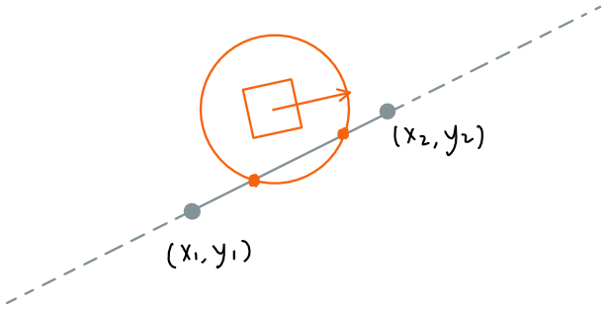

Fig: - 16

**NOTE: -** But in our application, we are taking the start point of the line as the robot location so there will be only one intersection point and also, we are taking look ahead distance equal to the current distance to the object and also the linear velocity is changed proportional to the look ahead distance. So, at one point robot will be hovering above the object and that’s when we go down and pick it.

# WHAT IS A SERVO MOTOR?

A DC [**servo motor**](https://robu.in/product-category/motors-drivers-actuators/servo-motor/) is an assembly of four major components,

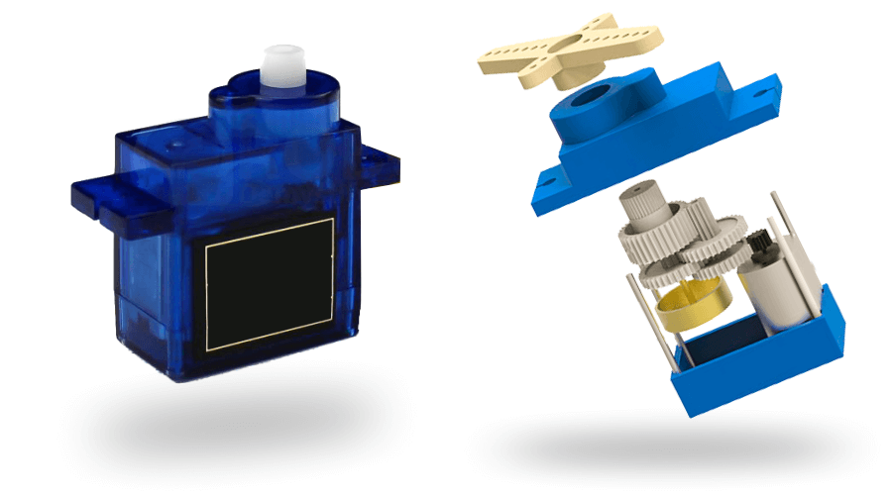

1.[DC motor](https://robu.in/product-category/motors-drivers-actuators/dc-motor/)

2.Position sensing device

3.Gear assembly

4.Control circuit

In digital control, [micro controller](https://en.wikipedia.org/wiki/Microcontroller) used for generating the PWM pluses in terms of duty cycles to produce more accurate control signals.

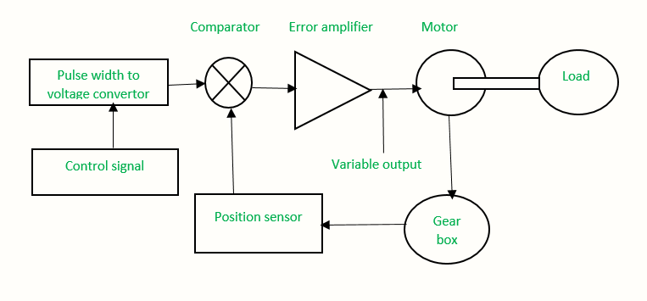

Fig: - 17

The position sensor provides a feedback signal corresponding to the present position of the load. This sensor is normally a potentiometer that produces the voltage corresponding to the absolute angle of the motor shaft through gear mechanism. Then the feedback voltage value applies on the input of error amplifier.

The error amplifier is a [negative feedback amplifier](https://en.wikipedia.org/wiki/Negative-feedback_amplifier) and it reduces the difference between its inputs. It compares the voltage related to current position of the motor with desired voltage related to desired position of the motor.  And it produces the error either a positive or negative voltage.

This error voltage applied to the armature of the motor. If the error is more than motor armature gets more output.

The amplifier amplifies the error voltage and powers the armature. The motor rotates till the error becomes zero. If the error is negative, the armature voltage reverses and hence the armature rotates in the opposite direction. See fig 17.

# HOW TO CONTROL SERVO?

The below figure 18 shows the parts that consisting in RC servo motors in which small [DC motor](https://robu.in/product-category/motors-drivers-actuators/dc-motor/) employees for driving the loads at precise speed and position.

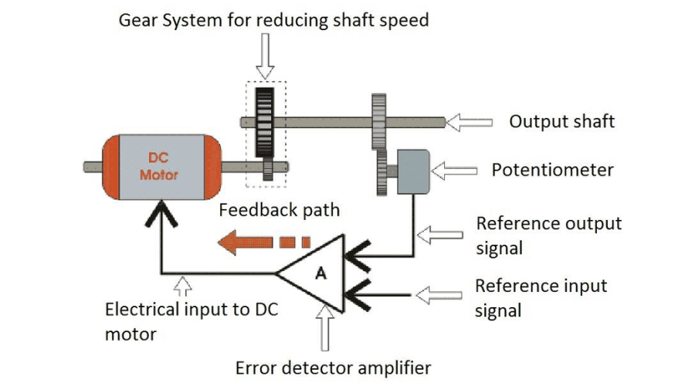

Fig: - 18

The pulse width determines the angular position of the servo motor. In some circuits, a control pulse uses to produce DC reference voltage corresponding to desired position or speed of the motor. And it applies to a pulse width to voltage converter.

In this converter, the capacitor starts charging at a constant rate when the pulse is high. when the pulse is low, the charge on the capacitor fed to the buffer amplifier. So, the length of the pulse decides the voltage applied at the error amplifier as a desired voltage to produce the desired speed or position.

For example, a 1.5ms pulse will make the motor turn to the 90° position. Shorter than 1.5ms moves it in the counter clockwise direction toward the 0° position. Any longer than 1.5ms will turn the servo in a clockwise direction toward the 180° position. See fig 19.

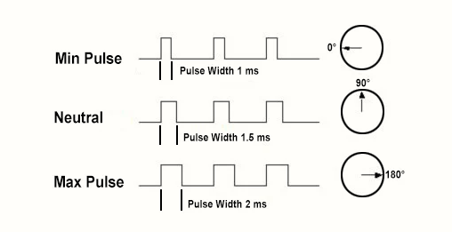

Fig: - 19

Servos are controlled by sending an electrical pulse of variable width, or [pulse width modulation](https://en.wikipedia.org/wiki/Pulse-width_modulation) (PWM), There is a minimum pulse, a maximum pulse, and a repetition rate. A servo motor can usually only turn 90° in either direction for a total of 180° movement. The motor's neutral position is defined as the position where the servo has the same amount of potential rotation in the both the clockwise or counter-clockwise direction.

As per the command, servo will move to the position and hold that position.  The maximum amount of force the servo can exert is called the **torque rating** of the servo. Servos will not hold their position forever. Though, the position pulse must be repeated to instruct the servo to stay in position.

# WHAT IS A STEPPER MOTOR?

A **Stepper Motor** or a **step motor** is a brushless, synchronous motor which divides a full rotation into a number of steps. Unlike a brushless DC motor which rotates continuously when a fixed DC voltage is applied to it, a step motor rotates in discrete step angles. The **Stepper Motor** are therefore manufactured with steps per revolution of 12, 24, 72, 144, 180, and 200, resulting in stepping angles of 30, 15, 5, 2.5, 2, and 1.8 degrees per step. The stepper motor can be controlled with or without feedback. See fig 20

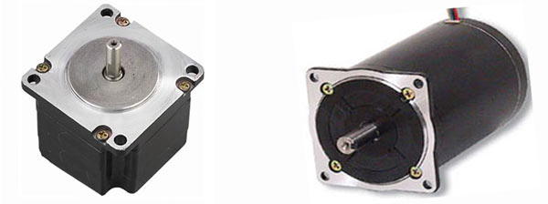

Fig: - 20

# HOW A STEPPER MOTOR WORKS?

Stepper motors work on the principle of electromagnetism. There is a soft iron or magnetic rotor shaft surrounded by the electromagnetic stators. The rotor and stator have poles which may be teethed or not depending upon the type of stepper. When the stators are energized the rotor moves to align itself along with the stator (in case of a permanent magnet type stepper) or moves to have a minimum gap with the stator (in case of a variable reluctance stepper). This way the stators are energized in a sequence to rotate the stepper motor. See fig 21

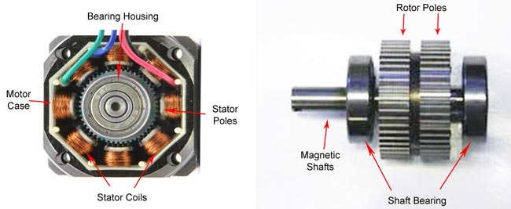

Fig: - 21

# NEMA

Refers to the frame size of the motor as standardized by the US [National Electrical Manufacturers Association](https://en.wikipedia.org/wiki/National_Electrical_Manufacturers_Association) in its [Publication ICS 16-2001](http://classxboats.com/htdocs/Engineering_Research/NEMA/ics_16.pdf). It specifies the 'face' size of the motor but not its length. For example, a NEMA 23 stepper has a face of 2.3 x 2.3 inches with screw holes to match. Note: just because a motor is bigger does not mean it is more powerful in terms of torque. It is perfectly possible for a NEMA 14 to 'out pull' a NEMA 17 or a NEMA 23.

Based upon the NEMA 17 specification the mounting holes are spaced 31 mm (1.22 inch) apart along the edge of the motor.

# STEPPER MOTOR DRIVING TECHNIQUES

**Stepper motor driving techniques** can be possible with some special circuits due to their complex design. There are several methods to drive this motor, some of them are discussed below by taking an example of a four-phase stepper motor.

# SINGLE EXCITATION MODE

The basic method of driving a stepper motor is a single excitation mode. It is an old method and not used much at present but one has to know about this technique. In this technique every phase otherwise stator next to each other will be triggered one by one alternatively with a special circuit. This will magnetize & demagnetize the stator to move the rotor forward.

# FULL STEP DRIVE

In this technique, two stators are activated at a time instead of one in a very less time period. This technique results in high torque & allows the motor to drive the high load.

# HALF STEP DRIVE

This technique is fairly related to the Full step drive because the two stators will be arranged next to each other so that it will be activated first whereas the third one will be activated after that. This kind of cycle for switching two stators first &after that third stator will drive the motor. This technique will result in improved resolution of the stepper motor while decreasing the torque.

# MICRO STEPPING

This technique is most frequently used due to its accuracy. The variable step current will supply by the [stepper motor driver circuit](https://www.elprocus.com/what-is-a-stepper-motor-driver-types-and-its-applications/) toward stator coils within the form of a sinusoidal waveform. The accuracy of every step can be enhanced by this small step current. This technique is extensively used because it provides high accuracy as well as decreases operating noise to a large extent.

# STEPPER DRIVER

These chips keep the power that drives the motors separate from the power that is on the Arduino. The Arduino can't provide enough juice to power the stepper motors directly. This is why you have to use separate chips to sort of act as valves that control how the motor spins.

Another benefit that stepper driver chips provide, is that they provide *fractional* steps. This helps smooth out the motion of the stepper motor. Without fractional steps, stepper motors can have a tendency to vibrate or resonate at certain RPMs.

# MICROCONTROLLER-BASED STEPPER DRIVERS

Microcontroller based steppers drivers can achieve very high rotation speeds in stepper motors. Using a microcontroller, it is possible to have extreme control over exactly how each individual coil is energized inside the motor. This is absolutely necessary to obtain high speeds because as speed increases, timing of the coils firing must be perfectly in sync.

If you've ever pushed someone on a swing, you know that a small, well-timed push can cause that person to swing higher and higher. Miss a push or two by even a small amount and the 'power transfer' is significantly less. This is the situation in stepper motors at high speeds. If you don't match the pushes or steps to the actual state of the motor it will run poorly.

In order to handle current higher than what the microprocessor can allow, the controller needs to use full H-bridge chips.

Normally, an H-bridge is used for controlling a plain old DC-motor but in this case, the h-bridge chips are used for exactly controlling the amount of electricity that goes to each individual coil on the stepper motor. Thus, for bipolar stepper motors, it needs 2 chips per motor.

# ARDUINO UNO

The Arduino UNO is a standard board of Arduino. Here UNO means 'one' in Italian. It was named as UNO to label the first release of Arduino Software. It was also the first USB board released by Arduino. It is considered as the powerful board used in various projects. Arduino.cc developed the Arduino UNO board.

Arduino UNO is based on an ATmega328P [microcontroller](https://www.javatpoint.com/microcontroller). It is easy to use compared to other boards, such as the Arduino Mega board, etc. The board consists of digital and analog Input/Output pins (I/O), shields, and other circuits.

The Arduino UNO includes 6 analog pin inputs, 14 digital pins, a [USB](https://www.javatpoint.com/usb-full-form) connector, a power jack, and an ICSP (In-Circuit Serial Programming) header. It is programmed based on IDE, which stands for Integrated Development Environment. It can run on both online and offline platforms.

The [IDE](https://www.javatpoint.com/arduino-ide) is common to all available boards of Arduino.

# ARDUINO UNO PINOUT

The Arduino UNO is a standard board of Arduino, which is based on an **ATmega328P** microcontroller. It is easier to use than other types of Arduino Boards.

The Arduino UNO Board, with the specification of pins, is shown below in fig 22.

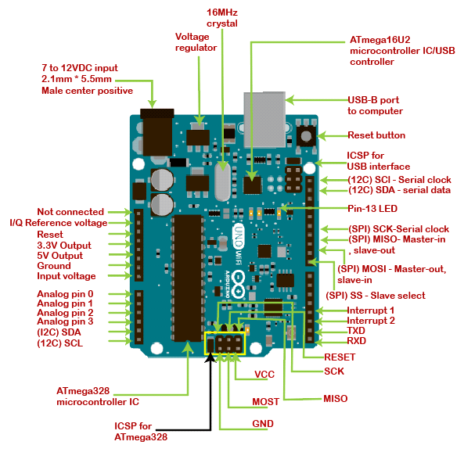

Fig: - 22

# ARDUINO PINS

* **ATmega328 Microcontroller**- It is a single chip Microcontroller of the ATmel family. The processor core inside it is of 8-bit. It is a low-cost, low powered, and a simple microcontroller. The [Arduino UNO](https://www.javatpoint.com/arduino-uno) and Nano models are based on the ATmega328 Microcontroller.
* **Voltage Regulator-**The voltage regulator converts the input voltage to 5V. The primary function of voltage regulator is to regulate the voltage level in the [Arduino board](https://www.javatpoint.com/arduino-boards). For any changes in the input voltage of the regulator, the output voltage is constant and steady.
* **GND** - Ground pins. The ground pins are used to ground the circuit.
* **TXD and RXD-**TXD and RXD pins are used for serial communication. The TXD is used for transmitting the data, and RXD is used for receiving the data. It also represents the successful flow of data.
* **USB Interface-**The USB Interface is used to plug-in the USB cable. It allows the board to connect to the computer. It is essential for the programming of the [Arduino](https://www.javatpoint.com/arduino) UNO board.
* **RESET-**It is used to add a Reset button to the connection.
* **SCK-**It stands for **Serial Clock**. These are the clock pulses, which are used to synchronize the transmission of data.
* **MISO-**It stands for **Master Input/ Slave Output**. The save line in the MISO pin is used to send the data to the master.
* **VCC-**It is the modulated DC supply voltage, which is used to regulate the IC's used in the connection. It is also called as the primary voltage for IC's present on the Arduino board. The VCC voltage value can be negative or positive with respect to the GND pin.
* **Crystal Oscillator-**The Crystal oscillator has a frequency of 16MHz, which makes the Arduino UNO a powerful board.
* **ICSP-**It stands for **In-Circuit Serial Programming**. The users can program the Arduino board's firmware using the ICSP pins. The program or firmware with the advanced functionalities is received by microcontroller with the help of the ICSP header. The ICSP header consists of 6 pins. The structure of the ICSP header is shown below in fig 23.

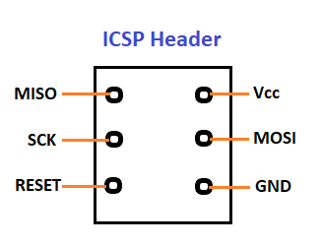

Fig: - 23

* **SDA-**It stands for **Serial Data**. It is a line used by the slave and master to send and receive data. It is called as a **data line,** while SCL is called as a clock line.
* **SCL-**It stands for **Serial Clock**. It is defined as the line that carries the clock data. It is used to synchronize the transfer of data between the two devices. The Serial Clock is generated by the device and it is called as master.
* **SPI-**It stands for **Serial Peripheral Interface**. It is popularly used by the microcontrollers to communicate with one or more peripheral devices quickly. It uses conductors for data receiving, data sending, synchronization, and device selection (for communication).
* **MOSI-**It stands for Master Output/ Slave Input. The MOSI and SCK are driven by the Master.
* **SS-**It stands for **Slave Select**. It is the Slave Select line, which is used by the master. It acts as the enable line.
* **I2C-**It is the two-wire serial communication protocol. It stands for Inter Integrated Circuits. The I2C is a serial communication protocol that uses SCL (Serial Clock) and SDA (Serial Data) to receive and send data between two devices.3.3V and 5V are the operating voltages of the board.

# WHAT IS CNC?

CNC stands for Computerized Numerical Control. It is a computerized manufacturing process in which pre-programmed software and code controls the movement of production equipment. CNC machining controls a range of complex machinery, such as grinders, lathes, and turning mills, all of which are used to cut, shape, and create different parts and prototypes. On the day to day, CNC machinists combine elements of mechanical design, technical drawings, mathematics, and computer programming skills to produce a variety of wood, metal and plastic parts. CNC operators can take a sheet of metal and turn it into a critical airplane or automobile part. See fig 24

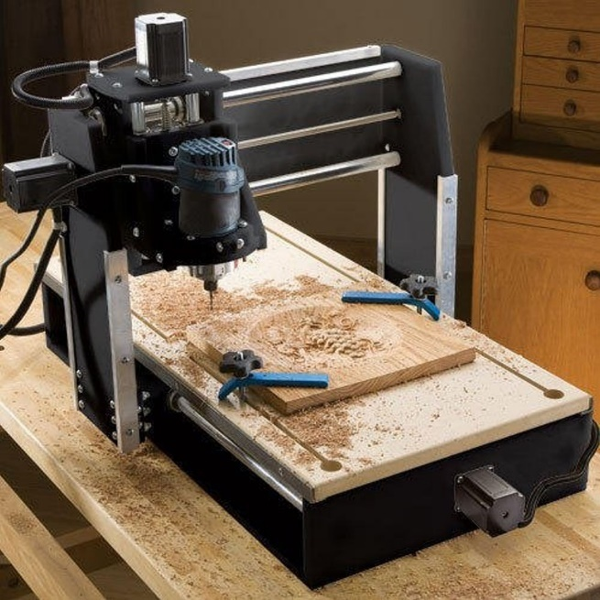

Fig: - 24

# WHAT IS A CNC MACHINE?

Computer Numerical Control machines are automated machines, which are operated by computers executing pre-programmed sequences of controlled commands. CNC machines are essentially the opposite of “old-school” devices that are manually controlled by hand wheels or levers, or mechanically automated by cams alone. Today’s modern CNC machines understand and function using CNC machining language – called G-code – which tells them precise measurements for production, like feed rate, speed, location, and coordination.

Today’s design and mechanical parts for CNC systems are highly automated – unlike the old, dangerous, factory machines you’d think of back in the day. The parts’ mechanical dimensions are defined using computer-aided design (CAD) software, and then translated into manufacturing directives by computer-aided manufacturing (CAM) software. Therefore, it is important to have knowledgeable CNC machinists and programmers in the industry to operate this high-tech machinery.

# WHAT IS FUSION 360?

Fusion 360 is a 3D based modelling software, capable of modelling, simulation, and documentation. It was developed by AutoCAD in 2013, and is a cloud-based system with a top-down approach. This means that it allows the users to create larger structures, which are then broken down into smaller components. The user can tweak each specific component to their liking and requirement.

Fusion 360 is a relatively young software, and it is capable of:

* Parametric modelling
* Mesh Modelling
* Surface Modelling
* CAD and CAM integration
* Extremely realistic renders
* Printed Circuit Board (PCB) layout, planning and manufacturing
* Cooling of electronics
* Topology and shape optimisation

See the whole process in the fig 25 below

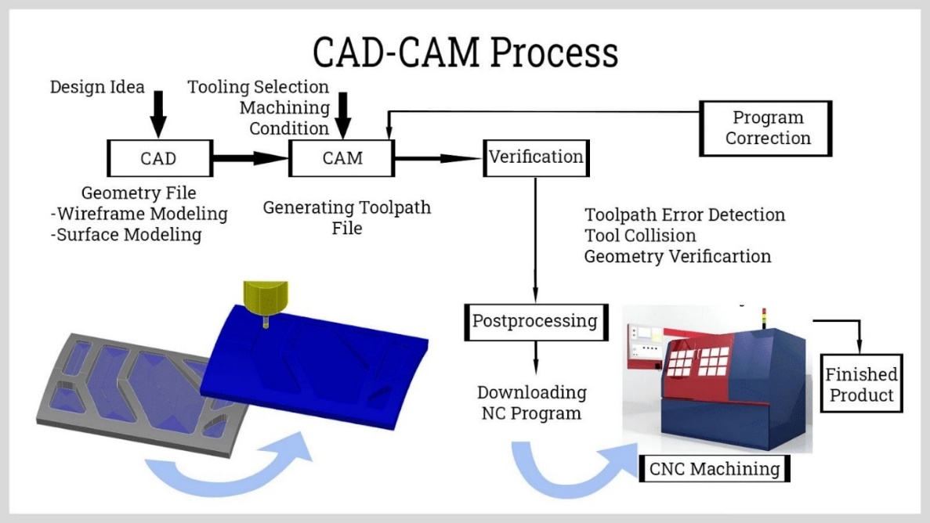

Fig: - 25

# 

# ELECTRONICS USED

HD webcam Uno R3 based USB 18 servo controller:

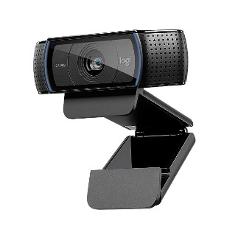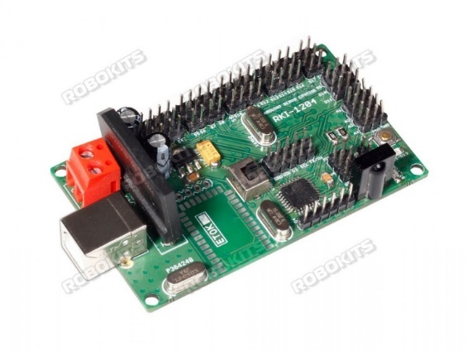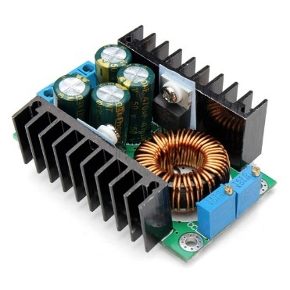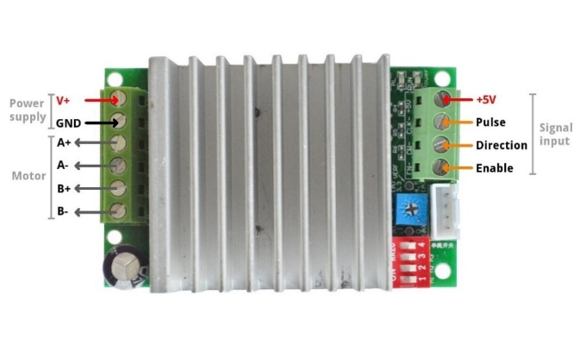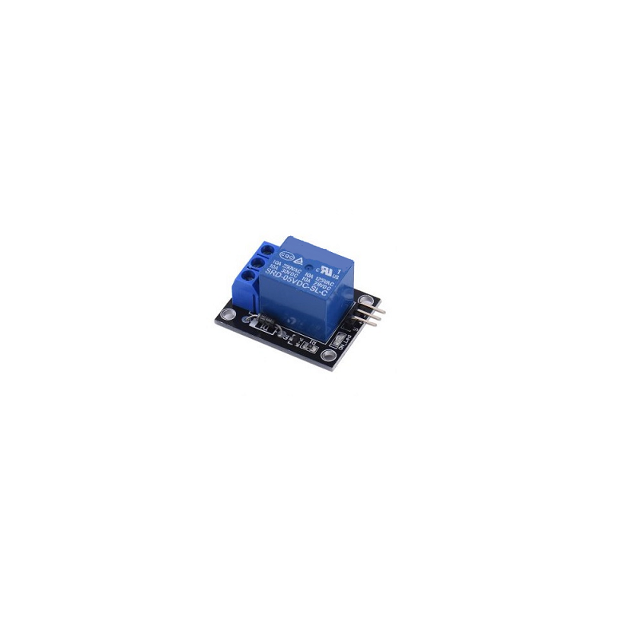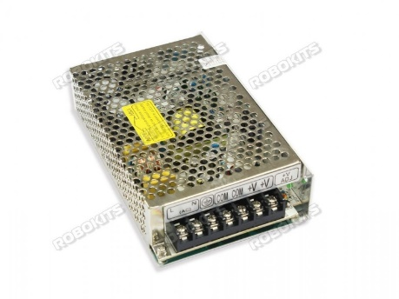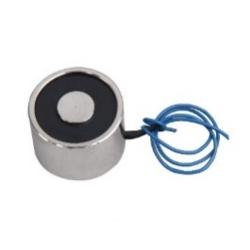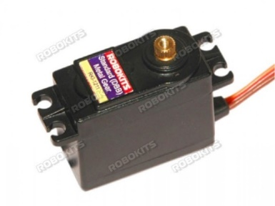

10A DC-DC Step-down: Stepper Motor Driver Controller 8~50V 4.5A:

5V 1 Channel Relay Module: Industrial power supply 12v 10a 120w:

DC 12V solenoid electromagnet: Metal gear standard digital servo:

NEMA 17 5.6kgcm stepper motor:

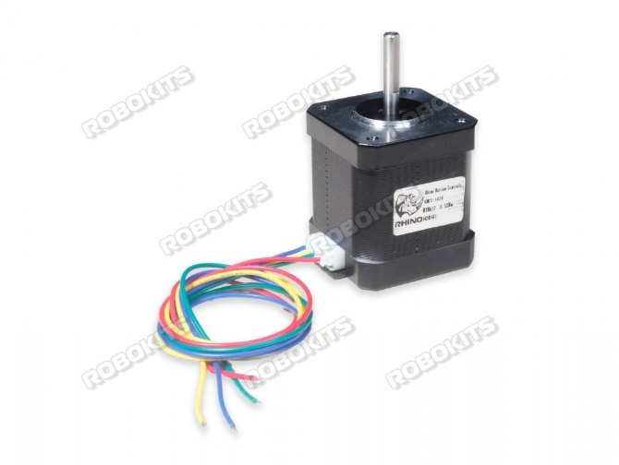

# HARDWARE USED

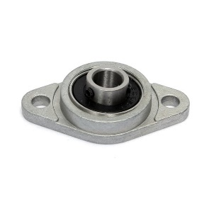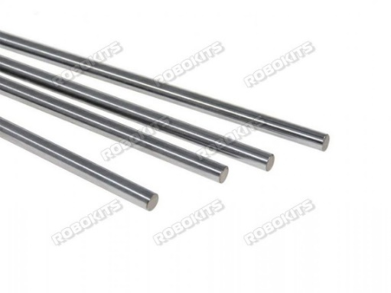8mm ID pillow block flange bearing: 8mm OD carbon steel rod 300mm:

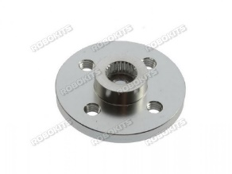Metal horn for servo 25t: 8mm, 5mm motor coupling hub:

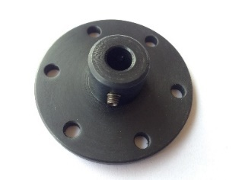

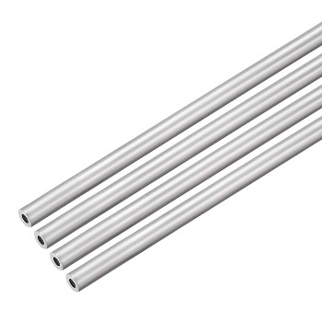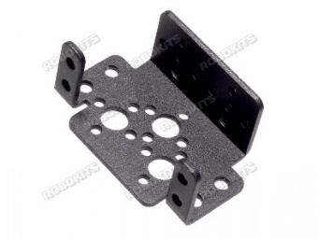Standard servo bracket: Aluminium Tubes:

# CNC COMPONENTS

Conveyor sides: Robot biceps:

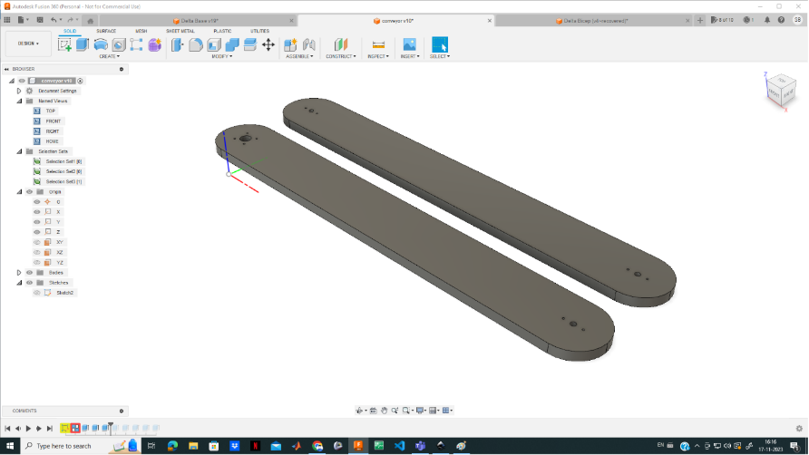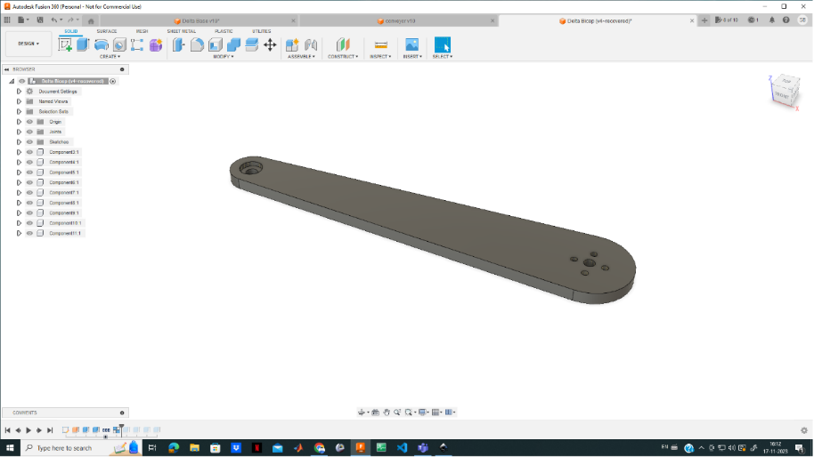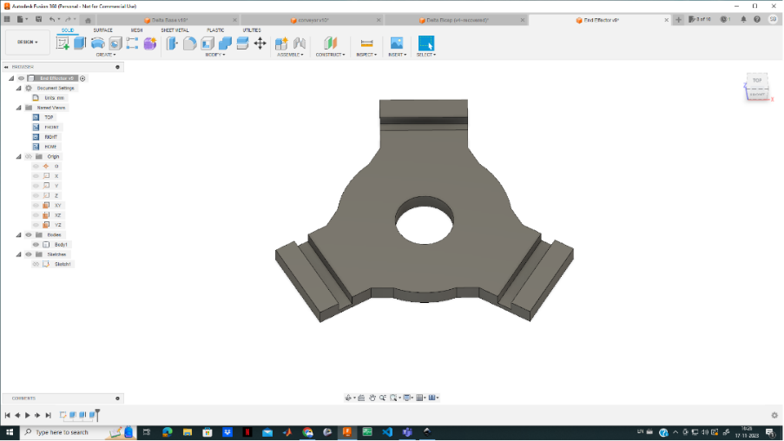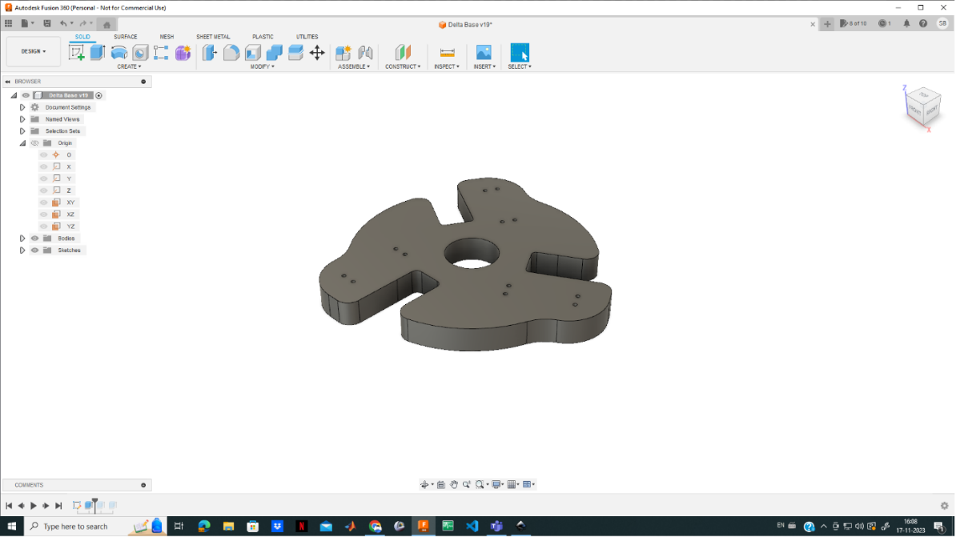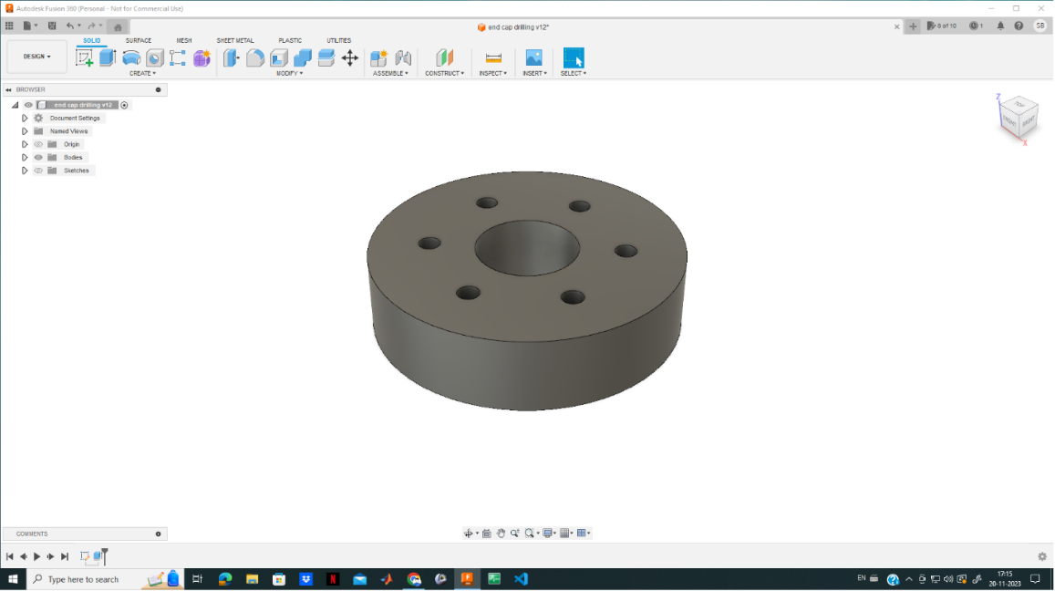

End effector: Robot base:

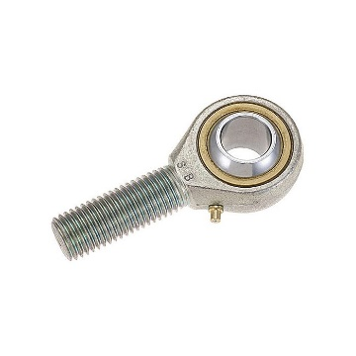End caps: End joint bearing:

# CONNECTIONS

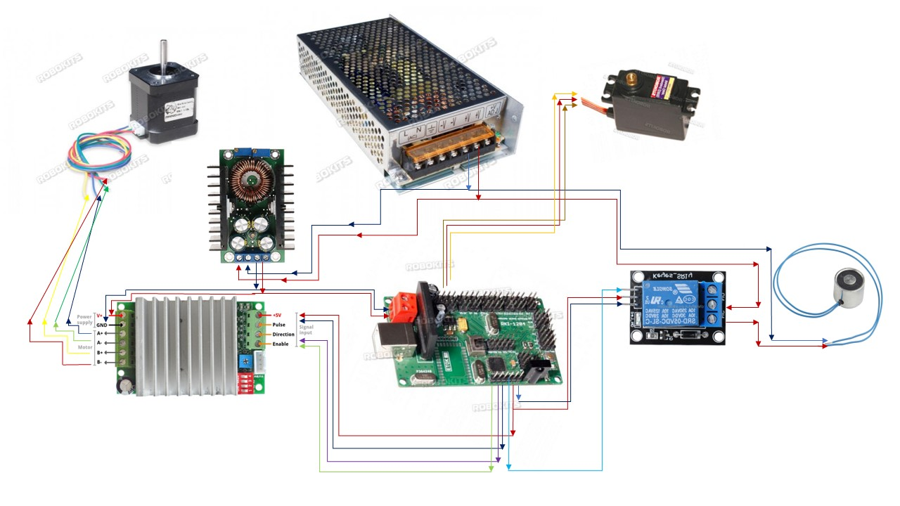

**Computer Vision System for Delta Robot**

* + **INTRODUCTION**

**Computer vision** is a multidisciplinary field that enables computers to interpret, analyze, and make decisions based on visual data. It seeks to mimic the human visual system by teaching machines to understand and extract meaningful information from images or videos. Computer vision involves a range of tasks, including image recognition, object detection, segmentation, and tracking.

In recent years, computer vision technology has been developed with many algorithms for image processing, especially detection and classification algorithm. These algorithms can be integrated into robot systems for many applications in the industry. With the help of computer vision, the robot becomes more flexible, responds to changes in the environment, and perceives the surroundings more clearly, thereby providing more accurate operations. Integrating computer vision systems brings many benefits such as increased productivity, increased accuracy and quality, reduced material waste, and reduced product costs.

Information from a computer vision system is obtained from one or more cameras. The data is then processed by a central processor (usually a computer with powerful computing capabilities). The necessary information will be extracted and sent to the robot's controller. The extracted information can be color, shape, texture, histogram, 2D coordinates, or 3D coordinates. Some common applications of robots with vision systems are dynamic grasping, automatic sorting, visual servoing, vision guide robot, and vision-based inspection.

In this project, we develop an automatic sorting system using machine vision. The components of the system are a delta robot arm for grabbing objects, a belt conveyor for transmitting objects, a camera mounted above the conveyor to capture images of objects, and a computer for processing images to classify objects. An image processing algorithm is developed to classify objects by color. The blue, green, red (BGR) image of objects is converted to HSV color space and then different thresholds are applied to recognize the object’s color. The computer sends a command to the robot when it detects an object. The robot will move the object to the position according to the command received.

The computer vision component of this project plays a pivotal role in enabling the delta robot to accurately identify and classify objects for sorting purposes. The computer vision component employs a combination of OpenCV, image registration techniques, and other fundamental concepts to facilitate object recognition for sorting tasks. Initially, input frames from the camera are subjected to a series of preprocessing steps, including color space transformations, noise reduction, and morphological operations. This ensures optimal image quality for subsequent processing. Image registration techniques are utilized to align and stabilize frames, enabling consistent object recognition across different orientations and positions.

* + **METHODOLOGY**

Machine vision is the technology and methods used to provide imaging based automatic inspection and analysis for such applications as automatic inspection, process control, and robot guidance, usually in industry.

In order to develop a computer vision system for classifying objects on the conveyor, a computer, Camera Module, **Logitech C920 HD PRO WEBCAM**, with a 3-megapixel sensor is utilized for capturing images of objects. This camera has a resolution of up to 1080p/30 fps. In the project, we only use images with a resolution of 640×480 pixels to achieve faster processing speed.

In the pursuit of developing a comprehensive solution for object sorting with a delta robot, **Python** emerged as the primary programming language, offering a versatile and efficient platform for implementing intricate algorithms and handling complex data processes. The language's extensive ecosystem of libraries provided a robust foundation for the successful execution of the project.

**Libraries used -**

The key libraries employed in the development process include:

1. **OpenCV (Open Source Computer Vision Library)**
2. **NumPy (Numerical Python)**
3. **Image Registration**

Requirements:  
3.1 **FITS_tools==0.2**

3.2 **matplotlib==3.4.2**

3.3 **astropy==4.2.1**

1. **SciPy (Scientific Python)**

The utilization of these libraries within the Python environment facilitated a seamless integration of diverse functionalities, enabling the successful implementation of the machine vision algorithm and contributing to the overall efficacy of the project.

This section describes the design and development of the sorting system using a delta robot to sort products according to their color. The system is designed to work as follows: the products are transmitted on a conveyor belt to the position of the camera placed above it; the camera captures the image of the products; a computer processes the image to sort it by color and determine its present position i.e. present real-world coordinates on the conveyor; the computer then sends the processed information including the current coordinates and color label of the object to a robot; the robot will grasp the object on the conveyor and bring it to the correct location according to its color.

In order to achieve seamless and efficient coordination within our project, we implemented multi-threading to optimize the execution of distinct tasks. The concurrent operation is orchestrated through the utilization of three dedicated threads, each serving a specific purpose and a global queue that contains the required information (e.g. current object coordinates and color label). The first thread, the "**Imaging thread**," is designed for handling image processing and computer vision tasks. Leveraging this dedicated thread ensures the real-time processing of visual data with precision and responsiveness. Simultaneously, the **"updation thread"** is employed to manage the global queue, a shared repository accessible to all threads. This thread is responsible for updating and synchronizing the queue, ensuring seamless communication and data sharing among the threads. Lastly, the "**Delta thread**" utilizes the information extracted from the global queue to control the delta robot effectively. By employing this multi-threading approach and strategically allocating tasks to specialized threads, our project achieves a harmonious and streamlined workflow, optimizing the performance and responsiveness of the system.

**IMAGING THREAD**

* **Introduction**

The primary objective of the Imaging thread is to systematically extract required information, specifically the real-world coordinates of detected objects w.r.t the robotic arm and their corresponding color labels. Subsequently, the obtained information is appended to the shared queue, creating a streamlined and organized repository of data accessible to other threads within the system. To accomplish this, a comprehensive suite of well-defined techniques and methods has been crafted. These techniques are described below in detail. To provide a visual understanding of this intricate process, Figure 1.0 illustrates the interconnected flow of these methods, offering a comprehensive overview of the Imaging thread's functionality.

* **Image Acquisition and Preprocessing:**

The initial step in our image processing pipeline involves the activation of the camera through the **cv2.videocapture()** method, initiating the continuous capture and subsequent reading of frames. Subsequently, each frame undergoes a phase of enhancement and refinement through a method aptly named **preprocess()**. This method is indispensable for the preprocessing and segmentation of the raw, unprocessed frames directly captured by the webcam.

In addressing the inherent imperfections of these frames, preprocess() executes a series of essential operations. These include resizing the frame, potentially cropping it based on specific requirements, converting it to the grayscale color space, and applying Gaussian Blur to mitigate noise and improve overall image quality.

Significantly, the final stage of segmentation employs Binary Thresholding to yield a binarized image or mask. Notably, this thresholding operation is applied to each individual channel of the frame, and the result of each channel is bitwise ored to get the final segmented frame. Figure 1.1 provides a visual representation of the method's sequence of steps.

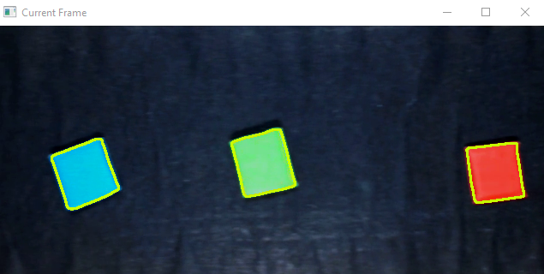 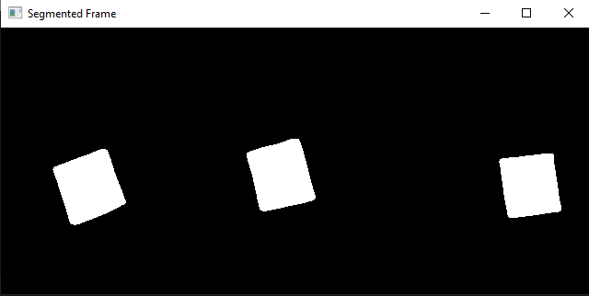

Fig- Segmented frame

Fig- Original Frame

* **Remove boundary:**

This method aims to remove components or objects touching the boundary, leaving only internal components visible. The connected components in the binary image are labeled using **cv2.connectedComponents()**. The code identifies connected components that touch the boundary of the frame by iterating through boundary pixels of the labeled image and collect the labels of connected components that have at least one pixel touching the boundary. The collected labels will later be used to create a mask for filtering out these components. A mask is created to filter out connected components touching the boundary. Then, using that mask, the original frame is modified, where boundary-touching components are set to black, and finally the frame with no boundary touching objects is returned and used for further processing. Figure 1.2 illustrates the procedural flow through a designed flowchart.

* **Draw Contours:**

The **draw_contours()** method, encapsulated within its implementation, employs the functionality of **cv2.findContours()** to identify and extract contours within a given image. Subsequently, the contours identified are rendered onto the original or an alternate image using the method **cv2.drawContours()**. This methodology facilitates the visualization and analysis of distinct boundaries and shapes present in the image, contributing to an understanding of the underlying structures within the visual data.

* **Image Registration:**

In the context of our conveyor belt system, where objects are consistently in motion and captured continuously by the camera traversing from one end to the other, a specific challenge arises. The objective is to selectively obtain the initial isolated image of each new object only once, as it enters the conveyor, ensuring that redundant images are disregarded. This step is imperative so that we can extract the required information of each object and do subsequent processing. To achieve this, we use a technique known as **Image Registration**.

**Image registration** is the process of spatially aligning two or more image of the same scene taken at different times, from different viewpoints, and/or by different sensors.

Through Image Registration, we align successive images captured during the object's journey, effectively pinpointing the moment of entry and allowing us to capture the initial frame exclusively. The entire process is executed through the dedicated **img_reg()** method. Figure(a) demonstrates the concept of Image Registration.

XOR between offset and registered or shifted image

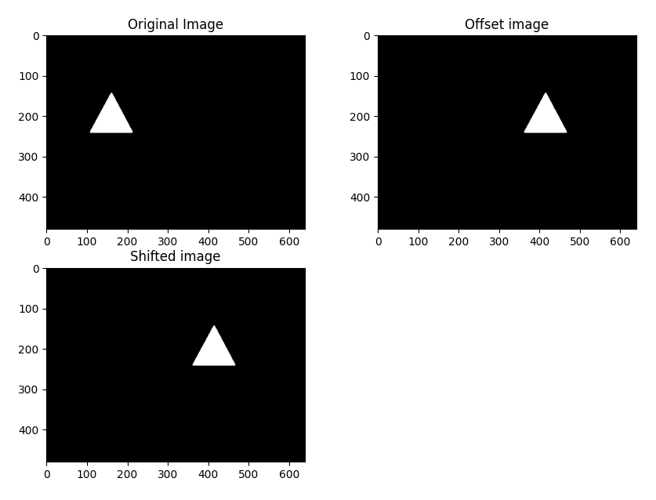

Figure(a)- Image Registration

**Working:**

For registering two images we use the **image_registration** package of python. Inside image registration package there are various methods that we can use for example some of them are chi2_shift() method, cross_correlation_shifts() etc.

The **chi2_shift()** finds the offsets between image 1 and image 2 using the DFT upsampling method combined with 𝛘2 to measure the errors on the fit. The main advantage of the **chi2_shift** approach is that it can return *statistical errors* on the best-fit shift. It is also fast and efficient for many image types and sizes.

The **chi2_shift()** takes the two images as arguments (original_image and the offset_image) and gives you four outputs i.e. xoff, yoff, exoff, eyoff. xoff, yoff measures the amount offset_image is offset from original_image and exoff, eyoff are errors in x and y directions.

**Note:** In our case the two images to be registered will be the two consecutive frames i.e. previous frame is the original_image and current frame is the offset_image.

Once we know by how much x is offset and y is offset, then we can go ahead and shift our original_image by that much to align it with the offset_image or we can also shift our offset_image to align it with the original_image. And for that we can use a function called **shift()** out of **scipy.ndimage**

The scipy.ndimage.shift function is part of the scipy library and is primarily used for shifting the elements of an array along specified axes. It is commonly employed in image processing and computer vision for tasks such as image registration, where aligning images with sub-pixel precision is crucial**.** Points outside the boundaries of the input are filled according to the given mode. It takes input parameters as: **input**: an image or array to be shifted, **shift**: The shift values along each axis, **mode:** the mode parameter determines how the input array is extended beyond its boundaries. Default is ‘constant’. Using the ‘constant’, the input is extended by filling all values beyond the edge with the same constant value, defined by the *cval* parameter. **cval** is a *scalar,*value to be filled past edges of input if *mode* is ‘constant’. Default is 0.0.The output parameter gives the shifted array or image.

Finally, Once we have registered/shifted/corrected image, we perform ‘bitwise xor’ operation between shifted/corrected image and the offset image(current frame in our case). XORing shifted and the current frame gives the isolated image of each new object coming over conveyor initially only once. This approach ensures that only the inaugural image of an object is taken into consideration. Subsequently, as the object traverses the conveyor belt, continuous registration and XORing take place, rendering subsequent frames with no same object to prevent redundant data collection.

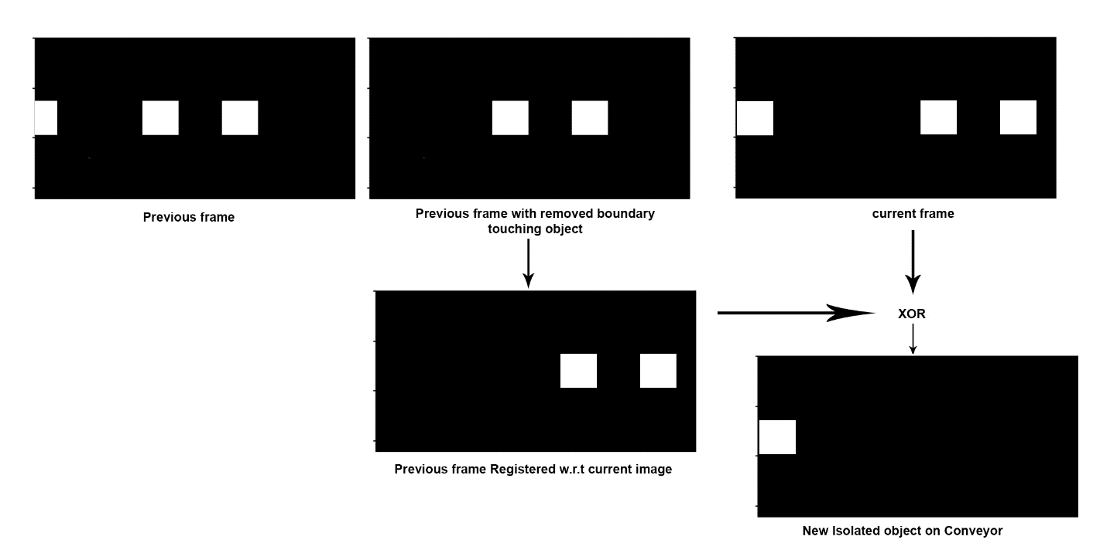

Fig – Isolating each new object coming over conveyor

Also, at last we perform morphological opening on each frame that effectively eliminates unwanted noise and fine details from the image

Figure 1.3 illustrates the procedural flow of the img_reg() method through a designed flowchart.

* **Getting details for each object:**

Having successfully isolated each object traversing the conveyor belt and obtaining its initial image uniquely, the subsequent task entails capturing pertinent details essential for further analysis. To facilitate this, we have introduced a method named **get_details()**. This method serves as a pivotal component in our image processing pipeline, requiring two primary parameters: a binary segmented image, delineating the isolated object, generated through the **img_reg()** method, and the authentic original image corresponding to the object.

The functionality of the **get_details()** method is distinctly defined to extract required information such as real-world coordinates, color label, count number, etc. By systematically processing the binary segmented image and the authentic object image, the method employs specialized algorithms to compute and encapsulate the essential attributes of the isolated object. The working of get_details() method is described below:

**Working:**

Firstly, we apply cv2.connectedComponentsWithStats() function on the isolated object mask generated through **img_reg()** method, that will give various information e.g. number of labels, an labelled image, bounding box of each labelled component, and centroid.

After that we have three main tasks and that are i) color detection and getting the color label for each object ii) getting the real-world coordinates of each object and iii) getting the object count means that we have to count each new object traversing over the conveyor.

Initially, we use the **cv2.connectedComponentsWithStats()** function on the isolated object mask created by the img_reg() method. This function provides essential details like the number of labels, a labeled image with each component uniquely identified, the bounding box coordinates encapsulating each labeled object, and the centroid coordinates of these components.

After this, we focus on three main tasks. Firstly, we detect and label the colors of each object. Secondly, we find the real-world coordinates of each object to understand their positions in space with respect to the origin of robotic arm. Lastly, we count each new object moving on the conveyor belt, this involves the enumeration of each new object traversing the conveyor belt, helping us keep track of the overall object count.

* **Color Detection:**

For color detection, we first create the mask of each isolated component and then perform the bitwise ‘and’ operation between the mask and the original image to get the original isolated colored component image. After that, we convert that image from BGR to HSV color format using the **cv2.cvtColor()** function, it takes the frame as the first input and the type of color conversion as the second input. HSV stands for hue, saturation, and value. Hue signifies the color itself, technically it denotes the angle in the HSV color model.

To detect objects with a specific color, we define and apply an upper bound and lower bound range of that color in HSV.

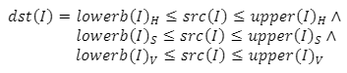

Where *src(I)* is the source image, *dst(I)*is the destination image, *[lowerb(I)H, upper(I)H]* is the range of hue, *[lowerb(I)s, upper(I)s]* is the range of saturation, *[lowerb(I)v, upper(I)v*] is the range of value.

To specify the lower and upper limit of a specific color. We create two NumPy arrays with the desired lower and upper limit as [H, S, V]. These NumPy arrays will be used as arguments in the thresholding function i.e. the **cv2.inRange()** function, discussed next in this section.

The main idea is to convert the input BGR image to HSV format, which will make it easier for us to mask the specific color out of the frame. That is, whatever color in the provided HSV range will be given a value of 255 and others will be simply 0, and as a result, every object with color in the specified range will change to white leaving the rest of the image i.e. background black, and for that we use the **cv2.inRange()** function, which takes three arguments, image source, lower limit, and the upper limit.

cv2.inRange() function sets all the values that lie within the range to 255 and the rest to 0.  The output of this function will be our mask.

In this project, objects have red, green, or blue colors. Firstly, the lower threshold and upper threshold for a range of red colors are applied. The resulting image is a binary image, if the objects are red, they will be white blobs in the binary image.

After that we get the area of the white blob using the**cv2.countNonZero()** which takes an image as parameter and returns the number of non-zero pixels in the image, and checks that area for a threshold value. So, If the area of the blob is larger than a threshold, it means that there is a red object. So, the color label will be set to the red color. After that, the thresholds for the green and blue objects are applied. If a green object or a blue object is detected, then the color label will be set to green or blue respectively. Figure(b) show the classification results for each color. Once the color label for each object is detected then we can enqueue that label to the shared queue where the delta robot can use it to sort that object by placing it in a particular distinct bin. Figure 1.4 provides the flowchart for color detection algorithm.

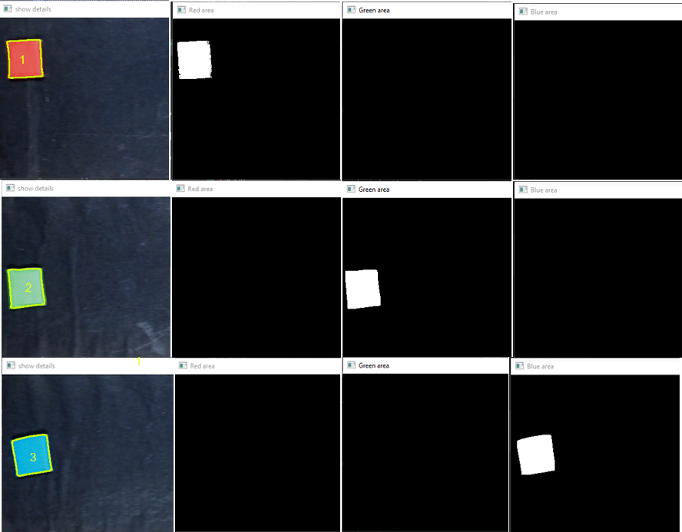

Figure(c)- Classification results

* **Real-world centroid detection:**

Upon initially acquiring the centroid coordinates of the object through the cv2.connectedComponentsWithStats() function, it is imperative to acknowledge that these coordinates are in pixel units and are referenced with respect to the image or viewport origin. The image or viewport origin is conventionally considered the top-left corner of the image, where the pixel (0, 0) resides. The subsequent step involves the conversion of these pixel-based centroid coordinates into millimeters(mm’s) aligning with the real-world origin of the image. This entails mapping viewport coordinates to real-world coordinates, ensuring accuracy in positioning. This conversion is pivotal for accurately determining the actual current position of the object's centroid on the conveyor relative to the origin of the robotic arm.

Subsequently, we continuously update these coordinates using a dedicated thread, which we will discuss later. This updating process ensures that the delta robot has the most up-to-date information about the object's position, allowing it to accurately pick up the object.

**Working:**

To facilitate the mapping of viewport centroid coordinates to real-world coordinates (i.e. conversion from pixels to millimeters), we employ a scaling factor known as the calibration factor, denoted as **calib_factor**. This factor represents the pixel-to-millimeter ratio, indicating the equivalent length in millimeters for each pixel. By multiplying this calibration factor with the centroid coordinates of the object in pixels, we obtain the corresponding coordinates in millimeters w.r.t real-world origin of the viewport.

The calculation of calibration factor is detailed in the upcoming section titled "Camera Calibration."

**- Calculation of relative coordinates:** Now. we have to determine the centroid coordinates relative to the origin of the robotic arm, signifying the spatial displacement of the object from the robotic arm. To achieve this, a distance representing the separation between the origin of the robotic arm and the real-world origin of the viewport is measured. This distance is subtracted from the previously computed mapped real-world centroid coordinates.

Upon obtaining these relative coordinates, indicative of the object's actual position w.r.t the robotic arm, we proceed to enqueue them into a shared queue. This queue serves as a dynamic repository where the coordinates undergo continuous updates. Subsequently, when the dynamically updated coordinates fall within the operational bounds of the delta robot, signifying that the object is positioned within the robot's permissible range, the delta robot proceeds to utilize these coordinates to pick up the object. The robot then places the object in the appropriate bin based on its color label. This straightforward process ensures precise and efficient object handling.

* **Counting and assigning unique ids to each object:**

To facilitate the counting and allocation of distinctive identifiers to each object traversing the conveyor, we have initialized a global variable set to zero. With the detection and isolation of each new object, this variable undergoes continuous increments. In this way we can track the overall count of incoming objects and concurrently assign each object a unique identifier corresponding to its arrival sequence.

Following the acquisition of essential details, including coordinates, color label, and count number, we compile this information into a list. Subsequently, we return this compiled list.

When we get the detail list from get_details() function we check it for a ‘none’ condition and check if a given object, specified by its coordinates, is a potential copy of an existing object in a queue, this is for validation purpose to ascertain whether a specified object, might represent a duplicate of an object already present in a queue. And for that we define a method named as **is_copy()**.The function takes two parameters:

* **lock**: This is a synchronization mechanism, likely a lock, to control access to shared resources in a multithreaded or multiprocessing environment.
* **obj**: This is a tuple representing the coordinates of the object under consideration.

When invoked, this function first checks if the length (size) of the global shared object_queue, in which the details of each object is going to be enqueued, is less than 1. If the queue is empty, the function returns False, indicating that the object cannot be a copy. Else if there is any object in the queue then the method calculates the distance between the specified object and each object in the queue. If the calculated distance falls below a predefined threshold, the function concludes that the object is a potential copy. This systematic validation process, encapsulated in the **is_copy()** function, ensures the accuracy and reliability of our object recognition system by preventing the inadvertent identification of duplicate objects.

**Camera Calibration:**

In this project, camera calibration process is used to calculate the calibration factor representing the pixel-to-millimeter ratio. This ratio is crucial for converting pixel measurements into real-world dimensions.

In this we perform a real-time camera calibration using a checkerboard pattern to calculate the pixel-to-millimeter ratio, essential for converting pixel measurements to real-world dimensions. Initially a video is captured from the default camera and, in a continuous loop, a checkerboard corners in each frame is identified using **cv2.findChessboardCorners()** function. Upon successful corner detection, we extract a region of interest, processes it by converting to grayscale, applying blur and thresholding, and conducts connected component analysis. The width and height of each connected component are measured, and the pixel-to-millimeter ratio is calculated using a known width in millimeters. The calculated ratio is then used for converting pixel measurements into real-world dimensions.

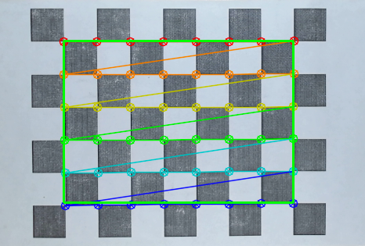

Fig- Chessboard Corner detection

**Flowcharts**

Fig 1.0: **Imaging Thread main loop**

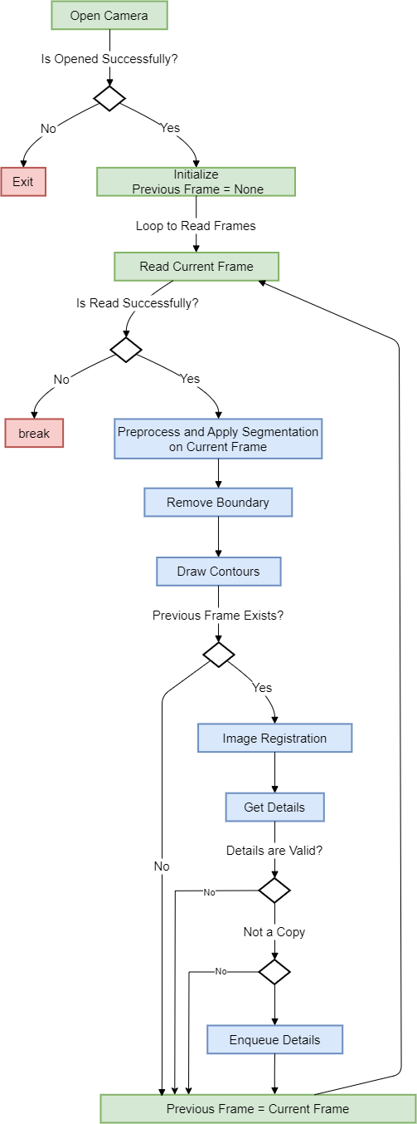

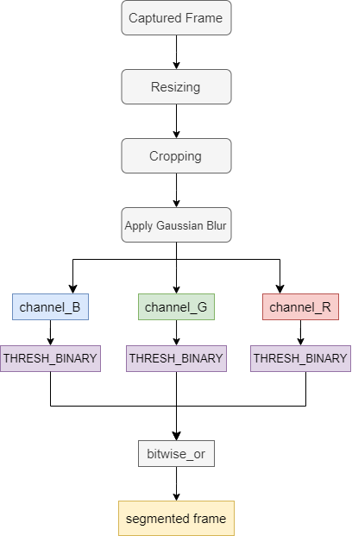

Fig 1.1: **Preprocessing**

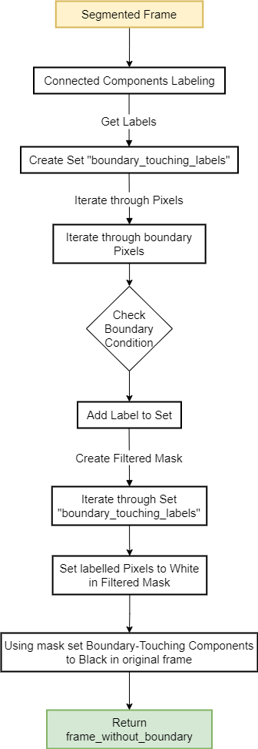

Fig 1.2: **Remove boundary**

Fig 1.3: **Image Registration**

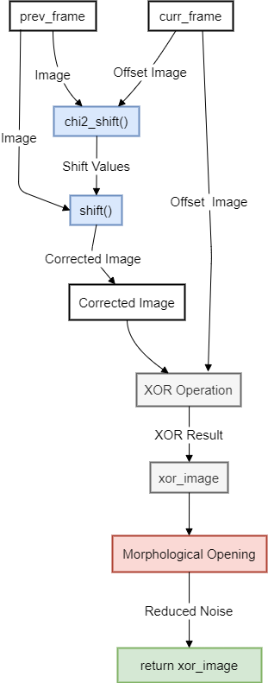

Fig 1.4: **Color Detection**

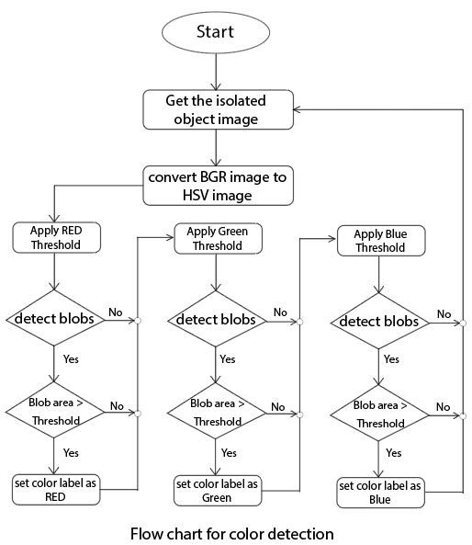

* **Implementation of Imaging Thread:**



**Implementation of preprocess()**

def preprocess(frame):  
 *# resizing* frame = cv2.resize(frame, (640, 480))  
  
 *# cropping* frame = frame[170:460, :]  
 output = frame.copy()  
 *# Applying Gaussian Blur* frame = cv2.GaussianBlur(frame, (11, 11), 0)  
  
 _, frame_b = cv2.threshold(frame[:, :, 0], 160, 255,

cv2.THRESH_BINARY)  
 _, frame_g = cv2.threshold(frame[:, :, 1], 160, 255,

cv2.THRESH_BINARY)  
 _, frame_r = cv2.threshold(frame[:, :, 2], 160, 255,

cv2.THRESH_BINARY)  
  
 frame = cv2.bitwise_or(frame_b, frame_g)  
 frame = cv2.bitwise_or(frame, frame_r)  
  
 *# Applying Image Thresholding  
 # _, frame = cv2.threshold(frame, 130, 255,*

*cv2.THRESH_BINARY)* return frame, output

**Implementation of remove_boundary()**

def remove_boundary(original_mask):  
 *# This line uses the cv2.connectedComponents method to perform*

*connected components labeling  
 # on the binary mask original_mask, it returns a labelled image*

*in which each component is represented by its unique label* _, labels = cv2.connectedComponents(original_mask)  
  
 *# Get frame dimensions* height, width = labels.shape  
  
 *# Create a set to store labels of components that touch the*

*bound*

*ary* boundary_touching_labels = set()  
  
 *# Iterate through the boundary pixels and collect component*

*labels* for i in range(height):  
 for j in range(width):  
 if i == 0 or j == 0 or i == height - 1 :  
 label = labels[i, j]  
 if label != 0: *# Exclude the background label* boundary_touching_labels.add(label)  
 *# boundary_touching_labels.add(labels[i, j])  
  
 # Create a mask for the components to ignore the components*

*touching the boundary.* filtered_mask = np.zeros_like(labels, dtype=np.uint8)  
  
 *# Iterate through the set* for label in boundary_touching_labels:  
 filtered_mask[labels == label] = 255  
  
 *# Set the boundary-touching components to black in the original*

*frame* original_mask[filtered_mask == 255] = 0  
 return original_mask

**Implementation of img_reg():**

def img_reg(prev_img, curr_img):  
 image = prev_img  
 offset_image = curr_img  
  
 *# chi squared shift  
 # Find the offsets between image 1 and image 2 using the DFT*

*upsampling method* noise = 0.1  
 xoff, yoff, exoff, eyoff = chi2_shift(image, offset_image,

noise, return_error=True, upsample_factor='auto')  
  
 *#print("Pixels shifted by: ", xoff, yoff)* from scipy.ndimage import shift  
 *# In order to get the shifted aligned image we use shift  
 # corrected_image = shift(offset_image, shift=(-yoff, -xoff),*

*mode='constant')* corrected_image = shift(image, shift=(yoff, xoff),

mode='constant')  
  
 *# xoring the corrected and offset images gives us the new object*

*in the frame only once* xor_image = cv2.bitwise_xor(offset_image, corrected_image)  
 *# cv2.imshow("xor1", xor_image)  
  
 # Using morphological opening to reduce noise in the frame* kernel = np.ones((13, 13), np.uint8)  
 xor_image = cv2.morphologyEx(xor_image, cv2.MORPH_OPEN, kernel,

iterations=1)  
 cv2.imshow("xor", xor_image)  
  
 height, width = xor_image.shape  
 mask = np.ones_like(xor_image, dtype=np.uint8) * 255  
 roi = mask[:, width // 3:]  
 roi[:, :] = 0  
  
 *# Apply the mask to the binarized image* masked_image = cv2.bitwise_and(xor_image, xor_image, mask=mask)  
 cv2.imshow("masked", masked_image)  
 return masked_image, xoff, yoff  
  
  
*# This will be used to create the mask*red_lower1 = np.array([1, 40, 70]) *# setting the red lower limit*red_upper1 = np.array([20, 255, 255]) *# setting the red upper limit*red_lower2 = np.array([140, 40, 70]) *# setting the red lower limit*red_upper2 = np.array([179, 255, 255]) *# setting the red upper limit*green_lower = np.array([20, 50, 100]) *# setting the green lower limit*green_upper = np.array([80, 255, 255]) *# setting the green upper limit*blue_lower = np.array([87, 30, 100]) *# setting the blue lower limit*blue_upper = np.array([130, 255, 255]) *# setting the blue upper limit*

**Implementation of get_details():**

def get_details(xor_mask, output):  
 *# Apply the Component analysis function* analysis = cv2.connectedComponentsWithStats(xor_mask)  
 (num_labels, labels, stats, centroids) = analysis  
  
 for i in range(1, num_labels): *# index 0 is for background  
  
 # Color detection* col_label = None  
  
 *# create a mask* obj_mask = np.zeros(labels.shape, dtype="uint8")  
 obj_mask[labels == i] = 255  
  
 *# AND with original image* res = cv2.bitwise_and(output, output, mask=obj_mask)  
  
 *# changing the color format from BGR to HSV* hsv_res = cv2.cvtColor(res, cv2.COLOR_BGR2HSV)  
  
 *# creating the mask using inRange() function  
 # this will produce an image where the color of the objects  
 # falling in the range will turn white and rest will be*

*black* red_mask1 = cv2.inRange(hsv_res, red_lower1, red_upper1)  
 *# red_area = cv2.countNonZero(red_mask1)* red_mask2 = cv2.inRange(hsv_res, red_lower2, red_upper2)  
 *# red_area = cv2.countNonZero(red_mask2)* red_mask = red_mask1 + red_mask2  
 *# getting the area of red color using red_mask* red_area = cv2.countNonZero(red_mask)  
 *# cv2.imshow("red area", red_mask)* green_mask = cv2.inRange(hsv_res, green_lower, green_upper)  
 *# getting the area of green color using green_mask* green_area = cv2.countNonZero(green_mask)  
 *# cv2.imshow("green area", green_mask)* blue_mask = cv2.inRange(hsv_res, blue_lower, blue_upper)  
 *# getting the area of blue color using blue_mask* blue_area = cv2.countNonZero(blue_mask)  
 *# cv2.imshow("blue area", blue_mask)  
  
 # checking the threshold condition* if red_area > 70:  
 col_label = 0 *# The color of the object is "Red"* elif green_area > 70:  
 col_label = 1 *# The color of the object is "Green"* elif blue_area > 70:  
 col_label = 2 *# The color of the object is "Blue"  
  
 # real-world centroid co-ordinates detection* x = stats[i, cv2.CC_STAT_LEFT]  
 y = stats[i, cv2.CC_STAT_TOP]  
 w = stats[i, cv2.CC_STAT_WIDTH]  
 h = stats[i, cv2.CC_STAT_HEIGHT]  
  
 (cX, cY) = centroids[i]  
 cX, cY = np.float16(cX), np.float16(cY)  
  
 *# pixel to mm conversion* mm_cX = cX * calib_factor  
 mm_cY = cY * calib_factor  
  
 *# Real-world coordinates w.r.t origin of the robotic arm* relative_x = mm_cX - new_origin_x  
 relative_y = mm_cY - new_origin_y  
  
 *# relative_x = new_origin_x - mm_cX  
 # relative_y = new_origin_y - mm_cY  
  
 # incrementing the count for each new detected object* global obj_count  
 obj_count = obj_count + 1  
  
 *# make a list of all collected details* queue_item = [relative_x, relative_y, col_label, w, h,

obj_count]  
 *# queue_item = [mm_cX, mm_cY, col_label, w, h, obj_count]* return queue_item

**Implementation of show_details():**

*# show_details function is used to annotate the image with relevant information*def show_details(obj, convey_img):  
 img = np.copy(convey_img)  
 if obj == None:  
 return img  
  
 *# In order to display some details of the object on the frame*

*con*

*taining the object  
 # we perform reverse conversion of real-world coordinates* mm_cX = obj[0] + new_origin_x  
 mm_cY = obj[1] + new_origin_y  
  
 *# mm_cX = new_origin_x - obj[0]  
 # mm_cY = new_origin_y - obj[1]* cenX = mm_cX/calib_factor *# centroid x* cenY = mm_cY/calib_factor *# centroid y* w = obj[3] *# object width* h = obj[4] *# object height* x = cenX - (w/2)  
 y = cenY - (h/2)  
  
 *# Checks if the calculated bounding box of the object, lies en*

*tirely within the dimensions of the output image* if x >= 0 and y >= 0 and x + w <= output_img.shape[1] and y + h

<= output_img.shape[0]:  
 *# Adds text annotation to the image* cv2.putText(img, str(obj[5]), (int(cenX), int(cenY)),

cv2.FONT_HERSHEY_SIMPLEX, 0.5, (0, 215, 255), 2)  
 *# cv2.rectangle(img, (int(x), int(y)), (int(x+w), int(y+h)),*

*(0, 255, 0), 2)  
 # cv2.imshow("show details", output_img)* return img *# Returns the annotated image.*

**Implementation of draw_contours ():**

def draw_contours(frame):  
 contours, _ = cv2.findContours(frame, cv2.RETR_EXTERNAL,

cv2.CHAIN_APPROX_SIMPLE)  
  
 for i in range(0, len(contours)):  
 if ((cv2.contourArea(contours[i])) > 100):  
 cv2.drawContours(output_img, contours, i, (0, 255, 200),

2)

**Implementation of is_copy():**

*# is_copy function is used to determine if a given object, is  
# a potential copy of an existing object in a queue*def is_copy(lock, obj):  
 *# check if the length (size) of the object_queue is less than 1* if length(lock) < 1:  
 return False  
 lock.acquire() *# acquires the lock* for q_obj in object_queue: *# Iterates through each object*

*(q_obj) in the object queue.  
 # Calculates the distance between the current object in the*

*queue (q_obj)  
 # and the object under consideration (obj).* dist = distance(Point(q_obj[0], q_obj[1]), Point(obj[0],

obj[1]))  
 print("Distance " + str(dist))  
  
 *# Checks if the calculated distance is less than a threshold*

*value (size_thresh)* if dist < size_thresh:  
 lock.release() *# Releases the lock* return True *# indicating that the given object is a*

*#copy.* lock.release() *# Releases the lock* return False *# indicating that the given object is not a*

**UPDATION THREAD**

* **Introduction**

In our system, a global queue named as **object_queue[]** serves as a central repository for storing comprehensive details about objects in transit along the conveyor. Also we know that this queue is designed for shared access among multiple threads. Specifically, the imaging thread takes on the responsibility of acquiring and enqueuing detailed lists pertaining to each detected object. Now, the primary objective of updation thread is to consistently update the relative coordinates of objects within the queue. This real-time updating is based on the conveyor speed, ensuring a synchronized representation of the object's movement. The overarching goal is to furnish the delta robot with the most current and accurate coordinates for a targeted object, enabling precise and timely robotic interaction.

**Working:**

The `**updation_thread()**` function operates as a dedicated thread responsible for the continuous and synchronized updating of object coordinates within our system.

Within an infinite loop, the function first captures the current time and then loop continuously calculates the time difference (`quanta`) between the current time and the time in the previous iteration. If the time difference is positive, it implies that a certain amount of time has passed, and the function proceeds to calculate the coordinate offsets based on this time difference and specified speeds.

This time difference, termed as "quanta," is used to compute the coordinate offsets along both the x and y axes, taking into account the conveyor speed specified as `xSpeed` and `ySpeed`. These offsets are temporarily stored in the `offset` list. Subsequently, the `**update()**` function is invoked, by passing a provided lock and the calculated offsets to add the offsets to the coordinates in the global coordinates queue. Then afterwards, the function resets the offset list for the subsequent iteration, ensuring accurate calculations. A brief sleep interval of 0.1 seconds introduces a controlled pace to the thread, contributing to the coherent and timely updating of object coordinates based on conveyor speed.

The term "quanta" is used to represent the time difference between successive iterations. In the context of the code, it's the amount of time that has passed since the last update. The calculated offsets are proportional to this time difference, ensuring that the coordinates are updated based on the conveyor's speed.

Overall, the `updation_thread()` function plays a pivotal role in maintaining the precision of object coordinates for the delta robot's dynamic interaction with objects on the conveyor. Figure 2.0 provides the flowchart for the functionality of the updation thread.

**Update() :**

The `**update()**` function is responsible for dynamically updating the global object coordinates queue based on a specified offset. Commencing with the acquisition of a lock to ensure thread safety, the function begins by checking if the object_queue is empty. In the absence of objects, it simply calls the show_detials() method and shows the image returned by that method. And finally releases the lock and return.

The show_details() function is used to annotate the image with relevant information e.g. object count or its bounding box etc. But, while checking the above empty condition show details doesn’t return any annotated image as there is no object in the queue.

Following the check, the update()function proceeds to iterate through each object in the original queue(object_queue). For each object, it incrementally adjusts both x and y coordinates using the provided offset. Importantly, a bounds check is implemented to ensure that the updated x-coordinate remains within a defined boundary (`xMax`). Objects that satisfy this condition are retained in a temporary queue (`queue_temp[]`). Simultaneously, the function calls the show_details() method for object annotation. Upon completion of the iteration, the global object queue is updated to reflect the contents of the temporary queue. Finally, the lock is released, and then annotated image for each updated object is displayed. Figure 2.1 illustrates the procedural flow of the update() method through a designed flowchart.

**Show_details():**

The **show_details()** function processes an object's details passed to it, to determine its position and size within an image and then annotates the image with relevant information.

It begins by reverse conversion of the coordinates stored in list passed to it into pixel-based coordinates, so that those coordinates can be used for annotation purposes. Also, the function calculates the bounding box coordinates of the object. Importantly, the code performs a bounds check to ensure that the calculated bounding box, representing the spatial extent of the object, remains entirely within the dimensions of the output image. This check prevents annotations from extending beyond image boundaries. The function then proceeds to annotate the image by adding text at the object's centroid. The text comprises the object's count label, retrieved from the list, and is styled with a specified font size, color, and thickness. Overall, this function contributes to the visual depiction of object details, enhancing the interpretability of computer vision outputs by providing labeled annotations and potential bounding box representations within the image.

**Flowcharts:**

Fig 2.0: **Updation thread main loop**

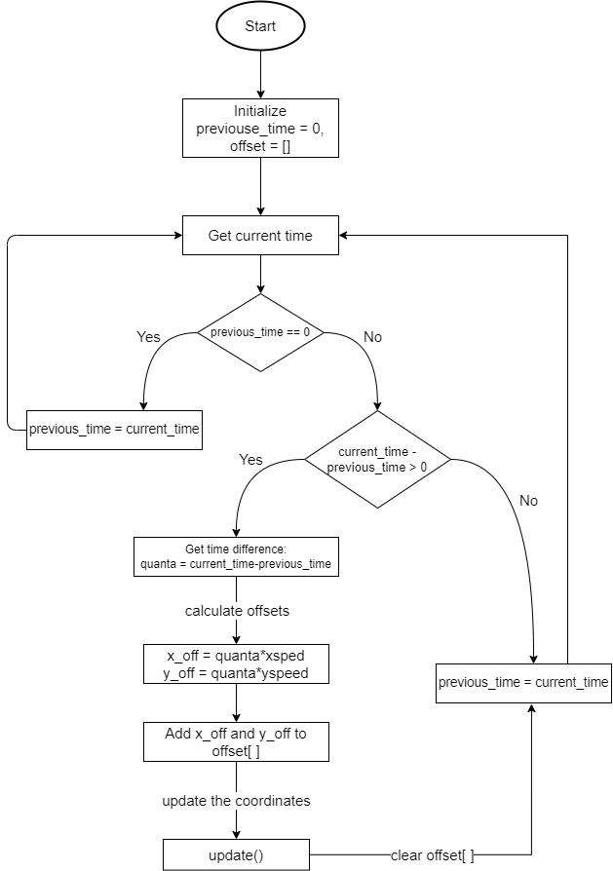

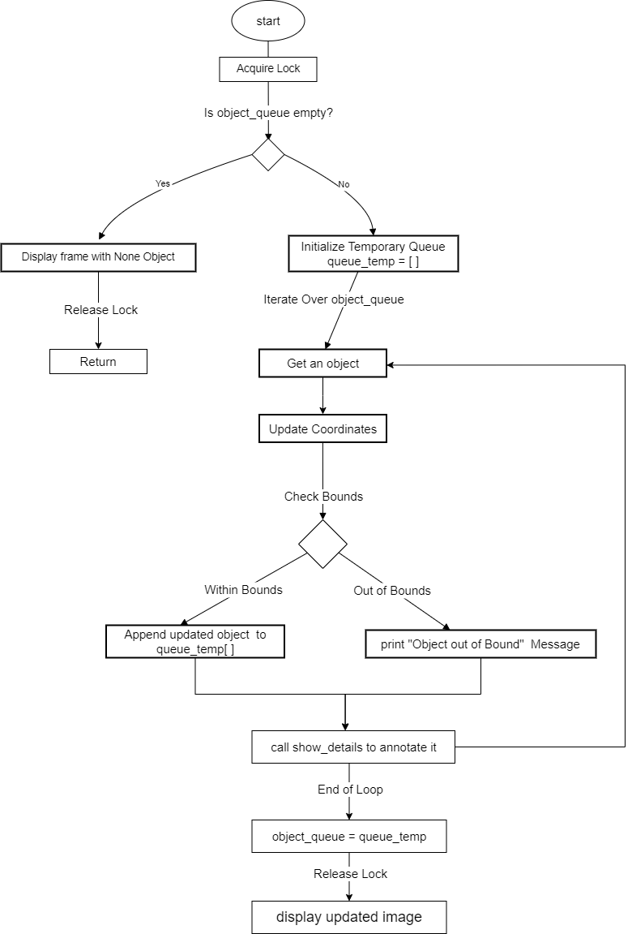

Fig 2.1: **update() method**

* **Implementation of Updation Thread:**

*# updation thread main loop*

*# updation thread is used to consistently update  
# the relative coordinates of objects within the queue.*def updation_thread(lock):  
 *# To update the coordinates* previous_time = 0 *# Initialize previous_time to keep track of*

*#the time in the previous iteration* offset = [] *# Initialize offset list to store the calculated*

*# coordinate offsets.* while(1): *# Create an infinite loop to continuously update*

*#coordinates.* current_time = time.time() *# Obtain the current time.  
 # if first iteration, set previous_time and continue* if(previous_time==0):  
 previous_time = current_time  
 continue  
 *# else if there's a positive time difference* elif(current_time - previous_time > 0):  
 *# Calculate the time difference (quanta) and use it to*

*# calculate  
 # coordinate offsets based on the specified xSpeed and*

*# ySpeed.  
 # Append the offsets to the offset list.* quanta = current_time-previous_time  
 offset.append(quanta*xSpeed)  
 offset.append(quanta*ySpeed)  
 update(lock, offset) *# Call the update function to*

*# update the coordinates.  
  
 #print("offset",offset)* offset.clear() *# Clear the offset list for the next*

*# iteration.* previous_time = current_time *# Update previous_time* time.sleep(0.1)

**Implementation of update():**

*# The update function is responsible for updating the global object coordinates queue  
# (object_queue) based on a specified offset.*def update(lock, offset):  
 global object_queue  
 img = np.copy(output_img)  
 lock.acquire() *# Acquires the lock* if (len(object_queue) < 1): *# Checks if the object queue is*

*# empty.* img = show_details(None, img) *# If so, it displays details*

*# for a None object* cv2.imshow("show details", img)  
 cv2.waitKey(1)  
 lock.release() *# release the lock* return  
 print("length", len(object_queue)) *# Display Queue Length* queue_temp = [] *# Initializes a temporary queue* for i in range(0, len(object_queue)): *# iterate through each*

*# object in the original queue.* obj = object_queue[i]  
  
 print("obj", obj)  
 *# Updates the x and y coordinates of each object in the*

*# queue* obj[0] = obj[0] + offset[0]  
 obj[1] = obj[1] + offset[1]  
  
 *# Checks if the updated x-coordinate is within a specified*

*# bound (xMax).  
 # If so, the object is appended to the temporary queue;* if (obj[0] < xMax):  
 queue_temp.append(obj)  
 else:  
 print("object out of bound") *# otherwise, print "object*

*# is out of bounds".* img = show_details(obj, img) *# call show_details to*

*# annotate at updated coordinates* object_queue = queue_temp *# Update Global Queue  
 # print(object_queue)* lock.release() *# release the lock* cv2.imshow("show details", img) *# Display Updated Image* cv2.waitKey(1)

**DESIGN AND FUNCTIONALITY OF THE GUI**

* **Introduction**

In this section, we explore the conceptualization, design considerations, and functional aspects of the Graphical User Interface (GUI) developed for our project. In this part, we'll explore the user-friendly design philosophy and essential features that empower operators for seamless interaction with the system, offering a comprehensive grasp of the fundamental principles behind our GUI.

In the pursuit of enhancing user interaction and control within our innovative project—focused on the classification of objects traversing a conveyor belt using a delta robot and OpenCV—we recognized the pivotal role that an intuitive and efficient Graphical User Interface (GUI) could play. This section delves into the design, development, and functionalities of the GUI component, which serves as the gateway for users to effortlessly engage with the system. From real-time object tracking to parameter adjustments, our GUI encapsulates a user-friendly experience, ensuring seamless communication between the operator and the system.

**Libraries Used**

The robust design and development of our Graphical User Interface (GUI) were made possible through the utilization of various powerful libraries. Below is a list of the key libraries incorporated in crafting an intuitive and effective user interface:

**Tkinter:** Tkinter, the standard GUI toolkit for Python, forms the backbone of our GUI, providing essential building blocks for interface elements.

**ttkbootstrap:** This library enhances the visual aesthetics of our GUI, offering themed styling options for a modern and cohesive appearance.

**PIL (Python Imaging Library):** PIL, now known as the "Pillow" library, enables image processing functionalities within the GUI, contributing to dynamic visualizations. From PIL, **Image** and **ImageTk** are two key modules that are used to deal with image handling and integration with Tkinter.

**json:** The json library facilitates seamless data interchange between the GUI and backend processes, ensuring efficient communication and configuration handling.

**GUI Layout and Design:**

In the design of the graphical user interface (GUI), careful consideration has been given to provide an organized and user-friendly layout.

**- Root Window-** The main root window is styled using the `ttkbootstrap` theme “superhero” with a geometric configuration of **1000x650 pixels**. To ensure consistent dimensions during the program's runtime, we have set both minimum and maximum sizes for the root window using the attributes **minsize** and **maxsize**. The root window is titled as “Spider Vision” and an icon with ‘.ico’ format is added to the title bar. At the top of the window, a prominent banner image has been incorporated to showcase the branding, positioned at the top of the root window using the `pack` method. The remaining area has been divided into two frames: one on the left and another on the right.

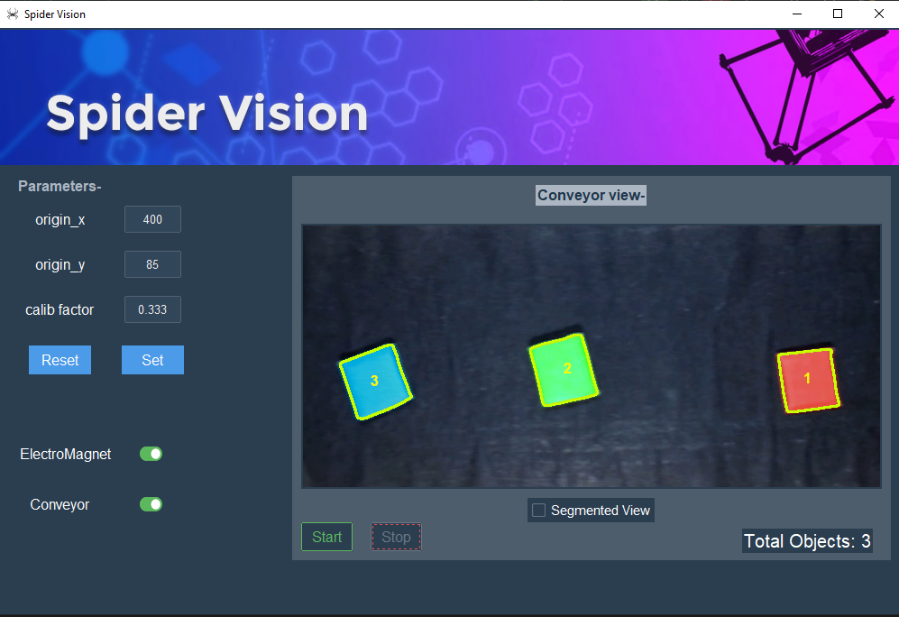

Fig- UI Design

* **Left Frame Components and their Functionality:**

Within the **left frame**, the design focuses on presenting essential parameters to the user.

* **Top label:**

A top label, named '**Parameters**,' has been created and placed inside the left frame using the `pack` method. This label acts as a title for the widgets placed under it.

* **Entry Widgets and Corresponding Labels:**

Beneath the top label 'Parameters,' a structured grid has been established within the left frame, featuring three entry widgets paired with their corresponding labels (origin_x, origin_y, calib_factor). This organized arrangement of these entry widgets are used to take the input parameters from the user and to display those parameters, that are used throughout the program.

* **Origin_x and Origin_y: Coordinates of Robotic Arm Origin:**
  + The entry widgets labeled as 'origin_x' and 'origin_y' serve the purpose of entering and displaying the coordinates of the robotic arm's origin with respect to the real-world origin of the viewport.
* **Calib_factor: Calibration Factor:**
  + The entry widget 'calib_factor' is dedicated for entering and displaying the calibration factor value. This factor is instrumental in the conversion from pixels to millimeters, as discussed earlier.
* **Set and Reset buttons for** **Parameter Set and Reset:**

To facilitate convenient parameter management within the left frame, two buttons, labeled '**Set**' and '**Reset**,' have been incorporated. These buttons allow users to set custom values and restore default initial values for various entry widgets, enhancing the adaptability of the program.

* **Setting Custom Values:**

Clicking the '**Set**' button triggers the execution of the **save_value()** function. This function begins by checking for a value error exception to ensure the entry of valid data types. Upon successful completion of the check, it retrieves values from the entry widgets, saves them permanently to a file named 'config.json', and subsequently calls the **disp_values()** and **set_vals()** methods.

* + The **disp_values()** method clears entry widget fields, checks for the existence of the 'config.json' file, opens the file, loads the values from the file and displays the values stored in the file, within the widgets, by inserting the loaded values into the corresponding entry widgets.
  + The **set_vals()** method opens the file, loads the values from the file and assigns the loaded values to the variables, used throughout the program. Utilizing a file ensures the persistent storage of user responses.
* **Resetting to Default Values:**

The '**Reset'** button invokes the **reset_vals()** function when clicked. This function retrieves already defined default values, opens 'config.json' file for writing, writes the default values to the file 'config.json' file, and calls both the disp_values() and set_vals() functions.

disp_values() clears entry widget fields, checks for the file's existence, and displays stored default values.

set_vals() opens the file, retrieves default values, and assigns them to program variables for continued use.

This systematic approach allows users to seamlessly manage and customize parameters while ensuring the preservation of their preferences across sessions.

* **Toggle Buttons:**

In our UI, there are two toggle buttons labeled as **'Electromagnet'** and '**Conveyor**.'   
The first toggle button, '**Electromagnet**,' is responsible for controlling the on/off state of the electromagnet, serving as our end effector. Clicking this toggle button triggers the **toggle()** function, which, in turn, sets the value of the variable '**switch**' to either 0 or 1 based on the toggle's on/off state. This '**switch**' variable is then utilized to manage the on/off functionality of the electromagnet.

The second toggle, labeled '**Conveyor**,' is designed to control the on/off state of the conveyor belt. Upon clicking, the '**Conveyor**' toggle triggers the **convey_on_off()** function. This function initially sets the value of the variable **'con_switch**' to either 0 or 1, depending on the toggle's on/off state. Following a conditional check, if **'con_switch**' is set to 1, the conveyor starts operating; otherwise, it halts the conveyor.

* **Right Frame Components and their Functionality:**

In the configuration of the right frame, an arrangement has been implemented to provide users with a comprehensive view of the conveyor belt and also facilitates control over the initiation and cessation of the entire system.

* **Conveyor View:**

Initially, a label ‘**video_label**’ titled with another label **'Conveyor View**' has been introduced, serving as a visual indicator for users, to dynamically showcase the continuous images or video related to the conveyor belt. Both labels have been placed and packed initially at the top of the right frame, incorporating subtle padding to enhance the overall aesthetics.

To display the conveyor belt's view continuously, we use a label(video_label) that updates itself with the **update_video_label()** function. Once the update_video_label() is invoked, this function begins by converting the image array(i.e. the globalized image of the conveyor that the imaging thread is continuously updating) into a format suitable for display, converts the color space of the frame from BGR to RGB, and then a PhotoImage object is created from the frame using the ImageTk module using **Image.fromarray()** and **ImageTk.PhotoImage()**.

* **Image.fromarray(frame)**: This creates a PIL (Pillow) image object from the NumPy array representation of the frame.
* **ImageTk.PhotoImage(img)**: This converts the PIL image to a Tkinter-compatible format using **ImageTk.PhotoImage**, allowing for display in a Tkinter window. The 'image' attribute of the 'video_label' widget keeps on updating with the new PhotoImage, replacing the previous image with the current one, to display the latest image without interruption. A reference to the PhotoImage object is retained to prevent it from being garbage collected. The **update_video_label()** function is scheduled to be called after a delay of 10 milliseconds, ensuring continuous updates.
* **Segmented View Checkbutton:**

To provide a visual representation of the segmentation process applied to objects, we've incorporated a check button named **'Segmented View'**. Activating this button triggers the **seg()** function, which toggles the variable '**switch2**' between 0 and 1 based on the button's state. If '**switch2**' is set to 1, indicating the button is checked, the function proceeds to call **'create_second_win()**'—a method responsible for generating a separate window titled 'Segmented View'. Within this window, a label named **'seg_label'** is dynamically created to continuously display the segmented view of the conveyor belt in real time. The updating process of the seg_label is managed by the **'update_seg_label()**' function, analogous to the operation of **'update_video_label()**' in capturing the globalized segmented images from the imaging thread and updating the seg_label continuously after a certain amount of time. Lastly, the **seg()** function also checks that when the button is unchecked it will destroy the second window.

* **Start and Stop buttons:**

To regulate the execution of critical threads, namely the Imaging thread, Updation thread, and Delta thread, start and stop functionalities have been integrated into the graphical user interface via dedicated buttons. The whole system starts when the Start button is pressed and stops when the stop button is pressed. The threads initially continually check an essential flag variable, **stop_flag**, during their execution. If **stop_flag** is set to False, the threads persist in their execution; otherwise, if set to True, the threads gracefully terminate, preventing further execution.

**Start Button:** The **start_but()** function serves as the command handler for the "Start" button in the graphical user interface. Upon invocation, this function initially resets the object count (obj_count) to zero and clears the global object queue (object_queue). If the threads responsible for imaging capture, delta robot control, and coordinate updates (identified as thread1, thread2, and thread3, respectively) are either not initialized or are no longer alive, the function sets the stop flag to False and launches these threads concurrently using Python's threading module. The Start button upon clicking also triggers another **disable_buttons()** function, that sets the state of the "Start" button and other buttons(have been appended to buttons[] list) to 'disabled' and sets the state of the Stop button to 'normal'.

**Stop Button:** The **stop_but()** function serves as the command handler for the "Stop" button in the graphical user interface. Upon invocation, this function simply sets the **stop_flag** to True i.e. checked by each thread initially to break out, signaling threads to cease execution. The Stop button upon clicking also triggers another **enable_buttons()** function, that restores the state of the "Start" button and other buttons(have been appended to buttons[] list) to 'normal' and sets the state of the Stop button to disabled.

* **Object counter label:**

Concluding the user interface design, a pivotal feature involves displaying real-time information about the total number of identified objects on the conveyor. A dynamic label displaying "**Total Objects**" is positioned to the right of the aforementioned buttons. The label defined as 'counter_label' serves as an informative visual element, dynamically presenting the current count of detected objects. The task of updating this label falls upon the **update_counter()** function. This function relies on the global variable **obj_count**, continually retrieving its value and promptly refreshing the counter label text. The continuous update of this label provides users with instant feedback on the evolving count of objects, enhancing the overall user experience. The time-sensitive frequency at which the label is updated ensures real-time accuracy in reflecting the conveyor's dynamic object flow.

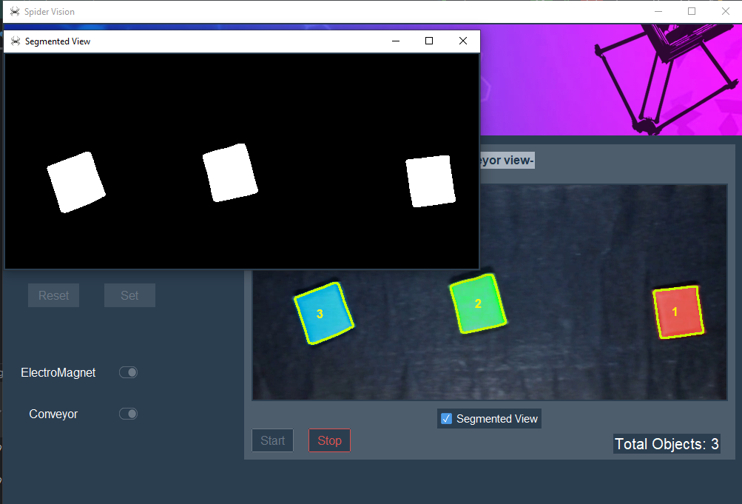

Fig- Layout of UI with Segmented View ON

**Implementation of GUI:**

import tkinter as tk  
from tkinter import messagebox  
import json  
import ttkbootstrap as tb  
from PIL import Image, ImageTk  
from ttkbootstrap.constants import *

thread1 = None  
thread2 = None  
thread3 = None  
stop_flag = False  
  
switch = 0  
switch2 = 0  
con_switch = 0  
  
  
def gui(lock):  
  
 *# The set_vals() method retrieves the values from the file and*

*# assigns the values to the variables, used throughout the*

*# program.* def set_vals():  
 *# Declare global variables to be used* global calib_factor  
 global new_origin_x  
 global new_origin_y  
  
 *# Open 'config.json' file for reading* with open("config.json", "r") as file:  
 *# Load values from the file* loaded_list = json.load(file)  
  
 *# Assign the loaded values to global variables* new_origin_x = loaded_list[0]  
 new_origin_y = loaded_list[1]  
 calib_factor = loaded_list[2]  
  
 *# print the values* print("origin_x ", new_origin_x)  
 print("origin_y ", new_origin_y)  
 print("calib ", calib_factor)  
 print("con_Speed ", con_speed)  
 print("xSpeed ", xSpeed)  
  
 *# reset_vals() function is used to reset the default values to*

*# the parameter variables used throughout the program* def reset_vals():  
 *# Define a list of default values* value_list = [default_origin_x, default_origin_y,

default_calib_factor]

*# Open 'config.json' file for writing*

with open("config.json", "w") as file:  
 *# Save the default values to the file* json.dump(value_list, file)  
  
*# Call disp_values() and set_vals() to display and set the*

*# default values* disp_values()  
 set_vals()

*# save_value() function retrieves values from the entry*

*# widgets, and saves them permanently to a file named*

*# 'config.json'* def save_value():  
 try:  
 *# Retrieve values from entry widgets* value_list = [int(text1.get()), int(text2.get()),

float(text3.get())]  
 *# Save values permanently to 'config.json' file* with open("config.json", "w") as file:  
 json.dump(value_list, file)  
 *# Display stored values* disp_values()  
 *# Set values for program usage* set_vals()  
 except ValueError: *# Handle Value Error* print("Value Error")  
 messagebox.showerror('Error', 'Please Enter Numeric

values as parameters!')

*# disp_values() funtion displays the values stored in the file,*

*# within the widgets.* def disp_values():  
 *# Clear the current content of entry widgets* text1.delete(0, tk.END)  
 text2.delete(0, tk.END)  
 text3.delete(0, tk.END)  
 try: *# check for the existence of the 'config.json' file* with open("config.json", "r") as file: *# opens the file  
 # Load the values from the file* loaded_list = json.load(file)  
  
 *# Insert the loaded values into the corresponding*

*# entry widgets* text1.insert(0, loaded_list[0])  
 text2.insert(0, loaded_list[1])  
 text3.insert(0, loaded_list[2])  
 except FileNotFoundError:  
 *# Handle the case when 'config.json' file is not found* print('File not found')

*# toggle() function is used to set the value of switch variable*

*# to either 0 or 1* def toggle():  
 *# Global variable to store the state of the 'Electromagnet'*

*# toggle* global switch  
 switch = toggle_var.get()  
 print('toggle1;;;', switch)  
  
 *# convey_on_off() function is used control the on/off state of*

*# the conveyor belt* def convey_on_off():  
 *# Global variable to store the state of the 'Conveyor'*

*# toggle* global con_switch  
 con_switch = toggle_var2.get()  
 print('toggle2;;;', con_switch)

*# Check the state of the 'Conveyor' toggle* if con_switch:  
 *# If the toggle is ON, Start the conveyor(ON-logic)*  
 else:  
 *# If the toggle is OFF, stop the conveyor(OFF-logic)*

*# update_video_label() function is used to update the video label* def update_video_label():  
 *# Convert the image array to a format suitable for display* frame = img.astype(np.uint8)  
  
 *# Convert the color space of the frame from BGR to RGB* frame = cv2.cvtColor(frame, cv2.COLOR_BGR2RGB)  
  
 *# This allows us to display the image in a Tkinter window.* photo = ImageTk.PhotoImage(Image.fromarray(frame))  
  
 *# Update the 'image' attribute of the 'video_label' widget*

*# with the new PhotoImage* video_label.config(image=photo)  
  
 *# Retain a reference to the PhotoImage object to prevent*

*# from being garbage collected* video_label.image = photo  
  
 *# Schedule the function to be called after a delay (10*

*# milliseconds)* video_label.after(10, update_video_label)

*# update_counter() function is used to update the  
 # counter label with the total number of detected objects* def update_counter():  
 global obj_count  
 *# update the counter label text with the current object*

*# count* counter_label.config(text=f"Total Objects: {obj_count}")  
 counter_label.after(200, update_counter) *# Update every 200*

*# milliseconds*

*# start_but() checks if the threads are not already running and*

*# starts them if they are not alive.* def start_but():  
 global thread1, thread2, thread3, stop_flag, obj_count,

object_queue  
  
 *# Reset object count and clear the object queue* obj_count = 0  
 object_queue.clear()  
  
 *# Check if threads are not already running* if (thread1 and thread2 and thread3) is None or not

(thread1.is_alive() and thread2.is_alive() and

thread2.is_alive()):  
 *# Set the stop flag to False* stop_flag = False  
  
 *# Create and start imaging, delta, and updatation*

*# threads* thread1 = threading.Thread(target=imaging_thread,

args=(lock,))  
 thread2 = threading.Thread(target=delta_thread,

args=(lock,))  
 thread3 =

threading.Thread(target=updation_thread,args=(lock,))  
 thread1.start()  
 thread2.start()  
 thread3.start()  
  
 *# stop_but() is invoked when the Stop button is clicked and is*

*# used to stop the threads from being executed* def stop_but():  
 global stop_flag  
 *# Set the stop flag to True* stop_flag = True  
  
 *# disable_buttons function sets the state of the "Start" button  
 # and other buttons to 'disabled' and sets the state of the Stop*

*# button to 'normal'* def disable_buttons():  
 start_button.config(state='disabled')  
 for button in buttons:  
 button.config(state='disabled')  
 stop_button.config(state='normal')  
  
 *# enable_buttons() function, restores the state of the "Start"*

*# button and other buttons to 'normal' and sets the state of the*

*# Stop button to 'disabled'.* def enable_buttons():  
 start_button.config(state='normal')  
 for button in buttons:  
 button.config(state='normal')  
 stop_button.config(state='disabled')

*# The update_seg_label is analogous to update_video_label and*

*# updates the seg_label after a certain amount of time* def update_seg_label():  
 seg_frame = seg_image.astype(np.uint8)  
 frame = cv2.cvtColor(seg_frame, cv2.COLOR_BGR2RGB)  
 photo = ImageTk.PhotoImage(Image.fromarray(frame))  
 seg_label.config(image=photo)  
 seg_label.image = photo  
 seg_label.after(10, update_seg_label)

*# on_second_close() is used to reset the value of the switch2 to*

*# 0 and uncheck the Segmented View checkbutton when the*

*# Segmented View window is closed.* def on_second_close():  
 global switch2  
 seg_var.set(0)  
 switch2 = 0  
 second_window.destroy()

*# create_second_win() creates a new top-level window*

*# (second_window) for displaying the segmented view.* def create_second_win():  
 global second_window, seg_label  
 *# Create a new top-level window for segmented view* second_window = tk.Toplevel(root)  
 second_window.title("Segmented View")  
 second_window.iconbitmap('icon.ico')  
  
 *# Bind the on_second_close function to the window close*

*# event* second_window.protocol("WM_DELETE_WINDOW", on_second_close)

*# Create a label to display segmented view* seg_label = tb.Label(second_window)  
 seg_label.pack(

*# Call the update_seg_label function to continuously update*

*# the label* update_seg_label()

*# seg() function checks the state of the 'Segmented View' check*

*# button (seg_var) and performs actions accordingly* def seg():  
 global switch2  
 switch2 = seg_var.get()  
 *# If the button is checked (switch2 is True)* if switch2:  
 *# Create the second window* create_second_win()  
 else:  
 *# If the second window exists, destroy it* if 'second_window' in globals():  
 second_window.destroy()  
  
 set_vals()  
  
 *# creating a lock* lock = threading.Lock()

*# Create the main window* root = tb.Window(themename="superhero")  
 root.title('Spider Vision') *# title for the root window* root.iconbitmap('icon.ico') *# titlebar icon* root.geometry('1000x650') *# set the geometry configuration* root.minsize(1000, 650) *# minsize for the root window* root.maxsize(1000,650) *# maxsize for the root window  
  
 # create a list of widgets that will get disabled* buttons = []  
  
 *# open a banner image and show it on the top of root window* ban_img = ImageTk.PhotoImage(Image.open('spider_banner.png'))  
 panel = tb.Label(root, image=ban_img)  
 panel.pack(side="top", fill="both")  
  
 *# Create a frame for the left side* frame1 = tb.Frame(root, width=400, height=800)  
 *# Create a frame for the left side* frame2 = tb.Frame(root, width=650, height=800,

bootstyle="secondary")  
  
 *# pack the both frames in the root window* frame1.pack(side="left", padx='10', pady='10', anchor='ne')  
 frame2.pack(side="left", padx=(100, 10), pady='10', anchor='ne')

*# frame1 Labels* label0 = tb.Label(frame1, text="Parameters-", font=("Helvetica",

12, 'bold'), bootstyle='light')  
 label1 = tb.Label(frame1, text="origin_x", font=("Helvetica",

12))  
 label2 = tb.Label(frame1, text="origin_y", font=("Helvetica",

12))  
 label3 = tb.Label(frame1, text="calib factor",

font=("Helvetica", 12))  
 label5 = tb.Label(frame1, text="ElectroMagnet",

font=("Helvetica", 12))  
 label6 = tb.Label(frame1, text="Conveyor", font=("Helvetica",

12))  
  
 *# grid the labels in the frame1(left frame)* label0.grid(row=0, column=0)  
 label1.grid(row=1, column=0)  
 label2.grid(row=2, column=0)  
 label3.grid(row=3, column=0)  
 label5.grid(row=6, column=0, padx=(12, 0))  
 label6.grid(row=7, column=0, padx=(5, 5))  
  
 *# create the entry widgets in Frame1 to get the user input* text1 = tb.Entry(frame1, width=7, justify='center',

font=("Helvetica", 10))  
 text2 = tb.Entry(frame1, width=7, justify='center',

font=("Helvetica", 10))  
 text3 = tb.Entry(frame1, width=7, justify='center',

font=("Helvetica", 10))  
  
 *# grid the entry widgets inside the frame1(left frame)* text1.grid(row=1, column=1, padx=10, pady=10)  
 text2.grid(row=2, column=1, padx=10, pady=10)  
 text3.grid(row=3, column=1, padx=10, pady=10)  
  
 *# Append the entry widgets to buttons[] list* buttons.append(text1)  
 buttons.append(text2)  
 buttons.append(text3)  
  
 *# define style for buttons and checkbuttons* my_style = tb.Style()  
 my_style.configure('primary.TButton', font=("Helvetica", 12))  
 my_style.configure('TCheckbutton', font=('Helvetica', 11),

padding=5)  
  
 *# create set button* b1 = tb.Button(frame1, width=5, text="Set", bootstyle='primary',

style='primary.TButton', command=save_value)  
 b1.grid(row=4, column=1, padx=10, pady=(15, 50)) *# grid the*

*set button in frame1* buttons.append(b1) *# append Set button to buttons[] list*

*# create reset button* b2 = tb.Button(frame1, width=5, text="Reset",

bootstyle='primary', style='primary.TButton',

command=reset_vals)  
 b2.grid(row=4, column=0, padx=10, pady=(15, 50)) *# grid the set*

*# button in frame1* buttons.append(b2) *# append Reset button to buttons[] list* disp_values() *# call to disp_values() method to display*

*# parameters for the first time* set_vals() *# call to set_vals() method to set parameters from*

*# config file for the first time*

*# create a toggle button for controlling 'Electromagnet' inside*

*# frame1* toggle_var = tk.IntVar() *# create a variable for on and off*

*# values* toggle_button = tb.Checkbutton(frame1, bootstyle='success,

Roundtoggle.Toolbutton',  
 variable=toggle_var,  
 onvalue=1,  
 offvalue=0,  
 command=toggle)  
 toggle_button.grid(row=6, column=1, ipady=30) *# grid the toggle*

*# button* buttons.append(toggle_button) *# append toggle_button to*

*# buttons[] list*

*# create a toggle button inside frame1 for controlling 'conveyor*

*# belt'* toggle_var2 = tk.IntVar() *# create a variable for on and off*

*# values* toggle_button = tb.Checkbutton(frame1, bootstyle='success,

Roundtoggle.Toolbutton',  
 variable=toggle_var2,  
 onvalue=1,  
 offvalue=0,  
 command=convey_on_off)  
 toggle_button.grid(row=7, column=1, ipady=10) *# grid the toggle*

*# button* buttons.append(toggle_button) *# append toggle_button to*

*# buttons[] list*

*# *** frame2 ***  
 # create a 'conveyor view' label* label1_f2 = tb.Label(frame2, text="Conveyor view-",

font=("Helvetica", 12, 'bold'), bootstyle='inverse light')  
 label1_f2.pack(padx=10, pady=10)  
  
 *# Create a label to display the video stream  
 # no_vid_img = ImageTk.PhotoImage(Image.open('No_Video.png'))* video_label = tb.Label(frame2)  
 video_label.pack(padx=10, pady=10)

*# segmented view checkbutton* seg_var = tk.IntVar()  
 segment_button = tb.Checkbutton(frame2, text='Segmented View',  
 variable=seg_var,  
 onvalue=1,  
 offvalue=0,  
 command=seg)  
 segment_button.pack()  
  
 *# Call the function to start updating the video label* update_video_label()  
  
 my_style = tb.Style()  
 my_style.configure('success.Outline.TButton', font=("Helvetica",

12))

*# Create Start button* start_button = tb.Button(frame2, text="Start",  
 bootstyle="success-outline",  
 style='success.Outline.TButton',  
 command=lambda: [start_but(),

disable_buttons()])  
 start_button.pack(padx=10, pady=(0, 10), side='left')  
  
 my_style.configure('danger.Outline.TButton', font=("Helvetica",

12))

*# Create Stop button* stop_button = tb.Button(frame2, text="Stop", command=lambda:

[stop_but(), enable_buttons()],  
 bootstyle="danger-outline",

state='disabled',  
 style='danger.Outline.TButton')  
 stop_button.pack(padx=10, pady=(0, 10), side='left')  
  
 *# label for total objects* counter_label = tb.Label(frame2, text="", font=("Helvetica",

15))  
 counter_label.pack(side='right', padx=(0, 20))

*# Call the update_counter() function to start updating the*

*# counter_label* update_counter()

root.mainloop()

# DELTA ROBOT METHODOLOGY

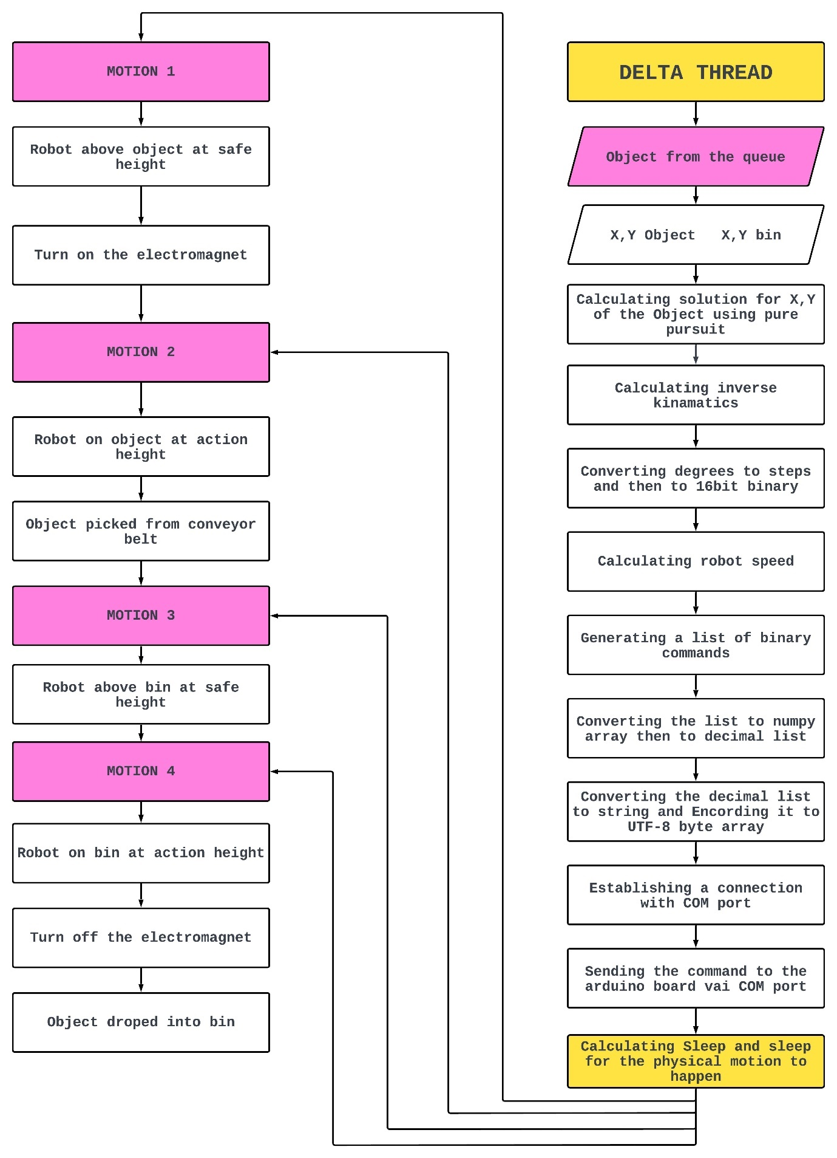

The delta thread takes the object from the object queue and then calculates the solution using a pure pursuit algorithm after that the inverse kinematics is calculated for the solution point and then the degrees +90,-90 are converted to 0-180 and then those angles are converted to steps for the motor ranging from 500-2500 steps, now those step values are converted to binary list and then to NumPy array then to decimal list and then to a string after that this string gets converted to a UTF-8 byte array, then a connection is established with the COM port, while calculating the speed and delay, then this byte array of command is send to the Arduino based servo controller which we have reverse engineered for our purpose of taking motor commands from the COM port and executing them.

# CODE

# Height of delta in between Pick and Drop

zSafe = -290#mm

# Height of delta when picking and droping

zAction = -328#mm

# Home height of delta

zRetract= -250#mm

# Queue to store the target objects

object_queue = []

# Conveyor speed for imaging

xSpeed = 71

ySpeed = 0

# Minimum range of motion for X axis

xMin = -100#mm

# Maximum range of motion for X axis

xMax = 100

# Minimum range of motion for Y axis

yMin = -100

# Maximum range of motion for Y axis

yMax = 100

# Location(coordinates) of the bins

bins = [[0,-150],[0,110],[-80,110]]

# To move the delta robot

def delta_thread(lock):

    #Testing Bounds for reference

    test_bounds()

    # Homing the Delta to homing Height

    test_ik(0,0,zRetract)

    # To convert degrees to steps (steps ranging from 500-2500)

    degreesToSteps()

    #To set the speed of the servo motor

    speedSet(80)

    # To set the Positions of the servo motor

    positionSet()

    currentX=0

    currentY=0

    currentZ=zSafe

    # Infinite loop

    while(1):

        # Delay

        time.sleep(0.1)

        # Loop while the length of the object queue is greater then 0

        while(length(lock)>0):

            # Infinite loop

            while(1):

                # To place the target object ahead

                xAhead=xSpeed*0.5

                yAhead=ySpeed*0.5

                obj = get(lock)

                targetX = obj[0]+xAhead

                targetY = obj[1]+yAhead

                # To check if target object is outside minimum x bounds

                if(targetX<xMin):

                    time.sleep(0.05) #Sleep

                    break # Break loop

                # To check Else if target object is outside maximum x bounds

                elif(targetX>xMax):

                    dequeue(lock) # Dequeue the object from the object queue

                    print("object out of bound")

                    break # Break the loop

                # Calculating the Euclidean distance from the robot to the

target object

                step = abs(distance(Point(currentX,currentY),

Point(targetX,targetY)))

                # Normalizing distance to speed

                speed = minMaxNormalize(step)

                # To find the solution using pure pursuit

                # Taking current coordinates of robot as current position and

point 1 as current position also

                # Taking full step to the target object

                midPoint = pursuit([currentX,currentY],

[currentX,currentY],[targetX,targetY],step)

                # Assigning the solution Coordinates

                motionX = midPoint[0]

                motionY = midPoint[1]

                # Updating the current position beforehand

                currentX=motionX

                currentY=motionY

                print(motionX,motionY)

                # Checking if the target object coordinates are withen the

bounds of the robot

                if(motionX>=xMin and motionX<=xMax and motionY>=yMin and

motionY<=yMax):

                    # To calculate the motor angles/degrees given target

object coordinates

                    test_ik(motionX,motionY,zSafe)

                    # Converting degrees to steps

                    degreesToSteps()

                    # Setting the servo motor's speed

                    speedSet(speed)

                    # Command to take the robot to the target object location

                    positionSet()

# Sleep, giving time for the physical motion of the robot

to happen

                time.sleep(minMaxDelay(speed))

                # Re calculating the distance between the robot and the object

                current_diff =

abs(distance(Point(motionX,motionY),Point(targetX,targetY)))

                # To check if there is any distance between the robot and the

object

                # If its less the or equal to 5mm

                if(current_diff<=5):

                    # To turn on the electtromagent

                    setElectroMagnet(1)

                    # Sleep

                    time.sleep(0.15)

                    # To calculate the motor angles/degrees given target

object coordinates

                    # Going down to pick the target object at Action height

                    test_ik(motionX,motionY,zAction)

                    # Converting degrees to steps

                    degreesToSteps()

                    # Setting the servo motor's speed

                    speedSet(100)

                    # Command to go down to pick the target object

                    positionSet()

                    # Sleep, giving time for the physical motion of the robot

to happen

                    time.sleep(0.2)

                    print("object picked at", currentX, currentY)

                    print("object position", targetX, targetY)

                    # To calculate the motor angles/degrees given target

object coordinates

                    # Going Up to the Safe height

                    test_ik(motionX,motionY,zSafe)

                    # Converting degrees to steps

                    degreesToSteps()

                    # Setting the servo motor's speed

                    speedSet(100)

                    # Command to go Up to the Safe height

                    positionSet()

                    # Sleep, giving time for the physical motion of the robot

to happen

                    time.sleep(0.2)

                    # To assign the bin lable of the object

                    lable = obj[2]

                    # To asign the bin coocrdinates

                    bin_cord = bins[lable]

                    #Calculating the Euclidean distance from the robot to the

target object BIN

                    step = distance(Point(currentX, currentY),

Point(bin_cord[0],bin_cord[1]))

                    # Normalizing distance to speed

                    sped = minMaxNormalize(step)

                    print("speed at the time of dropping",sped)

                    # To calculate the motor angles/degrees given target

object BIN coordinates

                    # Going to the target object BIN coordinates

                    test_ik(bin_cord[0],bin_cord[1],zSafe)

                    # Converting degrees to steps

                    degreesToSteps()

                    # Setting the servo motor's speed

                    speedSet(sped)

                    # Command to go to the target object BIN coordinates

                    positionSet()

                    # Sleep, giving time for the physical motion of the robot

to happen

                    time.sleep(minMaxDelay(sped))

                    # To calculate the motor angles/degrees given target

object BIN coordinates

                    # Going down to drop the target object into the BIN

                    test_ik(bin_cord[0],bin_cord[1],zAction)

                    # Converting degrees to steps

                    degreesToSteps()

                    # Setting the servo motor's speed

                    speedSet(100)

                    # Command to go down to drop the target object into the

BIN

                    positionSet()

                    # Sleep, giving time for the physical motion of the robot

to happen

                    time.sleep(0.2)

                    # Command to turn off the electromagnet

                    setElectroMagnet(0)

                    # To calculate the motor angles/degrees given target

object BIN coordinates

                    # Going up to the Safe height

                    test_ik(bin_cord[0],bin_cord[1],zSafe)

                    # Converting degrees to steps

                    degreesToSteps()

                    # Setting the servo motor's speed

                    speedSet(100)

                    # Command to go up to the safe height

                    positionSet()

                    # Sleep, giving time for the physical motion of the robot

to happen

                    time.sleep(0.2)

                    print("object dropped")

                    # Dequeue to target object from the target object queue

                    dequeue(lock)

                    # Breaking out of the loop

                    break

# CALCULATING SOLUTION USING PURE PURSUIT ALGORITHM

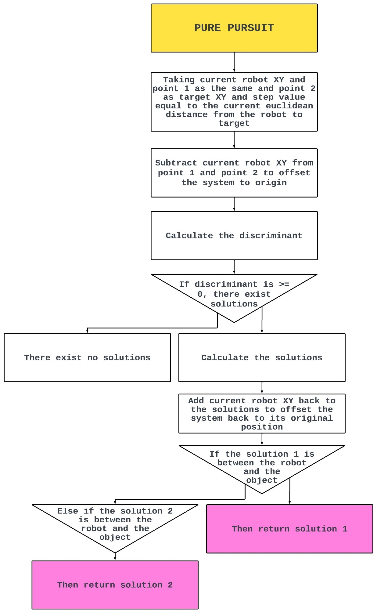

The pure pursuit algorithm takes current position of robot, point 1, point 2, and look ahead distance as arguments and then returns the solution point for the robot to pursue an object, in our case we have modified this algorithm so that it will take point 1 as the robot location also the current location as the robot location and the look ahead distance is set to the distance from the robot to the object, it then calculates the intersection point of the circle with the line from point 1 to point 2 with look ahead distance as the radius of that circle, after the intersection is found it returns that point as a solution.

# CODE

# Class to initialize x and y for the pursuite and distance functions

class Point:

  def __init__(self,x, y):

    self.x = x

    self.y = y

# To check if the cross product of (b-a) and (c-a) is 0, tells you if the points a, b and c are aligned.

# Then if you want to know if c is between a and b,

# You also have to check that the dot product of (b-a) and (c-a) is positive,

# And is less than the square of the distance between a and b.

# It returns true if c is between a and b

def isBetween(a, b, c):

    # To calculate cross product of (b-a) and (c-a)

    crossproduct = (c.y - a.y) * (b.x - a.x) - (c.x - a.x) * (b.y - a.y)

    # compare versus epsilon for floating point values, or != 0 if using

integers

    if abs(crossproduct) >0.00000001:

        return False

    # To calculate dot product of (b-a) and (c-a)

    dotproduct = (c.x - a.x) * (b.x - a.x) + (c.y - a.y)*(b.y - a.y)

    if dotproduct < 0:

        return False

    # To check if the dot product is less than the square of the distance

between a and b.

    squaredlengthba = (b.x - a.x)*(b.x - a.x) + (b.y - a.y)*(b.y - a.y)

    if dotproduct > squaredlengthba:

        return False

    # Return true

    return True

# To calculate the Euclidean distance between the two points

def distance(a,b):

    return math.sqrt((a.x - b.x)**2 + (a.y - b.y)**2)

# To return -1 if num is negative, 1 otherwise

def sgn (num):

    if num >= 0:

        return 1

    else:

        return -1

# currentPos: [currentX, currentY]

# pt1: [currentX, currentY]

# pt2: [Targetx, Targety]

# lookAheadDis: step value

def pursuit(currentPos, pt1, pt2, lookAheadDis):

    # extract currentX, currentY, x1, x2, y1, and y2 from input arrays

    currentX = currentPos[0]

    currentY = currentPos[1]

    x1 = pt1[0]

    y1 = pt1[1]

    x2 = pt2[0]

    y2 = pt2[1]

    # Assigning robot [currentX, currentY] to p1 and [Targetx, Targety] to p2

    p1 = Point(pt1[0],pt1[1])

    p2 = Point(pt2[0],pt2[1])

    # boolean variable to keep track of if intersections are found

    intersectFound = False

    # output (intersections found) should be stored in arrays sol1 and sol2

# if two solutions are the same, store the same values in both sol1 and

sol2

# subtract currentX and currentY from [x1, y1] and [x2, y2] to offset the

system to origin

    x1_offset = x1 - currentX

    y1_offset = y1 - currentY

    x2_offset = x2 - currentX

    y2_offset = y2 - currentY

    # calculate the discriminant

    dx = x2_offset - x1_offset

    dy = y2_offset - y1_offset

    dr = math.sqrt (dx**2 + dy**2)

    D = x1_offset*y2_offset - x2_offset*y1_offset

    discriminant = (lookAheadDis**2) * (dr**2) - D**2

    # if discriminant is >= 0, there exist solutions

    if discriminant >= 0:

        intersectFound = True

        # calculate the solutions

        sol_x1 = (D * dy + sgn(dy) * dx * np.sqrt(discriminant)) / dr**2

        sol_x2 = (D * dy - sgn(dy) * dx * np.sqrt(discriminant)) / dr**2

        sol_y1 = (- D * dx + abs(dy) * np.sqrt(discriminant)) / dr**2

        sol_y2 = (- D * dx - abs(dy) * np.sqrt(discriminant)) / dr**2

        # add currentX and currentY back to the solutions, offset the system

back to its original position

        sol1 = [sol_x1 + currentX, sol_y1 + currentY]

        sol1_pt = Point(sol1[0],sol1[1])

        sol2 = [sol_x2 + currentX, sol_y2 + currentY]

        sol2_pt = Point(sol2[0],sol2[1])

    # If the intersection is equal to false then No intersection Found

    if intersectFound == False :

        print ('No intersection Found!')

    # Else Solution found

    else:

        print ('Solution 1 found at [{}, {}]'.format(sol1[0], sol1[1]))

        print ('Solution 2 found at [{}, {}]'.format(sol2[0], sol2[1]))

        # To check if the solution 1 is between the robot and the object then

return solution 1

        if(isBetween(p1,p2,sol1_pt)):

            return(sol1)

        # To check Else if the solution 2 is between the robot and the object

then return solution 2

        elif(isBetween(p1,p2,sol2_pt)):

            return(sol2)

# CALCULATING INVERSE KINAMATICS

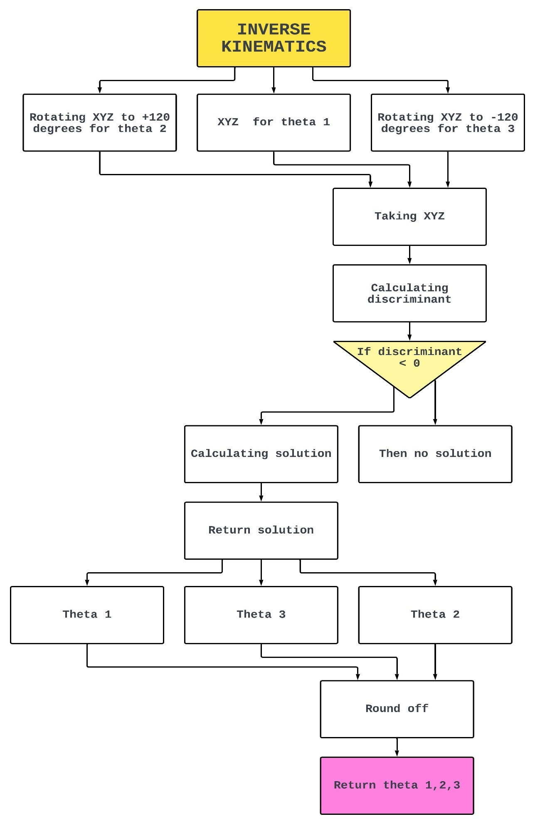

The inverse kinematics algorithm takes the XYZ coordinates as an argument and calculates the angles for the motors of the robot and then return it. It uses the robot geometry to calculate the motor angle for one motor by drawing two circles, circle with centre in point *F1* and radius *rf*. forming sphere with centre in point *E1* and radius *re*. Intersection of this sphere and YZ plane is a circle with centre in point *E'1* and radius *E'1J1*, where *E'1* is the projection of the point *E1* on YZ plane. The point J1 can be found now as intersection of two circles of known radius with centres in *E'1* and *F1* (we should choose only one intersection point with smaller Y-coordinate). And if we know *J1*, we can calculate*theta1* angle. The remaining angles *theta2* and *theta3*, we should use the symmetry of delta robot. First, let's rotate coordinate system in XY plane around Z-axis through angle of 120 degrees counter clockwise, as it is shown in fig 7. We've got a new reference frame X'Y'Z', and it this frame we can find angle *theta2* using the same algorithm that we used to find *theta1*. The only change is that we need to determine new coordinates *x'0* and *y'0* for the point *E0*, which can be easily done using corresponding [rotation matrix](http://en.wikipedia.org/wiki/Rotation_matrix). To find angle*theta3* we have to rotate reference frame clockwise.

# CODE

# Robot geometry

e = 40.0        #End Effector radius

f = 70.0        #Base radius

re = 322.0      #Forearm length

rf = 175.0      #Bicep length

btf = 400.0     #Base to floor distance

s = 1000        #Steps per turn

# inverse kinematics

# helper functions, calculates angle theta1 (for YZ-pane)

def delta_calcAngleYZ(x0, y0, z0, t):

    y1 = -0.5 * 0.57735 * f  # f/2 * tan(30 deg)

    y0 -= 0.5 * 0.57735 * e  # shift center to edge

    # z = a + b*y

    a = (x0*x0 + y0*y0 + z0*z0 + rf*rf - re*re - y1*y1)/(2.0*z0)

    b = (y1-y0)/z0

    # discriminant

    d = -(a+b*y1)*(a+b*y1)+rf*(b*b*rf+rf)

    if d < 0:

        return [1, 0]  # non-existing povar. return error, theta

    yj = (y1 - a*b - math.sqrt(d))/(b*b + 1)  # choosing outer povar

    zj = a + b*yj

    theta = math.atan(-zj/(y1 - yj))*180.0/math.pi+(180.0 if(yj>y1) else 0.0)

    return [0, theta]  # return error, theta

# inverse kinematics: (x0, y0, z0) -> (theta1, theta2, theta3)

# returned {error code, theta1,theta2,theta3}

# Returns +ve angles for upward motion of the arm

# Returns -ve angles for downward motion of the arm

def delta_calcInverse(x0, y0, z0):

    theta1 = 0

    theta2 = 0

    theta3 = 0

    t=0

    status = delta_calcAngleYZ(x0, y0, z0, t)

    if status[0] == 0:

        theta1 = status[1]

        status = delta_calcAngleYZ(x0*cos120 + y0*sin120, y0*cos120-x0*sin120, z0, theta2)  # rotate coords to +120 deg

    if status[0] == 0:

        theta2 = status[1]

        status = delta_calcAngleYZ(x0*cos120 - y0*sin120, y0*cos120+x0*sin120, z0, theta3)  # rotate coords to -120 deg

    theta3 = status[1]

    return [status[0], theta1, theta2, theta3]

# To round off the value

def roundoff(x, y):

    z = math.pow(10, y)

    if y == 0:

          y = 3

    return round(x * z) / z

# To get the theta1,theta2,theta3 given X,Y,Z coordinates

def test_ik(a,b,c):

    # Taking Y coordinate

    x = float(a)

    # Taking Y coordinate

    y = float(b)

    # Taking Z coordinate

    z = float(c)

    # Call to get the theta1,theta2,theta3 given X,Y,Z coordinates

    results2 = delta_calcInverse(x, y, z)

    global theta1_glb

    global theta2_glb

    global theta3_glb

    # Rounding off the result

    theta1_glb = roundoff(results2[1], 3)

    theta2_glb = roundoff(results2[2], 3)

    theta3_glb = roundoff(results2[3], 3)

    # Theta 1, Theta 2, Theta 3

    print("Motor 1 degrees:" + str(theta1_glb))

    print("Motor 2 degrees:" + str(theta2_glb))

    print("Motor 3 degrees:" + str(theta3_glb))

# CONVERTING DEGREES TO STEPS

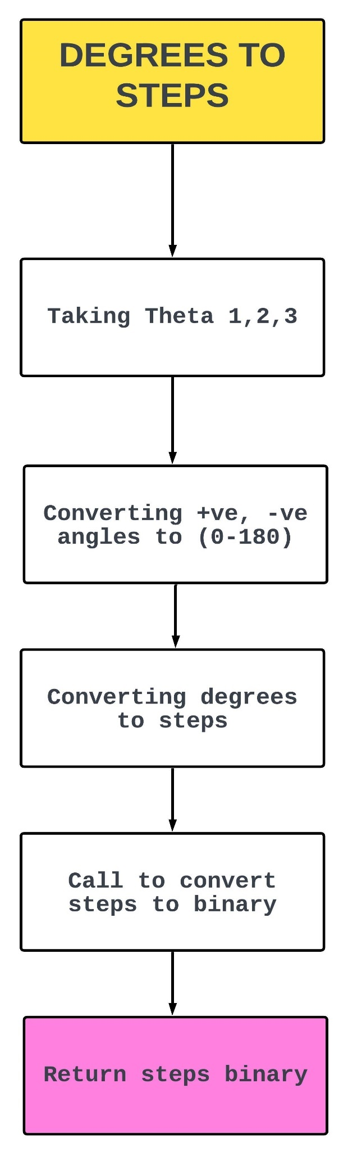

The algorithm takes the degrees from the inverse kinematics algorithm and then converts them to 0-180 degrees as the inverse kinematics algorithm returns the degrees as +90, -90 degrees and then maps 0-180 degrees to 500-2500 steps for the motors, it then converts them to binary by calling another algorithm and returns binary step values.

# CODE

# To convert +ve,-ve angles to (0-180)

# To convert degrees to steps (steps ranging from 500-2500)

# Total steps 2000

def degreesToSteps():

    global theta1_glb

    global theta2_glb

    global theta3_glb

    global binary1_glb

    global binary2_glb

    global binary3_glb

    # converting +ve,-ve angles to (0-180)

    theta1_glb=180-(theta1_glb+90)

    theta2_glb=180-(theta2_glb+90)

    theta3_glb=180-(theta3_glb+90)

    # Theta 1, Theta 2, Theta 3

    print("Motor 1 degrees:" + str(theta1_glb))

    print("Motor 2 degrees:" + str(theta2_glb))

    print("Motor 3 degrees:" + str(theta3_glb))

    # Doing some angle corrections of 1st and 2nd arms to put them at 90

degree

    theta1_glb = theta1_glb-4

    theta2_glb = theta2_glb+2

    # converting degrees to steps

    step1 = (2000/180)*theta1_glb+500

    step2 = (2000/180)*theta2_glb+500

    step3 = (2000/180)*theta3_glb+500

    # Step value 1, Step value 2, Step value 3

    print("Motor 1 Steps:" + str(step1))

    print("Motor 2 Steps:" + str(step2))

    print("Motor 3 Steps:" + str(step3))

    # Call to convert step values to binary

    binary1_glb = stepsToBinary(step1)

    binary2_glb = stepsToBinary(step2)

    binary3_glb = stepsToBinary(step3)

# CONVERTING STEPS TO BINARY

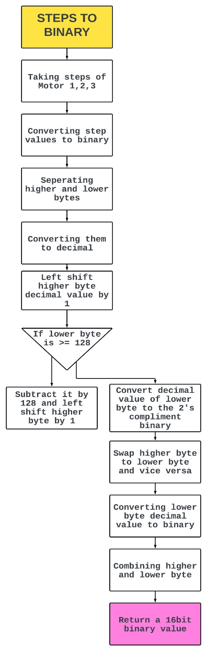

The algorithm takes step values and convert them to binary values, then separating higher and lower bytes, and converting them to decimal after that it takes the higher byte and left shifts it by 1, if lower byte is >= to 128, it subtracts it by 128 and left shift higher byte by 1, now converting the decimal values of lower byte to the 2’s compliment binary value, swap higher byte to lower byte and vice versa, converting lower byte decimal to binary, now combining both bytes and returning a 16 bit binary step value, this had to be done in order to match the commands that the servo controller takes.

# CODE

# To convert step values to binary

# Reterns 16bit values

def stepsToBinary(s):

    # Converting a step value to 16bit binary

    positive_binary = '{0:016b}'.format(int(s))

    # Taking higher and lower 8 bits into variables

    hb= positive_binary[0:8]

    lb= positive_binary[8:16]

    # To convert 8bit binary to decimal

    def binaryToDecimal(binary):

        decimal, i = 0, 0

        while(binary != 0):

            dec = binary % 10

            decimal = decimal + dec * pow(2, i)

            binary = binary//10

            i += 1

        return(decimal)

    # Assigning decimal values of higher and lower bytes into variables

    hib = binaryToDecimal(int(hb))

    lib = binaryToDecimal(int(lb))

    # Left shift decimal value of higher byte by 1

    hib = hib <<1

    # If lower byte is greater then or equal to 128 we subtract it by 128 and

left shift higher byte by 1

    if (lib>=128):

        lib = lib-128

        hib = (1<<1)-1 | hib

    # To convert decimal value of lower byte to the 2's compliment binary

value

    def to_twoscomplement(bits, value):

        if value < 0:

            value = ( 1<<bits ) + value

        formatstring = '{:0%ib}' % bits

        return formatstring.format(value)

    # Assigning 2's compliment binary value of lower byte to the variable

    lib= to_twoscomplement(8,lib)

    # Swap higher byte to lower byte and vice versa

    temp = lib

    lib=hib

    hib=temp

    # Converting lower byte decimal value to binary(earlier it was higher byte

decimal value befor swap)

    #hib = '{0:08b}'.format(hib)

    lib = '{0:08b}'.format(lib)

    print(positive_binary)

    # Combining higher and lower byte to create a 16bit binary value and

return it

    binary = hib+lib

    return(binary)

# ESTABLISH CONNECTION VIA COMPORT

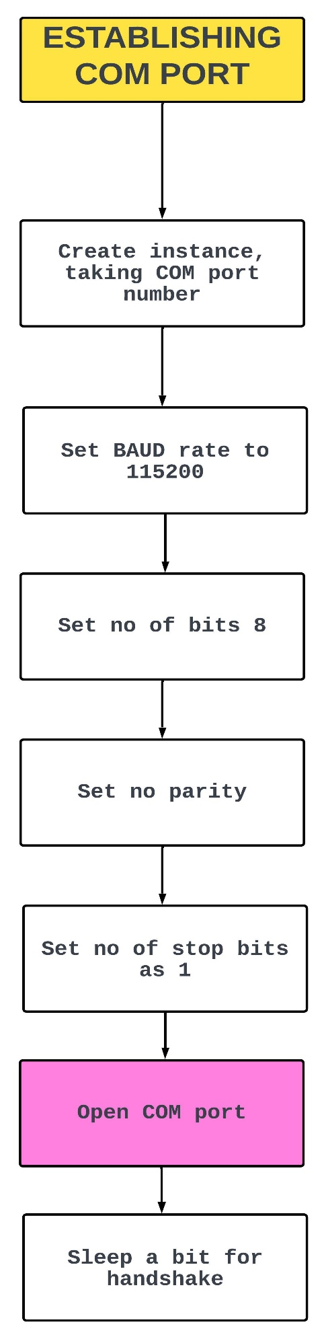

The algorithm takes COM port number and BAUD rate, byte size, parity and stop bits as argument and establishes a connection with the Arduino based servo controller.

# CODE

import time

import serial

#Creating an instance of serial, passing the COM port number as an argument

ser = serial.Serial("COM3")

# set Baud rate to 115200

ser.baudrate = 115200

# Number of data bits = 8

ser.bytesize = 8

# No parity

ser.parity   ='N'

# Number of Stop bits = 1

ser.stopbits = 1

#Open COM port

ser.open

#Delay time for handshake

time.sleep(3)

# GENRATING ROBOT MOTOR COMMANDS AND SET IT VIA COM PORT

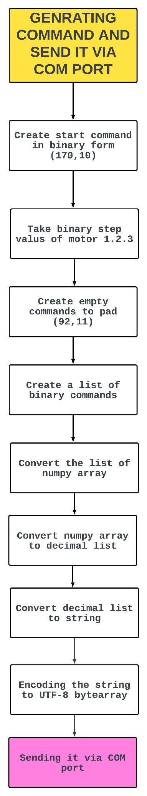

The algorithm generates the binary command to set the state of controller board to take the type of command and then sets the type to set servo position, this start command is appended with the motor step commands for the three motors and the generates an empty command to append them to the command, in whole generating 38 bytes of command and sending them over to the servo controller board via COM port.

# CODE

# To generate the binary command of 38 Bytes and send it over COM port to the Arduino

# First 2 Bytes as start command

# Rest of 36 Bytes for 18 servo motors, each motor receiving a command of 2 Bytes

def positionSet():

    # Command to put the Arduino into the state in which we can select as to

which operation we want to perform (170)

    # Command to put it in State Servo Position mode (10)

    #             170         10

    startcmd = "10101010"+"00001010"

    # Empty command as pading

    #             92         11

    emptycmd = "01011100"+"00001011"

    # List of start command and commands for motors

    list = [startcmd[0:8],startcmd[8:16],binary1_glb[0:8],binary1_glb[8:16],binary2_glb[0:8],binary2_glb[8:16],binary3_glb[0:8],binary3_glb[8:16],binary1_glb[0:8],binary1_glb[8:16],binary2_glb[0:8],binary2_glb[8:16],binary3_glb[0:8],binary3_glb[8:16],binary1_glb[0:8],binary1_glb[8:16],binary2_glb[0:8],binary2_glb[8:16],binary3_glb[0:8],binary3_glb[8:16]]

    # Padding the command list with empty commands to make 38 Bytes in total

    i=20

    while(i<38):

        list.insert(i,emptycmd[0:8])

        i = i+1

        list.insert(i,emptycmd[8:16])

        i = i+1

    # Creating a numpy array of the binary command list

    arr = np.array(list)

    # converting the binary values in numpy array to the decimal list

    decimal = [0]*38

    for i in range(38):

        decimal[i]= int(arr[i],2)

    # Converting the decimal list to a string

    st= ""

    for i in range(38):

        st += chr(decimal[i])

    print(st)

    # Converting deicmal list to Hex and printing it for reference

    my_hex = ''.join(f'{i:02x}' for i in decimal)

    print(my_hex)

    # Converting the string command to byte array while encoding it in UTF-8

    cmd= bytearray(st,'utf-8')

    # Sending the command to the Arduino via COM port

    comPort.ser.write(cmd[1:39])

# CHANGING ROBOT MOTOR SPEED

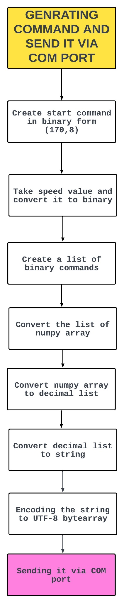

The algorithm takes the speed value and then generates the binary command to set the state of controller board to take the type of command and then sets the type to set servo speed, this start command is appended with the motor speed command for all the motors in whole generating 3 bytes of command and sending them over to the servo controller board via COM port.

# CODE

# To set the speed of the servo motors

# Taking speed value as input and generating the speed command and send it via COM port to Arduino

def speedSet(s):

    # Command to put the Arduino into the state in which we can select as to

which operation we want to perform (170)

    # Command to put it in State Speed mode (8)

    #             170         8

    startCmd = "10101010"+"00001000"

    # Converting the speed value to binary

    binary = '{0:08b}'.format(int(s))

    # Genrating a list of binary commands

    cm = [startCmd[0:8],startCmd[8:16],binary]

    # Converting the list to a numpy array

    arr1 = np.array(cm)

    # Initializing the list

    dec = [0]*3

    st1=""

    # Converting the Binary values in numpy array to the decimal list

    for i in range(3):

        dec[i]= int(arr1[i],2)

    # Converting the decimal list to a string

    st1= ""

    for i in range(3):

        st1 += chr(dec[i])

    print(st1)

    # Converting decimal list to Hex and printing it for reference

    hex = ''.join(f'{i:02x}' for i in dec)

    print(hex)

    # Converting the string command to byte array while encoding it in UTF-8

    speedCmd= bytearray(st1,'utf-8')

    # Sending the command to the Arduino via COM port

    comPort.ser.write(speedCmd[1:4])

# ACTIVATE/DEACTIVATE THE ELECTROMAGNET

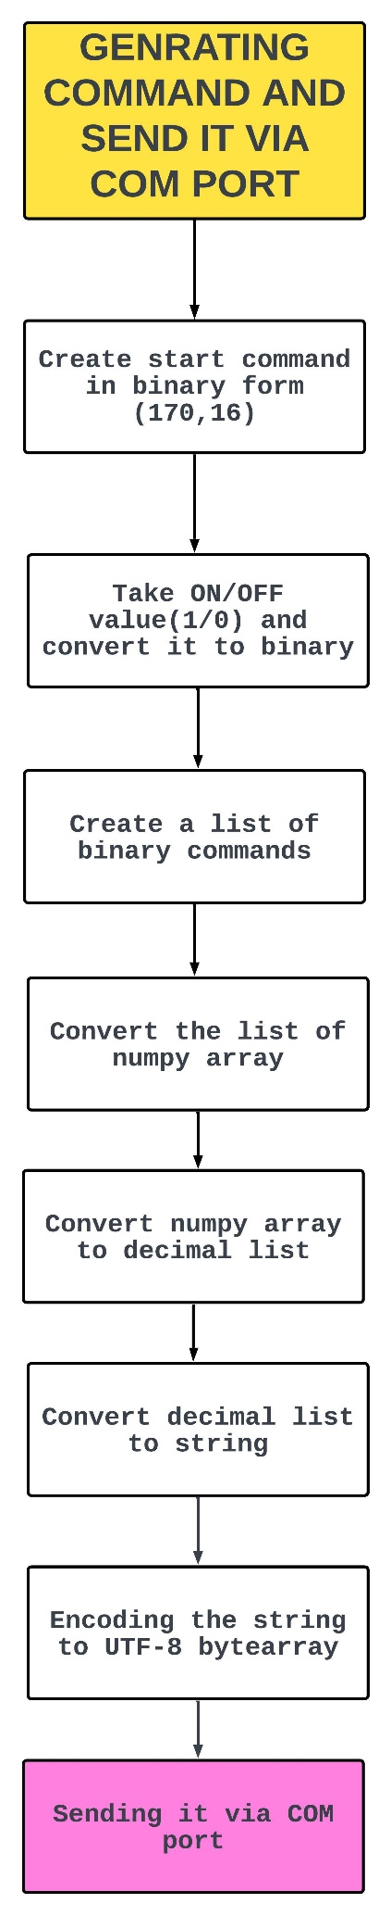

The algorithm takes the ON/OFF value and then generates the binary command to set the state of controller board to take the type of command and then sets the type to set electromagnet, this start command is appended with the electromagnet command, in whole generating 3 bytes of command and sending them over to the servo controller board via COM port.

# CODE

# To Activate/Deactivate the Electromagnet

# Taking 0/1 as input and generating the Activation/Deactivation command and send it via COM port to Arduino

def setElectroMagnet(state):

    # Command to put the Arduino into the state in which we can select as to

which operation we want to perform (170)

    # Command to put it in Electromagnet set mode (16)

    #             170         16

    startCmd = "10101010" + "00010000"

    # Converting state value to binary

    binary = '{0:08b}'.format(int(state))

    # Genrating a list of binary commands

    cm = [startCmd[0:8], startCmd[8:16], binary]

    # Converting the list to a numpy array

    arr1 = np.array(cm)

    # Initializing the list

    dec = [0] * 3

    st1 = ""

    # Converting the Binary values in numpy array to the decimal list

    for i in range(3):

        dec[i] = int(arr1[i], 2)

    # Converting the decimal list to a string

    st1 = ""

    for i in range(3):

        st1 += chr(dec[i])

    print(st1)

    # Converting deicmal list to Hex and printing it for reference

    hex = ''.join(f'{i:02x}' for i in dec)

    print(hex)

    # Converting the string command to byte array while encoding it in UTF-8

    electroMagnetCmd = bytearray(st1, 'utf-8')

    # Sending the command to the Arduino via COM port

    comPort.ser.write(electroMagnetCmd[1:4])

# SET CONVEYOR SPEED AND ON/OFF

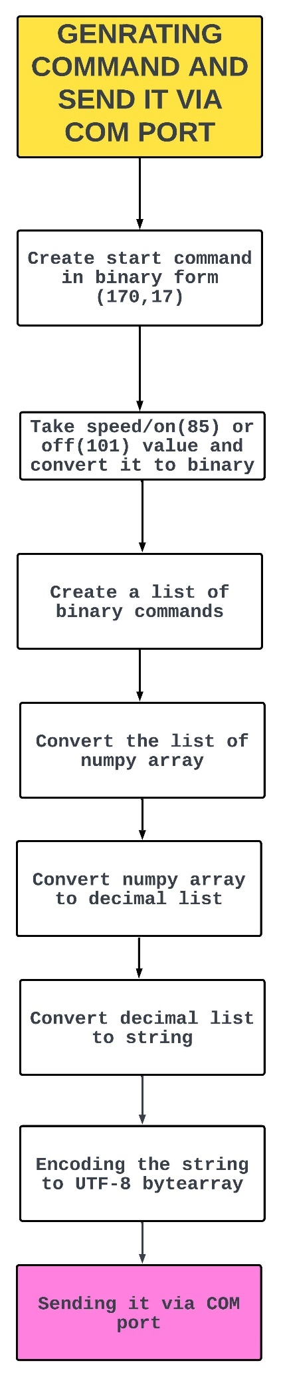

The algorithm takes the speed (0-100) or off (101) value and then generates the binary command to set the state of controller board to take the type of command and then sets the type to set stepper speed, this start command is appended with the stepper motor speed or off command in whole generating 3 bytes of command and sending them over to the servo controller board via COM port.

# CODE

# To set the speed of the Stepper motor(Conveyor belt)

# Taking speed value as input and generating the speed command and send it via COM port to Arduino

def setStepperSpeed(s):

    # Command to put the Arduino into the state in which we can select as to

which operation we want to perform (170)

    # Command to put it in State Speed mode (17)

    #             170         17

    startCmd = "10101010" + "00010001"

    # Converting the speed value to binary

    binary_1 = '{0:08b}'.format(int(s))

    # Genrating a list of binary commands

    cm = [startCmd[0:8], startCmd[8:16], binary_1]

    # Converting the list to a numpy array

    arr1 = np.array(cm)

    # Initializing the list

    dec = [0] * 3

    st1 = ""

    # Converting the Binary values in numpy array to the decimal list

    for i in range(3):

        dec[i] = int(arr1[i], 2)

    # Converting the decimal list to a string

    st1 = ""

    for i in range(3):

        st1 += chr(dec[i])

    print(st1)

    # Converting deicmal list to Hex and printing it for reference

    hex = ''.join(f'{i:02x}' for i in dec)

    print("stepper")

    print(hex)

    # Converting the string command to byte array while encoding it in UTF-8

    setStepperSpeedCmd = bytearray(st1, 'utf-8')

    # Sending the command to the Arduino via COM port

    comPort.ser.write(setStepperSpeedCmd[1:4])

NOTE: - Speed values 85 works best

# NORMALIZING STEP SIZE TO ROBOT SPEED

The algorithm takes the step value and normalises it to the speed and returns the speed for the robot to move faster or slower proportional to the step value, longer the step higher the speed.

# CODE

# To normalize step size of 0-180mm(distance to be travelled) with the speed of 90-100 and return it

# Bigger the distance greater the speed

def minMaxNormalize(s):

    speed = s/180*(10)+90

    return(speed)

# NORMALIZING ROBOT SPEED TO DELAY

The algorithm takes the speed value and normalises it to the sleep and returns the sleep value for the delta thread to sleep, higher the speed greater the sleep time for the thread in order to give time for the physical motion to happen.

# CODE

# To normalize speed of 90-100 with the delay of 0.01-0.31 and return it

# Greater the speed higher the delay time

def minMaxDelay(s):

    val = 0.01+(0.03)*(s-90)

    return val

# ARDUINO METHODOLOGY

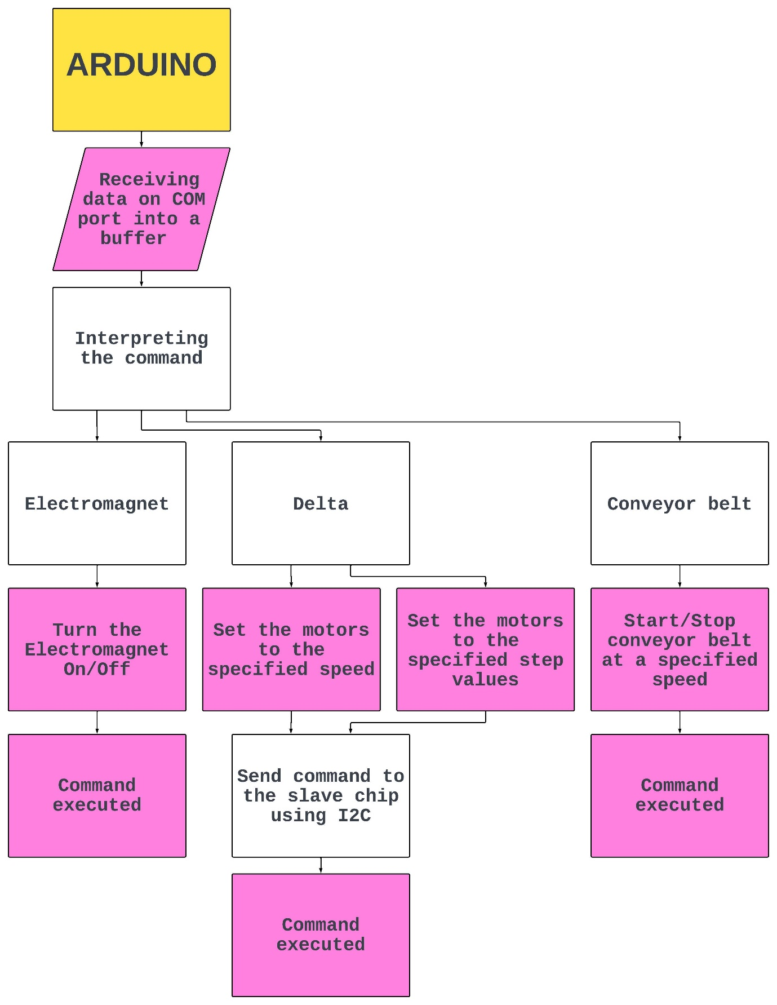

The Arduino board that we have used is UNO and it is integrated into a servo motor controller.

We had to reverse engineer its working so when we send the command from our python code it will interpret them and execute them accordingly. It uses I2C protocol to communicate to a slave chip which is also an ATmega328P which have been programmed by the company and is actually controlling the servos, the code that runs on the master chip is known and we have modified it as per our needs. We first have to set the master chip into the command state in which it takes the type of command that we want it to perform then it takes the values for that command and then send it to the slave chip after doing some necessity calculation then the slave chip executes the command.

# RECEIVING AND INTERPRETING THE COMMAND

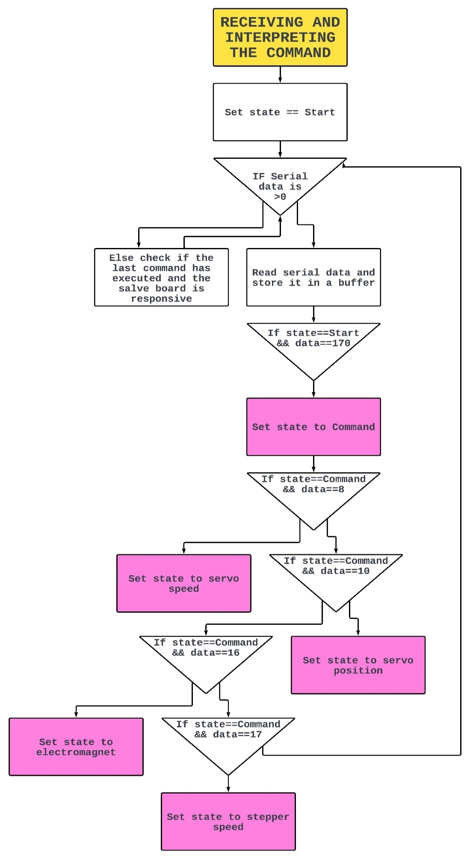

The algorithm takes the type of command and sets the board to that type to perform the type of action that has been specified using an if else ladder or else it will check if the previous command has been executed by the slave chip by checking if its responsive or not and it also toggles the led.

# CODE

//Defining Macros for different functions

#define State_Start  0

#define State_Command  1

#define State_Servoposition  2

#define State_Speed  3

#define electroMagnet_set 10

#define stepper_speed_set 11

//TO receive the commands from the COM port and execute them accordingly

void PCControlledCode(void)

{

  //Returns the number of milliseconds passed since the Arduino board began

running the current program

    currentMillis = millis();

  //To check if any data is available on the COM port(Serial port)

  //Using IF-ELSE ladder to determine State

    if(Serial.available()>0)

    {

    //Reading the data from the COM port and assigning it to c

        c=Serial.read();

    //Assigning the current time elapsed to pervious time elapsed

        previousMillis = currentMillis;

    //To check if the state is equal to State_start(0)

        if(state==State_Start)

        {

      //To check if the data read from the COM port is equal to 170

            if(c==170)

                state=State_Command;  //Changing the State to

State_command

        }

    //To check if the state is equal to State_servoPosition (set servo

position)

        else if(state==State_Servoposition)

        {

      //Saving the data command from the COM port into a buffer array

            servobuf[bytecnt]=c;

      //incrimenting the index

            bytecnt++;

//To check if the index has reached 36

            if(bytecnt==36)

            {

        //Ittrating through the commands (int values) for 18 Servo

motors

                for(int i=1;i<19;i++)

                {

                  //Accessing index starting from 1 and then 3 and so on

skipping 1 position

          //Accessing Lower Byte

          //Left shifting by 7 that value and assigning it to

servoval

                    servoval=servobuf[(i*2)-1]<<7;

          //Accessing index starting from 0 and then 2 and so on

skipping 1 position

          //Accessing Higher Byte

          //Adding that value to the lower byte and assigning it to

servoval

          //It is the step value command for the current ith

servo(i=servo No)

                    servoval=servoval+servobuf[(i*2)-2];

          //To Set the specified servo to the specified step value

                    I2C_SERVOSET(i,servoval);

                }

        //Reseting the index back to 0

                bytecnt=0;

        //Changing the state baack to state_start

                state=State_Start;

        //write "r" on the COM port

                Serial.write('r');

        //To check if the last command has executed and the salve

board is responsive

                CheckEndMovement();

        //Assigning the current time elapsed to perivious time elapsed

                previousMillis = currentMillis;

            }

        }

    //To check if the state is equal to State_Speed (set servo

speed)

        else if(state==State_Speed)

        {

          //To Set the specified speed value for the servos received from

the COM port

            I2C_SERVOSPEED(c);

      //Changing the state baack to state_start

            state=State_Start;

      //write "rs" on the COM port

            Serial.write("rs");

//To check if the last command has executed and the salve board is

responsive

            CheckEndMovement();

        }

    //To check if the state is equal to electroMagnet_set(set the

electromagnet ON/OFF)

    else if(state==electroMagnet_set)

        {

      //TO set the electromagnet to the specified ON/OFF command

            electroMagnet(c);

      //Changing the state baack to state_start

      state=State_Start;

      //write "k" on the COM port

      Serial.write('k');

      //To check if the last command has executed and the salve board

is responsive

      CheckEndMovement();

        }

    //To check if the state is equal to stepper_speed_set(set the Stepper

motor/Conveyor speed)

    else if(state==stepper_speed_set)

    {

      //TO set the Stepper motor/Conveyor to the specified speed

command

      stepperSpeed(c);

      //Changing the state back to state_start

      state=State_Start;

      //write "k" on the COM port

      Serial.write('k');

//To check if the last command has executed and the salve board is responsive

      CheckEndMovement();

    }

    //To check if the state is equal to State_Command(to set the state to

the specified state command from the COM port)

        else if(state==State_Command)

        {

        //To check if the state command from the COM port is equal to 8

        if(c==8)

        state=State_Speed;

//To check if the state command from the COM port is equal to

10

        if(c==10)

        state=State_Servoposition;

        //To check if the state command from the COM port is equal to

16

        if(c==16)

        state=electroMagnet_set;

        //To check if the state command from the COM port is equal to

17

        if(c==17)

        state=stepper_speed_set;

        //Reseting the index back to 0

        bytecnt=0;

        }

    //Else

        else

        {

      //write "e" on the COM port

            Serial.write('e');

      //To check if the last command has executed and the salve board i

responsive

            CheckEndMovement();

        }

    }

//Else check elapsed time

    else

    {

      //To check if the elapsed time is equal to 100miliseconds

        if ((unsigned long)(currentMillis - previousMillis) >= interval)

        {

      //write "i" on the COM port

            Serial.write('i');

      //write "i" on the COM port

            Serial.write('r');

      //To check if the last command has executed and the salve board is

responsive

            CheckEndMovement();

      //Assigning the current time elapsed to perivious time elapsed

            previousMillis = currentMillis;

        }

    }

}

//To check if the last command has executed and the salve board i responsive

void CheckEndMovement(void)

{

  //To check if the slave board has executed the last command and is

responsive

    if(I2C_SERVOEND())

        Serial.write('X');//Writing 'X' to the COM port

  //Else

    else

        Serial.write('G');//Writing 'G' to the COM port

  //To toggle the LED

    LEDToggle();

}

//To toggle the LED on the board

void LEDToggle(void)

{

  //To check if the LED state is 0

    if (LEDState == 0)

        LEDState = 1;//Making it 1

  //Else making it 0

    else

        LEDState = 0;

  //TO make the LED pin HIGH/LOW(Pin 13)

    digitalWrite(LED, LEDState);

}

# TO SET SERVO SPEED

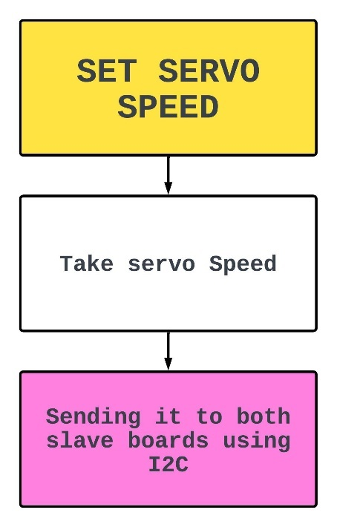

The algorithm takes the servo speed value and after doing some necessary calculation it sends it to the slave chip via I2C for execution.

# CODE

//To Set the specified speed value for the servos received from the COM port

void I2C_SERVOSPEED(unsigned char value)

{

  //To select slave board 1

  //Starting the transmission to using I2C wire library, sending (8)

    Wire.beginTransmission(servo1);

  //Transmitting to board 1, sending (36)

    Wire.write(18*2);

  //Transmitting to board 1, sending speed value (0-100)

    Wire.write(value);

  //Transmitting to board 1, sending (0)

    Wire.write(0);

  //Ending transmission to board 1

    Wire.endTransmission();

  //To select slave board 2

  //Starting the transmission to using I2C wire library, sending (9)

    Wire.beginTransmission(servo2);

  //Transmitting to board 2, sending (36)

    Wire.write(18*2);

  //Transmitting to board 2, sending speed value (0-100)

    Wire.write(value);

  //Transmitting to board 1, sending (0)

    Wire.write(0);

  //Ending transmission to board 2

    Wire.endTransmission();

  //Delay

    delay(20);

}

# TO SET SERVO/ROBOT POSITION

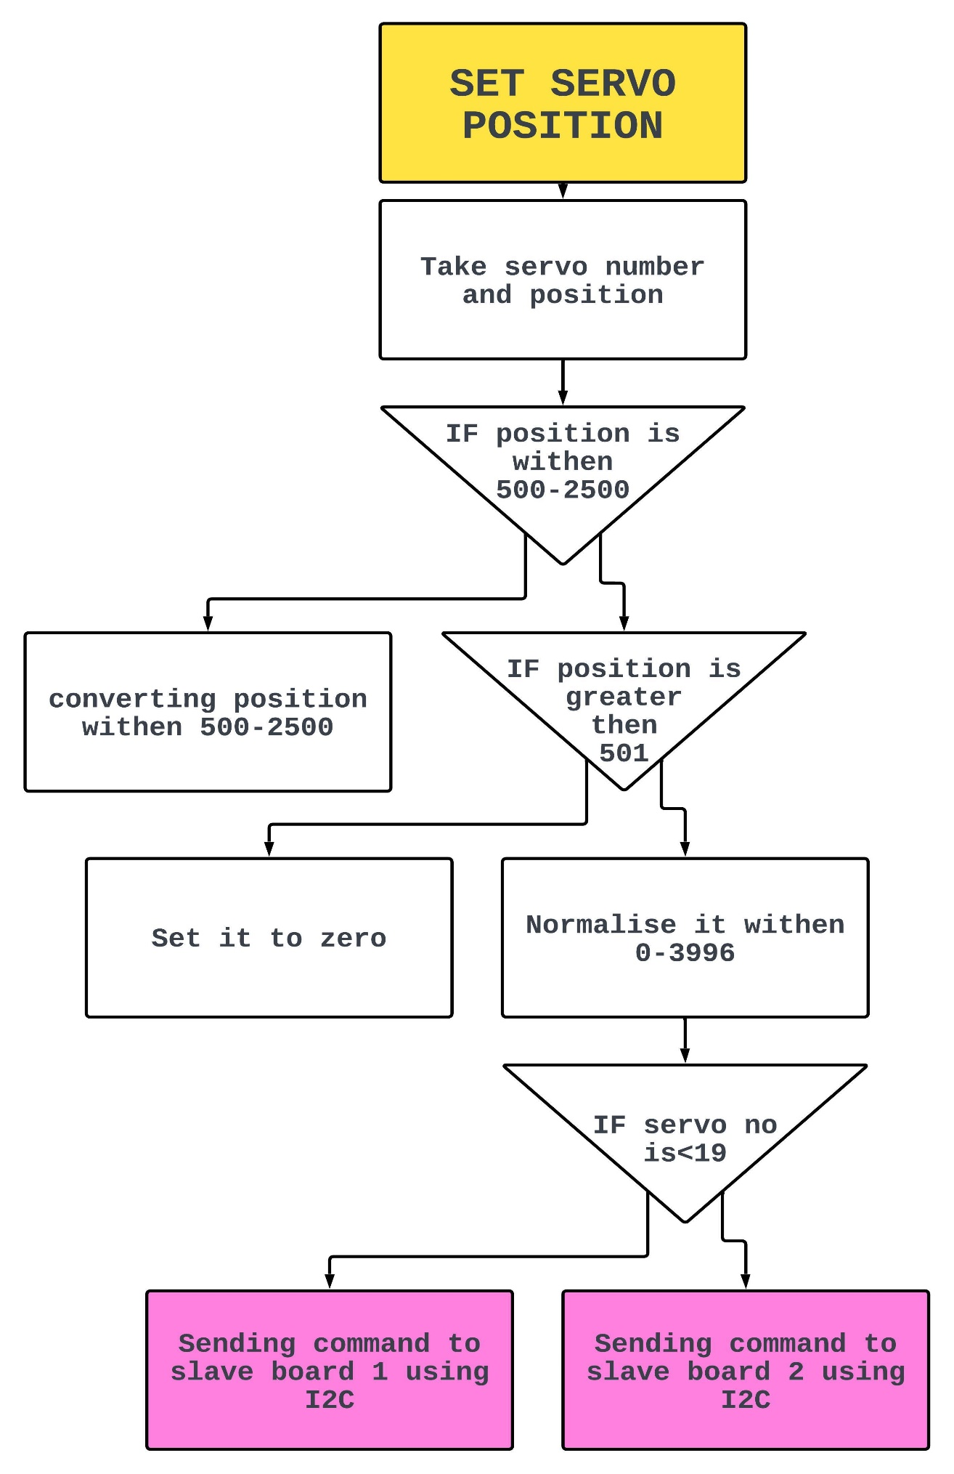

The algorithm takes the servo position value and after doing some necessary calculation it sends it to the slave chip via I2C for execution.

# CODE

//To set the specified servo to the specified step value

void I2C_SERVOSET(unsigned char servo_num,unsigned int servo_pos)

{

  //To check if the step value is less then 500

    if(servo_pos<500)

        servo_pos = 500; //Making it 500

  //To check if the step value is greater then 2500

    else if(servo_pos>2500)

        servo_pos=2500; //Making it 2500

  //To check if the step value is less then 501

    if(servo_pos>501)

        servo_pos=(((servo_pos-2)*2)-1000);//Normalising 500-2500 to 0-3996

    else

        servo_pos=0;//Making it zero

  //To check if the servo number is samller then 19

  //To select slave board 1

    if(servo_num<19)

        Wire.beginTransmission(servo1);//Starting the transmission to using

I2C wire library, sending (8)

  //Else select slave board 2

    else

        Wire.beginTransmission(servo2);//Starting the transmission to using

I2C wire library, sending (9)

  //Writing servo number to I2C

    Wire.write(servo_num-1);

    //Transmitting to board 1, sending servo step position value with left

shift by 8

    Wire.write(servo_pos>>8);

    //Transmitting to board 1, sending servo step position value that is

bitwise and with 0xFF to send one byte

    Wire.write(servo_pos & 0XFF);

    //Ending transmission to board 1

    Wire.endTransmission();

}

# TURN THE ELECTROMAGNET ON/OFF

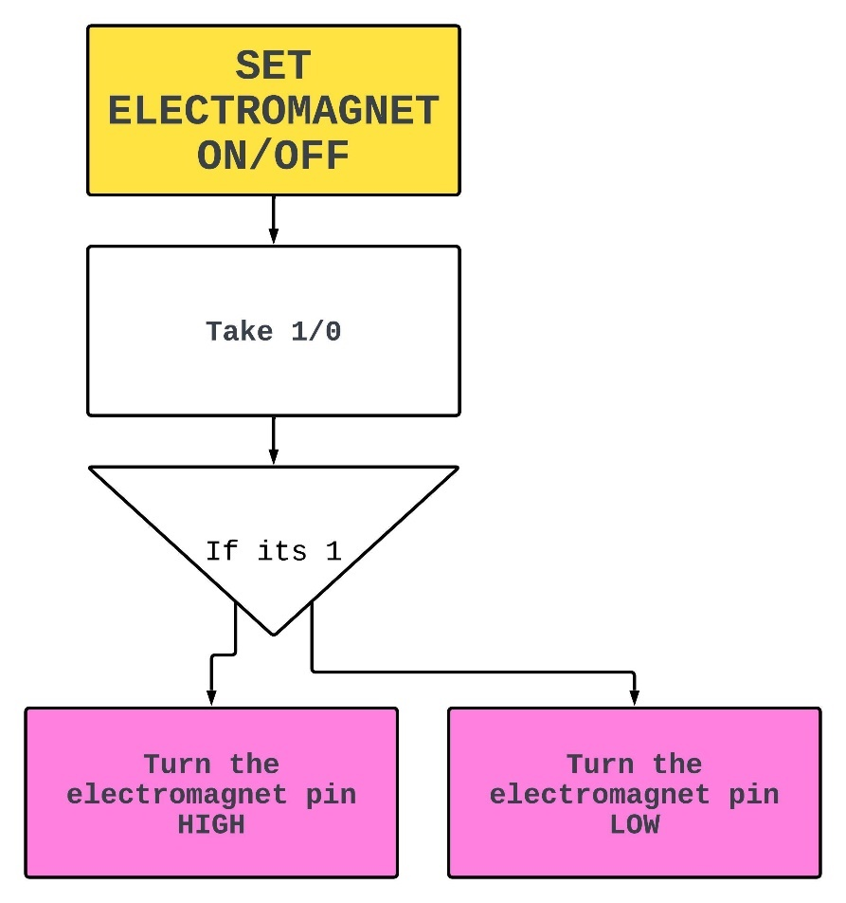

The algorithm takes the ON/OFF value and if its 1 it will turn on the electromagnet else it will turn off the electromagnet.

# CODE

//To Set electromagnet ON/OFF

void electroMagnet(int var)

{

  //To check if the var is equal to  1

  if(var==1)

  {

    //To set the pin 7 HIGH(to turn on the relay)

    digitalWrite(7,HIGH);

  }

  //To check if the var is equal to  0

  else if(var==0)

  {

    //To set the pin 7 LOW(to turn off the relay)

    digitalWrite(7,LOW);

  }

}

# SET THE CONVEYOR SPEED

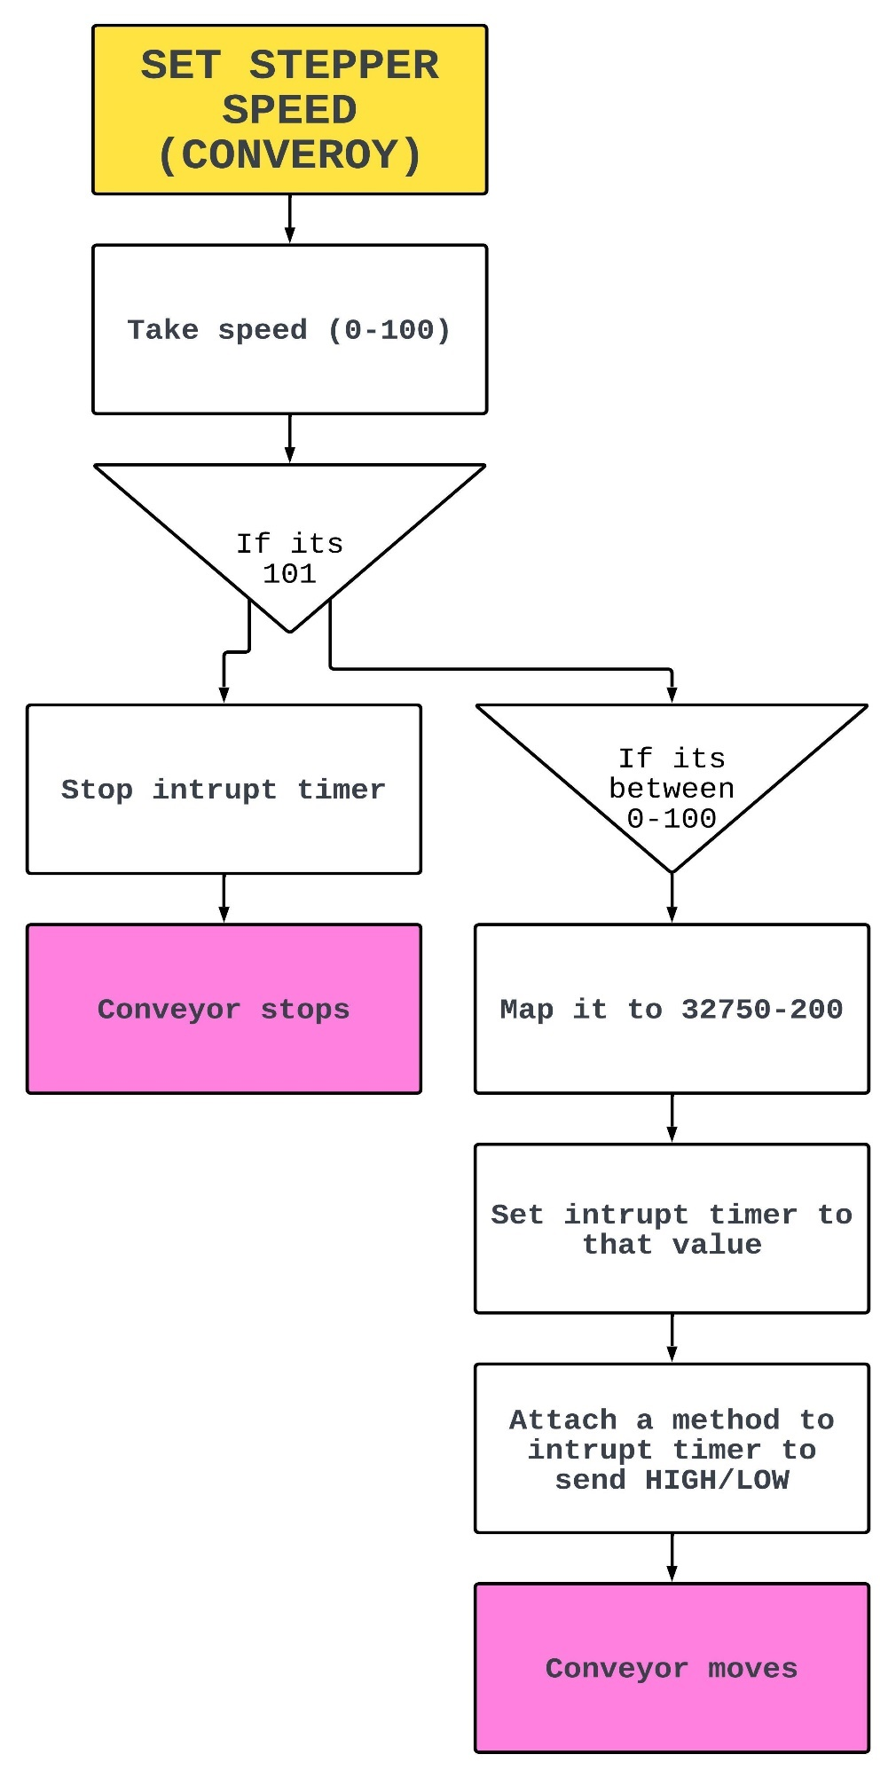

The algorithm takes the stepper speed value and if it’s between (0-100) it will map it to (32750-200) and set the interrupt timer to that value which in turn calls a function to generate HIGH /LOW to generate a frequency for the stepper pin, else if its (101) it will stop the interrupt timer and the conveyor stops.

# CODE

//To set the speed of the stepper motor (conveyor)

void stepperSpeed(int speed)

{

  //To check if the speed value is 101

  if(speed==101)

  {

    //To pass (0) to the timer function, to stop the interrupt timer

    timer(0);

  }

  //To check if the value less then or equal to 100

  if(speed<=100)

  {

    //To map (0-100) to (32750-200)

    //32750 being the lowest speed(interrupt timer delay)

    //200  being the highest speed(interrupt timer delay)

    delayInMicroSeconds=map(speed,0,100,32750,200);

    //To call the timer function and pass the interrupt timer delay

    timer(delayInMicroSeconds);

  }

}

//To generate a frequency which will drive the stepper motor

//Using TimerOne library to use the internal clock of the Arduino

//An interrupt will be generated after the specified amount of milliseconds

//The interrupt will call the function stepper which generates a HIGH/LOW signal

void timer(int t)

{

  //To check if the time is equal to 0

  if(t==0)

  {

    Timer1.stop();//Stop the timer

  }

  //To check if the timer is between 200-32750

  if(t>=200 && t<=32750)

  {

    Timer1.initialize(t);//Initialize timer

    Timer1.attachInterrupt(stepper);//Attach it to a function

  }

}

//To genrate ON/OFF for the stepper motor

void stepper(void)

{

  //To set stepper pin HIGH

  digitalWrite( stepPin, HIGH );

  //delay

  delay(0.001);

  //To set stepper pin LOW

  digitalWrite( stepPin, LOW );

}

# FUTURE SCOPE

For now, we have been using the end effector as an electromagnet and servo motors just for the proof of concept but by changing the end effector and motors we can use it for a much more practical and real-world applications for example by changing end effector to vacuum suction cup it can grab any food items like fruits and sort and grade them for packaging.

In case of Imaging, currently we are labelling and sorting objects on the basis of color. In future we can plan to implement YOLO and train a Machine Learning model for a specific problem for example apple sorting or any other sorting.

# ACTUAL SYSTEM AND DISCUSSION

After completing the design phase and fabricating/assembling the robot system, the actual system is depicted in the figure below. Subsequent to fabrication, comprehensive tests are conducted to demonstrate the model's ability to operate reliably and accurately classify objects.

In the realized system, a computer is connected to an Arduino-based servo controller and a camera equipped with lights. All system components are housed within a wooden cabinet. The operational sequence commences when the START button on the Graphical User Interface (GUI) is pressed.

Upon pressing the START button, the delta robot moves to the home position. The entire system is triggered to commence its operations when the delta robot receives a START command from the computer. Subsequently, the system systematically processes details for each object on the conveyor, utilizing this information for sorting objects, the delta robot places each object into the appropriate bins based on their color.

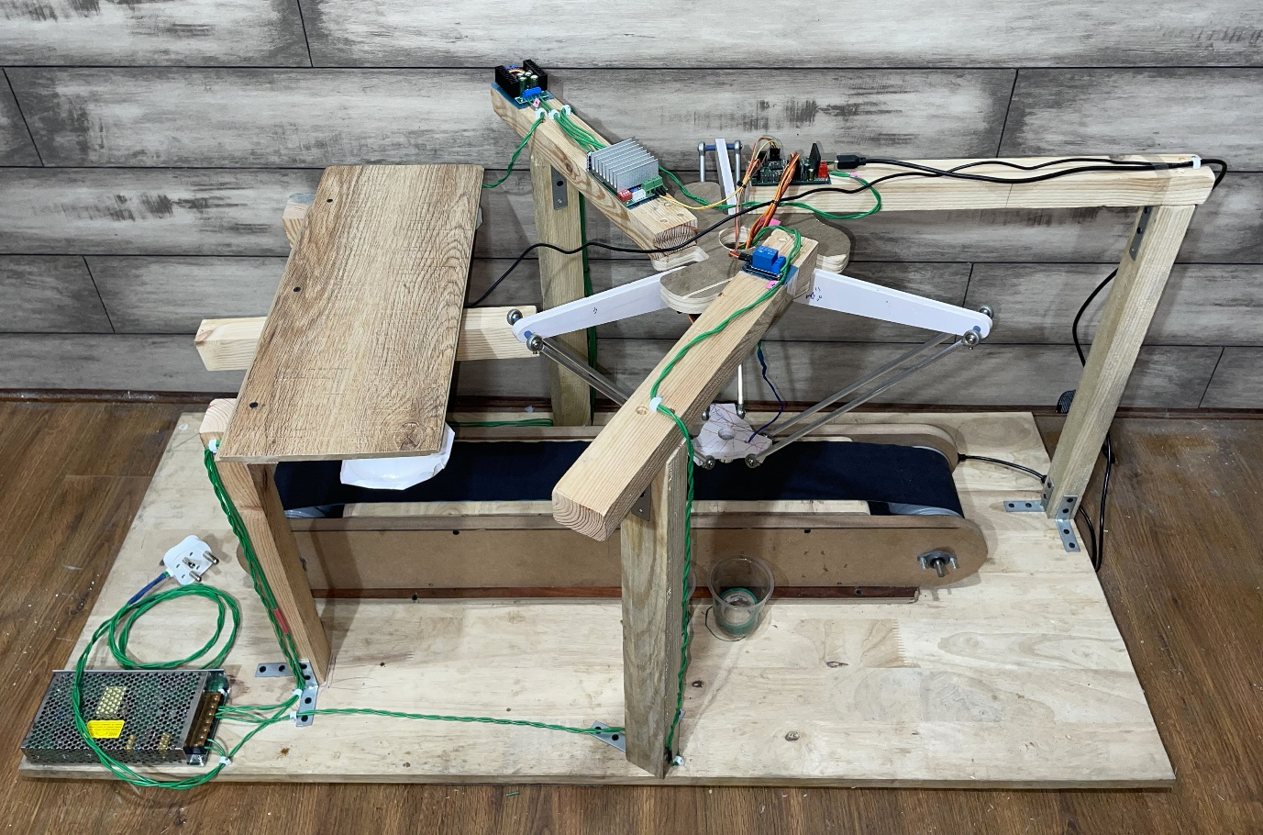

Fig- Real System